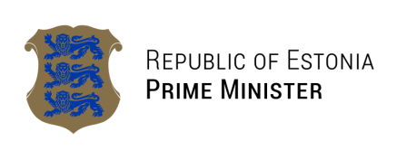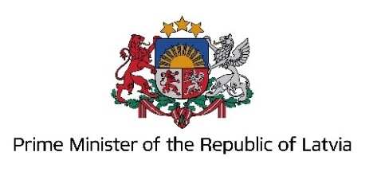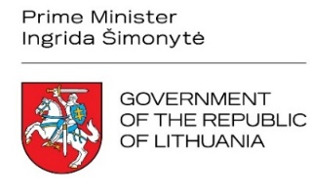

JOINT DECLARATION OF THE PRIME MINISTERS OF ESTONIA, LATVIA, AND LITHUANIA ON THE UNIFORM REGIONAL SANCTIONS IMPLEMENTATION
18 December 2023

ACKNOWLEDGING that Estonia, Latvia, and Lithuania (hereinafter ‘the Baltic States’) share a unique and challenging position being at the external border of the European Union with Russia and Belarus, also recognizing that closing loopholes and ensuring the effective implementation of sanctions is of critical importance in strengthening the impact of sanctions and disrupting Russia’s ability to continue its war of aggression against Ukraine, and that reinforcing the strict and uniform implementation and enforcement of European Union sanctions is a matter of integrity, impacting not only our own security but also that of the entire European Union;
HAVING REGARD TO:
The fact that since February 2022 the European Union has demonstrated determination and unity, leading to decisions of unprecedented scale that resulted in the adoption of twelve packages of sanctions on Russia in response to Russia’s unprovoked war of aggression against Ukraine;
In view of urgency the recently adopted restrictive measures arising from Russia’s unprovoked war of aggression against Ukraine and in response to Belarus’s involvement in the aggression, create closer alignment of European Union sanctions targeting Russia and Belarus, however, loopholes still exist, allowing for the circumvention of Russian sanctions through Belarus;
The sanctions imposed on Russia, unprecedented both in scale and scope and targeting its financial, trade and other economic activities, have presented new implementation challenges. Russia, in response, has devised numerous ways to circumvent these measures. Discrepancies in our enforcement and implementation efforts allow malign actors to profit from illegal conduct and pose a risk of jurisdiction shopping;
In an effort to eliminate the fragmentation and increase the effectiveness of the European Union’s sanctions, the Baltic States commit to applying regional approach towards uniform sanctions implementation. To this end:
THE SIDES HAVE AGREED TO:
Ensure uniform customs controls and information exchange; the relevant authorities in the Baltic States will adopt the regional approach no later than 31 January 2024;
Customs authorities will agree on principles for a common approach of handling the cases when illogical routes of goods are detected, to demand additional documentation concerning the transit or the end use of goods, to require additional declarations from manufacturers and exporters to minimize the risk of circumvention of sanctions.
Invite other Border States to join Baltic States in applying the regional uniform approach towards sanctions implementation.
We emphasise the utmost importance for the Baltic States to act together in ensuring the strict and uniform implementation of sanctions. While remaining committed to uniform sanctions implementation on the European Union level, we agree that, given our unique geographical position, the regional approach should be adopted without unnecessary delay.

Kaja Kallas  Prime Minister of the Republic of Estonia | Evika Siliņa  Prime Minister of the Republic of Latvia | Ingrida Šimonytė  Prime Minister of the Republic of Lithuania

