 | Building an integrated skills system in Lithuania

Better Skills, Better Jobs, Better Lives
Skills are the new currency. Skills are central to the capacity of countries and people to thrive in an increasingly interconnected and rapidly changing world. Megatrends such as globalisation, technological advance and demographic change are reshaping work and society, generating a growing demand for higher levels of skills, as well as new sets of skills.

OECD Skills Strategy Projects
OECD Skills Strategy projects provide a strategic and comprehensive approach to assess countries’ skills challenges and opportunities, and build more effective skills systems. The OECD works collaboratively with countries to develop policy responses that are tailored to each country’s specific skills challenges and needs. The foundation of this approach is the OECD Skills Strategy framework, the components of which are i) developing relevant skills over the life course, ii) using skills effectively in work and in society, and iii) strengthening the governance of the skills system.
So far, 20 OECD Skills Strategy projects have been completed or are underway in the following diverse countries: Austria, Belgium (Flanders), Italy, Korea, Latvia, Mexico, Netherlands, Northern Ireland, Norway, Peru, Poland, Portugal, the Slovak Republic, Slovenia, and Spain.
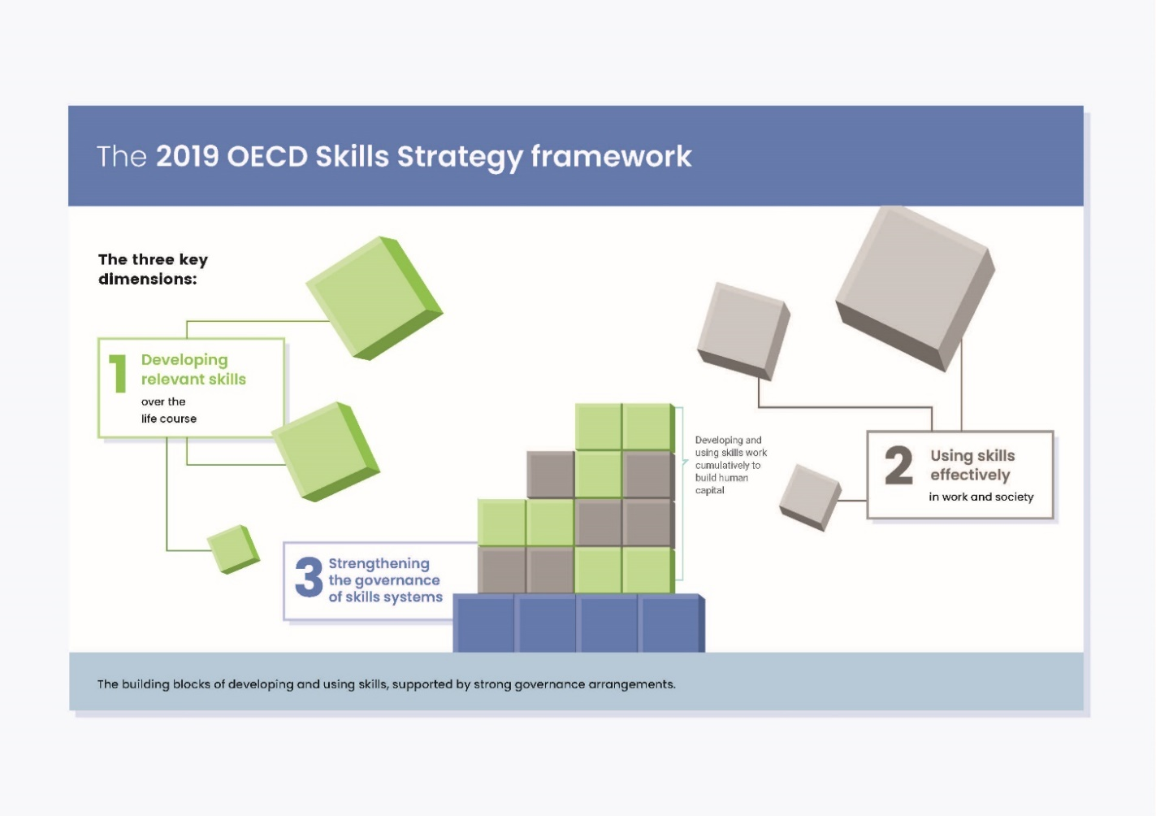

What contributions could an OECD Skills Strategy project offer to Lithuania?
OECD Skills Strategy projects make a number of important contributions to countries, including:
- Mapping the skills system to better understand the institutions, policies and stakeholders that influence the supply and demand for skills.
- Identifying policy priorities to help target investments to policy areas with the most potential to improve skills outcomes.
- Making recommendations for aligning polices to ensure that they are consistent and mutually reinforcing.
- Making concrete policy recommendations for improving current skills outcomes in areas of identified policy priorities.

How do OECD Skills Strategy projects achieve this?
- Strengthening whole-of-government collaboration. Maximising Lithuania’s skills potential requires collaboration and co-ordination across ministries and levels of government. A whole-of-government approach to skills involves coordinating policy initiatives of the Ministry of Education, Science and Sports; Ministry of Social Security and Labour; Ministry of Economy and Innovations; and Ministry of Finance, among others.
Each OECD Skills Strategy project starts with the country’s decision to establish an inter-ministerial National Project Team with representation from key ministries. Much of the project work is designed to foster greater interaction and exchange among relevant ministries in order to foster a shared understanding of skills challenges and opportunities as a basis for taking co-ordinated action. Most importantly, National Skills Strategy projects also identify where and how whole-of-government collaboration can be improved. In the countries the OECD has worked with to date, projects have involved between three and nine ministries, with ministries responsibilities for education, employment, and the economy, active in all projects.
- Strengthening stakeholder engagement. Effectively designing and implementing skills policies requires a shared understanding of the need to improve skills, the current strengths and challenges facing a country’s skills system, and the priority areas for action. This entails looking beyond government to build strong partnerships with all actors involved, such as employers, trade unions, training institutions, students and other stakeholders.
Each OECD Skills Strategy project is designed to facilitate stakeholder engagement and build a shared commitment to take concrete action. This is achieved through a combination of interactive workshops, focus groups and meetings with stakeholders. National Skills Strategy projects also identify how stakeholder engagement can be improved.
- Providing high quality analysis. A high quality analysis of a country’s skills performance is the foundation upon which better policies are built and implemented.
Each OECD Skills Strategy project leverages OECD, national and other data sources, as well as talent and expertise across the OECD, to provide countries with high quality advice on how to develop and implement effective policies for developing and using skills as well as for strengthening governance of the skills system. Each project provides an overall assessment of the performance of the national skills system and analyses between three and four specific priority areas identified by the OECD in collaboration with the national government (see Figure 3). Projects draw upon concrete examples of policy initiatives from other countries and regions that may provide important lessons, and make specific recommendations for improving performance in the identified priority areas.
- Providing international peer-learning opportunities: Peer learning opportunities will help countries to share experience with each other to widen and deepen understanding of policies that have work, or which have not.
Representatives of national project teams are invited to participate in annual workshops with other representatives of countries participating in OECD Skills Strategy projects.

The context for skills policy in Lithuania
Since its independence in the early 1990’s, Lithuania has engaged in bold political reforms, including the accession to the European Union in 2004 and the adoption of the Euro in 2015, leading the country to major economic and social changes within a context of strong economic performance. After a deep recession following the 2008 global financial crisis, Lithuania has regained the path to growth and prosperity. GDP growth is now among the strongest of OECD countries, and the employment rate has surpassed the pre-crisis levels and is now above the EU and OECD averages. In addition, despite having an unemployment rate still higher than before the crisis and higher than the OECD average, it has decreased from its 18% peak in 2010 to 6% in 2018. At the same time, Lithuania has made progress in improving it skills outcomes. Participation in education is now universal from early childhood to the end of upper secondary education, and the educational attainment of the adult population is well above OECD average.
However, the country still faces several pressing challenges in many areas. Population is declining by more than 1% annually since the early 2000s, mostly as a result of low fertility rates, and large and persistent emigration (with the young particularly at risk) mainly driven by relative low wages and poor working conditions. Income inequality and poverty are also relatively high, especially among women, the youngest, the elderly and those living in rural areas. Additionally, labour productivity is still at around two-thirds of OECD average, partially influenced by the high incidence of labour informality and skills mismatch. Lithuania has taken important steps to tackle these issues and in 2017 the country introduced the “New Social Model”, a set of far-reaching policy reforms (including labour relations, unemployment insurance and pensions) to make growth more inclusive.
Ensuring that Lithuania continues to improve its performance in developing and using its people’s skills will be essential for bolstering inclusive growth and wellbeing. The OECD’s Skills Strategy Dashboard (Figure 1) shows that Lithuania currently faces several performance challenges in developing and using the talent of its people.
Youth in Lithuania have comparatively low levels of skills. Results from the OECD Programme for International Students Assessment (PISA) show that the performance of 15-year-old students in reading, mathematics and science remains below the OECD average and has not improved over time. At the same time, there is a slightly larger share of Lithuanian students among low performers in mathematics, reading and science as compared to the OECD average.
Results from PISA also show that student performance varies greatly by the socioeconomic status of students, and the performance of students from rural areas is persistently lower than that of urban students, and by a wider margin than is typical within the OECD. Gender differences in student performance are wider than the OECD average and regional peers, with Lithuanian boys performing at especially low levels in reading proficiency.
Figure 1. Summary indicators of skills performance, Lithuania and selected OECD countries
Note: The Skills Strategy Dashboard has a focus on outputs of the skills system. A list of relevant indicators have been selected and aggregated and normalised in a way where a higher value and being among the “top 20%” reflects better performance. Colours in the dashboard represent the quintile position of the country in the ranking and "x" indicates insufficient or no available data for the underlying indicators, and dotted circles indicate missing data for at least one underlying indicator. Only OECD sources have been used.
In tertiary education, attainment is strong but quality and equity could be improved. While Lithuania performs among the top 20% of countries in the number of young adults that attain tertiary education, it performs in the bottom 20-40% of countries on how skilled are these tertiary graduates. Furthermore, it performs in the bottom 20% of countries on inclusiveness of tertiary education, an indicator that signals the share of people that attain tertiary education when both of their parents have attained less than tertiary education.
Lithuania performs in the bottom 20-40% of countries on the foundation skills of its adults. Improving the skills of Lithuania adults will be particularly important, given the large share of jobs (more than 60%) that are at significant or high risk of automation and large skills imbalances. However, participation in adult education and training in Lithuania is also below average.
As for the effective use of skills, the Skills Strategy Dashboard shows that Lithuania is among the top 20%-40% performers in the improvement of the use of skills at work. Similarly, it has a performance around the OECD average on indicators such as the effectiveness of the activation of skills and the inclusiveness of the labour market. However, there are still comparatively significant challenges in all other indicators.
Lithuania ranks in the bottom 20% of countries in regards to the alignment of skills with the labour market. The country has one of the largest proportions of over-skilled workers (in literacy and numeracy) across the countries/economies participating in the Survey of Adult Skills. In addition, Lithuania performs in the bottom 20% of countries on intensity of skills use in workplaces and on the adoption of high-performance workplace practices, which are found to stimulate skills use in the workplace.
Lithuania is making important efforts to boost a complex skills system. Still, Lithuania could benefit from a renewal of its strategic vision for the future to ensure that all of its people have the skills to respond to the challenges and opportunities of an interconnected and rapidly changing world. An integrated approach to skills policy will be essential to ensure the success of these initiatives and to improve Lithuania’s performance in both developing relevant skills and using those skills effectively. This will require effective whole-of-government co-ordination and stakeholder engagement, as well as sustainable financing and integrated information systems. The OECD stands ready to support the Government of Lithuania in undertaking a tailored OECD Skills Strategy project to this end.

A tailored OECD Skills Strategy project in Lithuania
The OECD would conduct an analysis and assessment of Lithuania’s skills system. This phase would involve a combination of desk research, workshops, and meetings with officials and stakeholders, and would result in the in the publication of “OECD Skills Strategy Lithuania: Assessment and Recommendations”.
This publication of around 140 pages would be published online within one month of finalisation. The publication will be composed of: i) an executive summary; ii) a key insights and policy recommendations chapter describing Lithuania’s skills performance and recent reforms, as well as identifying the key policy priorities and making concrete policy recommendations for government, social partners and other stakeholders; and iii) three to four thematic chapters on policy priorities that have been identified by the OECD in collaboration with the national project team.
Examples of policy priorities identified for countries, and covered in thematic chapters in recent OECD Skills Strategy publications include the following:
Figure 2. Examples of policy priorities in OECD skills strategy projects

On the basis of the OECD’s preliminary analysis and the priorities of the Government of Lithuania, the OECD would recommend focusing in this project on three to four of the following themes, subject to further analysis and agreement:
- Improving the skills of the youth. Consideration would be given to the improvement of students’ school performance with special attention paid to non-urban and rural areas, enhancing the equity within the educational system, as well as teacher training and quality, and a special focus on tertiary education.
- Reducing skills imbalances with a more responsive education system. Consideration would be given to retaining and attracting talent from Lithuania and abroad, making the migration framework better serve the skill needs of the country; enhancement of the responsiveness of the education system (including VET and tertiary education) as well as activation and retraining policies.
- Raising participation in adult learning of all forms. Consideration would be given to the motivation of adult learners, barriers to participation in adult learning, and enhancement of the general adult learning culture. Special consideration would be given to policies that support the participation of underrepresented groups in training that is relevant to the needs of the labour market, as well as to policies to encourage greater employer commitment to developing the skills of their workers.
- Improving skills use in workplaces. Consideration would be given to a range of high performance work practices.
- Strengthening the Governance of skills systems. Consideration would be given to measures to improve collaboration and coordination across ministries and levels of government as well as with stakeholders. Consideration would also be given to whether information systems and financial arrangements support the coordination and alignment of skills policies.

What would be the project activities and timelines?
OECD Skills Strategy projects require close collaboration between a dedicated OECD multi-disciplinary team and an inter-ministerial project team. During the first months of work, the OECD develops with the input of the country, an operational project plan that defines project activities, outputs and timelines. Sample timelines for are provided below.
Figure 3. OECD skills Strategy project activities and timelines

First Mission: Skills Strategy Seminar
The first mission to Lithuania would involve an OECD Skills Strategy Seminar to convene policy makers and senior officials from several relevant ministries – Ministry of Education, Science and Sports; Ministry of Social Security and Labour; Ministry of Economy and Innovations; and Ministry of Finance, among others. The seminar would have the following objectives:
- Present a high-level assessment of the performance of the skills system in Lithuania using the OECD Skills Strategy dashboard to help focus discussions on policy priorities.
- Agree on the priority areas to be covered in this phase (these should be discussed in advance of the meeting).
The first mission would also include an inter-ministerial project team meeting and technical bilateral meetings with Ministries.
Prior to the mission, the OECD would ask the Lithuania project team to complete a questionnaire that would provide important information about skills partners, policies and priorities in Lithuania.

Second Mission: Assessment workshop
An Assessment Workshop would be held to convene officials from ministries participating in the project team as well as other relevant public agencies and a broad cross-section of stakeholder representatives (e.g. employer associations, student associations, trade unions, education providers, vocational education and training schools and colleges, employment and economic development agencies). The objective of this workshop will be to discuss the key determinants of the identified skills policy priorities as well as to solicit ideas from government and stakeholders on how best to take action in these priority areas.
During the same mission, bilateral meetings and focus groups would be held with key information to better understand the skills priorities in Lithuania.

Third Mission: Recommendations Workshop
A third mission to Lithuania will take place to conduct a Recommendations Workshop. This workshop would convene government officials and stakeholders to discuss and refine a draft set of recommendations identified for Lithuania, identify key considerations for implementation, and discuss good practices in Lithuania and elsewhere.
During the same mission, bilateral meetings and focus groups would be held with key information to better understand the skills priorities in Lithuania.

Fourth Mission: Launch
A public event to launch the “OECD Skills Strategy Lithuania: Assessment and Recommendations” report will be held to raise public awareness and develop a broad base of support for future action in improving the skills system of Lithuania.

What is the proposed project cost?
The project, with a total duration of approximately 12-14 months, could be completed for an overall budget of 360 KEUR to cover the OECD costs, which would need to be covered by a Voluntary Contribution. As an EU Member State, Lithuania may be eligible for European Commission’s financial support. (Note: the costs associated with workshop logistics are not included in this budget figure).
Budget | EUR
Assessment and Recommendation phase
• Four missions to Lithuania
• Preparation and publication of an OECD Skills Strategy Assessment and Recommendation Report (in English),
• Stand-alone Executive Summary (in Lithuania and English)
TOTAL | 360 KEUR

What follow up is envisaged after this project?
Under the OECD Skills Strategy project design, each country or region that has completed an Assessment and Recommendations project may choose to proceed to an action phase project. This project would draw upon OECD input and support for policy implementation. A decision in principle to undertake the successive action phase may be taken by Lithuania at any point during the Assessment and Recommendations phase.
The aim would be to provide OECD expertise in assessing feasibility and supporting roadmap to develop and implement the government’s priorities for action, based inter alia, on the results of the Assessment and Recommendations phase. The action phase would be the subject of a new project proposal.
For more information on the OECD National Skills Strategy Country Projects please contact:
- Ms. Montserrat Gomendio, Head of the OECD Centre for Skills: montserrat.gomendio@oecd.org
- Mr. Andrew Bell, Head of National Skills Strategy projects: andrew.bell@oecd.org

 | Building an Integrated Skills System in Lithuania

Annex 1 – OECD team and inter-ministerial national project team of Lithuania: Roles and responsibilities

OECD team  - Overall project management and responsibility for process and outputs  - Assemble OECD project team drawing upon expertise from different directorates as relevant to the project and regional context  - Advise the project team on managing critical success factors  - Prepare overall project plan, sequencing and completion of project activities, within agreed budget and timeline  - Workshop facilitation  - Design and conduct workshops, in close cooperation with the project team  - Provide material and exercises for workshops, carefully selected from our range of material to ensure adaptability to the region’s circumstances and challenges  - Brief the project team before workshops, and debrief afterwards to ensure further use of common learning experiences  - Act as a neutral and independent external facilitator throughout  - Communication  - Maintain regular contact with the project team to ensure common understanding of goals, phases and progress during the project (e.g. via tele- or videoconferences)  - Inform and involve relevant colleagues within the OECD at each stage of the process  - Participate in relevant regional events by giving presentations of the Skills Strategy work, as needed  - Provide relevant and timely information about project progress and results through formal channels (e.g. OECD committees, OECD Skills Strategy Advisory Group) and to main stakeholders (e.g. European Commission)  - Promote and disseminate key project outputs and outcomes via the OECD’s communication platforms  - OECD comparative data, analysis and examples from OECD countries  - Provide comparative data and OECD analysis to illuminate the challenges relevant to Lithuania  - Identify and include relevant international examples and mobilise top practitioners from key countries and regions  - Drafting and publication of reports  - Prepare and circulate draft workshop reports to the project team for feedback in accordance with timeline agreed between OECD team and project team  - Draft initial outline and diagnostic report and circulate to the project team for comments  - Publish the OECD Skills Strategy Lithuania: Assessment and Recommendations Report within 1 month of finalisation | National Project Team of Lithuania  - Project coordination  - Appoint project manager and establish project team  - Conduct regular project team meetings in the course of the project  - Identify key stakeholders to engage in the project  - Coordinate, organise and secure all practical arrangements for project activities in Lithuania – including identifying and hiring venues for workshops, logistics, refreshments, interpretation (if needed)  - Source of expertise on skills  - Complete the background questionnaire.  - Provide information and expertise regarding main national and regional data and analysis on skills  - Provide guidance on the relevance of international data and on what other international experience would be most useful in the context of Lithuania  - Communication within Lithuania  - Provide timely and relevant reporting to ministers on project progress and outcomes  - Ensure relevant issues are discussed and shared within own ministry/organisation  - Act as the main interface with stakeholders during the project – including inviting them to workshops  - Provide regular updates and information to stakeholders (e.g. via brief meetings in between workshops, email updates)  - Communication with the OECD team  - Maintain regular contact with OECD team to ensure common understanding of goals and progress in the project  - Provide guidance for the design of the project process and workshops  - Provide timely input and feedback to the OECD on draft reports  - Coordinate feedback from stakeholders to the OECD team (e.g. on workshops, reports)  - Inform OECD team of any events which might impact on project completion  - Participate in design and conduction of workshops  - Provide relevant information and advice to the OECD team when planning workshops  - Identify and actively promote attendance by key stakeholders  - Act as facilitators for small group discussions in the workshops  - Provide feedback to the OECD following each workshop

