INTEGRATED NATIONAL ENERGY AND CLIMATE PLAN OF THE REPUBLIC OF LITHUANIA

Draft version
20th November 2018

Abbreviations
AROPE | At Risk of Poverty or Social Exclusion
BEMIP | Baltic Energy Market Interconnection Plan
BENTE | Baltic Energy Technology Scenario study
Biomass CHP | Biomass Combined Heat and Power
BJVK | Bio generation development cluster
CEF | Connecting Europe Facility
CO2 | Carbon Dioxide
DHS | District Heat Supply
DSO | Distribution System Operator
EE | Energy Efficiency
EIS | European Innovation Scoreboard
ENTSO-E | European Network of Transmission System Operators (electricity)
ETS | Emissions Trading System
EU | European Union
EV | Electric Vehicle
GDP | Gross Domestic Product
GHG | Greenhouse Gas
GIPL | Gas Interconnection Poland–Lithuania
Ignalina NPP | Ignalina Nuclear Power Plant
Incukalns UGS | Incukalns Underground Gas Storage
IT | Information Technology
JESSICA | Joint European Support for Sustainable Investment in City Areas
ktoe | Kilo Tons of Oil Equivalent
LitPol Link | Lithuania–Poland Electricity Interconnection
LNG | Liquefied Natural Gas
LRAs | Local and Regional Authorities
LULUFC | Land Use, Land-use Change, and Forestry
mFRR | Manual Frequency Restoration Reserve
Mtoe | Million Tons of Oil Equivalent
MWh | Megawatt hour
NECP | Integrated National Energy and Climate Plan
NEIS | National Energy Independence Strategy
NETP | Nordic Energy Technology Perspectives
NordBalt | Submarine Power Cable between Lithuania and Sweden
NZEB | Nearly Zero-energy Buildings
PaMs | Policies and Measures
PCI | Project of Common Interest
POTP | Post-taxes Total Price
RDI | Research, Development and Innovations
RES | Renewable Energy Sources
RES-district H&C | RES-district Heating and Cooling
RES-households H&C | RES-households Heating and Cooling
RES-E | RES-Electricity
RES-T | RES Transport
RGMCG | Regional Gas Market Coordination Group
SPM | Single-point Mooring
TSO | Transmission System operator
TWh | Terawatt hour
UNFCCC | United Nations Framework Convention on Climate Change
VESK | Wind energy promotion cluster

OUTLINE:

Abbreviations 2
SECTION A: NATIONAL PLAN 5
1. OVERVIEW AND PROCESS FOR ESTABLISHING THE PLAN 5
1.1. Executive summary 5
1.2. Overview of current policy situation 9
1.3. Consultations and involvement of national and Union entities and their outcome 14
1.4. Regional cooperation in preparing the plan 15
2. NATIONAL OBJECTIVES AND TARGETS 16
2.1. Dimension decarbonisation 16
2.1.1. GHG emissions and removals 17
2.1.2. Renewable energy 17
2.2. Dimension energy efficiency 23
2.3. Dimension energy security 24
2.4. Dimension internal energy market 29
2.4.1. Electricity interconnectivity 29
2.4.2. Energy transmission infrastructure 29
2.4.3. Market integration 31
2.4.4. Energy poverty 33
2.5. Dimension research, innovation and competitiveness 34
3. POLICIES AND MEASURES 38
3.1. Dimension decarbonisation 38
3.1.1. GHG emissions and removals 38
3.1.2. Renewable energy 49
3.1.3. Other elements of the dimension 54
3.2. Dimension energy efficiency 60
3.3. Dimension energy security 66
3.4. Dimension internal energy market 67
3.4.1. Electricity infrastructure 67
3.4.2. Energy transmission infrastructure 68
3.4.3. Market integration 69
3.4.4. Energy poverty 71
3.5. Dimension research, innovation and competitiveness 71
SECTION B: ANALYTICAL BASIS 76
4. CURRENT SITUATION AND PROJECTIONS WITH EXISTING POLICIES AND MEASURES, 76
4.1. Projected evolution of main exogenous factors influencing energy system and GHG emission developments 76
4.2. Dimension Decarbonisation 78
4.2.1. GHG emissions and removals 78
4.2.2. Renewable energy 87
4.3. Dimension Energy efficiency 90
4.4. Dimension energy security 91
4.5. Dimension internal energy market 93
4.5.1. Electricity interconnectivity 93
4.5.2. Energy transmission infrastructure 93
4.5.3. Electricity and gas markets, energy prices 95
4.6. Dimension research, innovation and competitiveness 100
5. IMPACT ASSESSMENT OF PLANNED POLICIES AND MEASURES 109
5.1. Impacts of planned policies and measures described in section 3 on energy system and GHG emissions and removals including comparison to projections with existing policies and measures (as described in section 4). 109
5.2. Macroeconomic and, to the extent feasible, the health, environmental, employment and education, skills and social impacts including just transition aspects (in terms of costs and benefits as well as cost-effectiveness) of the planned policies and measures described in section 3 at least until the last year of the period covered by the plan, including comparison to projections with existing policies and measures 110
5.3. Overview of investment needs 110
5.4. Impacts of planned policies and measures described in section 3 on other Member States and regional cooperation at least until the last year of the period covered by the plan, including comparison to projections with existing policies and measures 110

SECTION A: NATIONAL PLAN

OVERVIEW AND PROCESS FOR ESTABLISHING THE PLAN
NECP preparation and consultation process arrangements

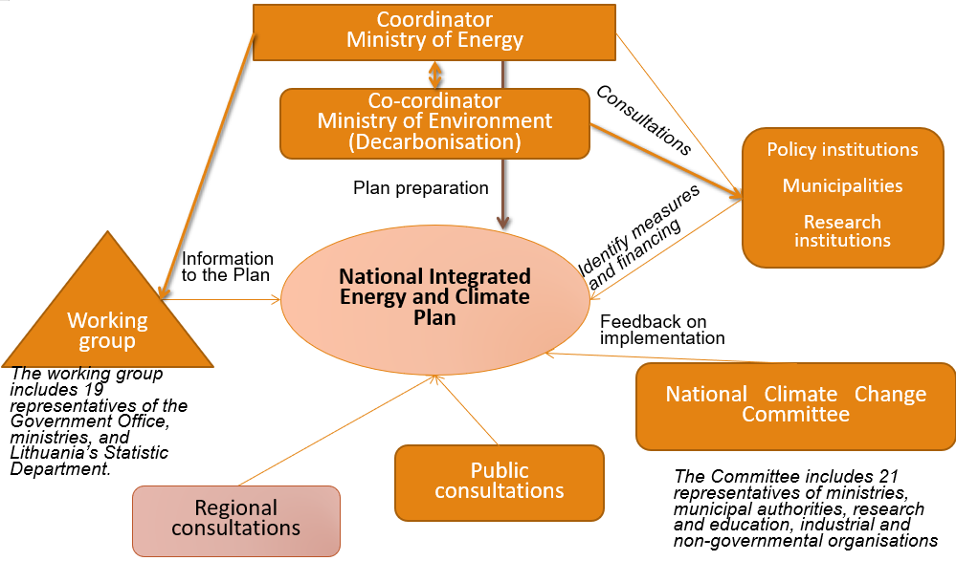

1.1. Executive summary
      - Political, economic, environmental, and social context of the plan
Lithuania presents an integrated national energy and climate plan (hereinafter – the Plan) for the period of 2021–2030 developed in line with the requirements of Article 3 of the Governance of the Energy Union Regulation. In the Plan outlined policies and measures of different economy sectors according to five dimentions of the Energy Union will contribute Lithuania’s fair share towards the implementation of the EU climate and energy targets till 2030 and long term goals of the Paris Agreement.
Table 1.1.1. Key country profile data
Area: | 65 300 km²
Population (2017): | 2 921 262
Forests: | Cover 33.4% territory
Climate: | Ranges between maritime and continental. The average temperatures are +19°C in July and -3°C in January
Lithuania's GDP growth | 3.6% in 2017
GHG emissions | 20.09 m t CO₂eq; 6.9 t CO₂eq GHG/capita

Environmental goals. Lithuania’s consistent and targeted actions in implementing the climate change targets are testified by reached decoupled emissions from economic growth. In 2015 greenhouse gas (GHG) emissions reduced by 58% while GDP grew by 38%, compared to 1990 levels, and constituted 20 100 kt of CO₂eq. or 6.9 t of CO₂eq. per capita, which accounted for 0.04% of the world GHG emissions or 0.55% of the EU total GHG emissions. It is expected to meet GHG emission reduction target under the Effort Sharing Decision by a margin of 13% points.
Labour market. The Lithuanian population continues to decline. Since 2007 the working-age population (20-64) has decreased by more than 12% (from 1.81 m in 2007 to 1.59 m in 2017) and continues to shrink at a fast pace. These demographic trends negatively affect labour supply and increase the risks to the sustainability of the social security system. Ir also affects targeted climate sphere goals statistically, so far the impact can be considered as insignificant.
The labour market continued to perform well in 2017. Unemployment has been falling steadily since 2010, with rising activity and risingemployment rates. It is estimated to have reached 7.3% in 2017, below the EU average of 7.8%.

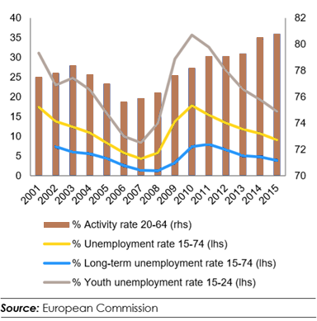
Figure 1.1.1. Major labour market trends in Lithuania

The benefits of economic growth have not been equally spread and the risk of poverty remains among the highest in the EU. The share of people at risk of poverty or social exclusion (AROPE) has increased compared to 2015, and is among the highest in the EU (30.1% in 2016, EU average 23.5%).
Income inequality remains one of the highest in the EU. Over the period 2010 to 2017, growth in household income has failed to keep pace with GDP growth, raising questions about the inclusiveness of the recovery. Largely driven by a tightening labour market and a catching-up effect, wages have grown faster than productivity since 2012, leading to rising unit labour costs.

Economics. Lithuania's public finances remain sound. After achieving a budget surplus in 2016 of 0.3% of GDP, the general government balance is set to stay in surplus in 2017 and 2018, reaching 0.1% and 0.2% of GDP, respectively.

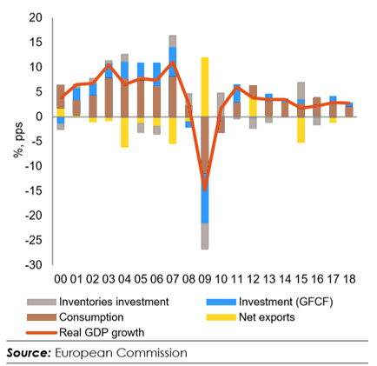
Figure 1.1.2. Real GDP growth and contributions

GDP grew 2.2% in 2016, led by private consumption and recovering exports. Solid wage and employment growth combined with subdued inflation supported household disposable incomes which in turn fuelled private consumption growth. Exports were forecasted to have grown by 2.6% following their disappointing performance in 2015. However, a decline in investments due to a temporary slowdown of EU fund disbursements weighed on overall growth.
Energy consumption. Primary energy consumption has been steadily decreasing in Lithuania. The current level (5.8 Mtoe in 2015) is already below the 2020 target for primary energy consumption (6.5 Mtoe). Lithuania's final energy consumption increased by 2% in 2015 (reached 4.9 Mtoe) and was above its 2020 target for final energy consumption (4.3 Mtoe). Although primary energy intensity decreased over the 2005-2015 period, it remains above the EU average.
Energy efficiency. In terms of energy efficiency, some progress was observed in the final energy intensity in industry and in the services sector as well as in the final consumption per square meter for the residential sector. However, energy intensity in these sectors is still above the EU average and timely renovation of residential buildings remains a challenge. Conversely, the final energy consumption in transport is increasing faster than GDP despite a higher use of public transport.
RES. Lithuania’s renewable energy share in gross final energy consumption was 25.8% in 2015, above its 2020 target of 23%. This good performance was driven mostly by the heating sector, where the share of renewables reached 46.1%. The renewables share in electricity production reached 16%. Lithuania is below the 2020 target of 10% for renewable energy share in transport, with 4.6% in 2015. Due to a consistent deployment of renewables since 2005, it was estimated that in 2015 Lithuania cut its consumption of fossil fuel by about 11.8% in gross inland consumption.
      - Strategy relating to the five dimensions of the Energy Union
Lithuania 2030 is a national strategy, which outlines the vision of Lithuania's future (it was adopted by Parliament in 2012).
Lithuania 2030 has three priorities:
- Smart Society
- Smart Economy: Flexible and competitive, it creates high added value rooted in knowledge, innovation and entrepreneurship. Competitive and environmentally sustainable energy sector will be of utmost importance for national economy: it is necessary to achieve energy independence and sustainable development of environment-friendly use of resources.
- Smart Governance.
The National Progress Program for 2014-2020 was prepared in order to implement the Strategy Lithuania 2030. The programme includes also the main provisions of EU strategy for smart, sustainable and inclusive growth Europe 2020. Under one of the Programme’s priorities Favorable environment for economic growth 2 objectives are identified, that are directly linked with energy sector:
- Create a sustainable and efficient economic infrastructure (the aim is to develop modern energy infrastructure in Lithuania and to ensure, first, the energy independence of the country from the influence of various monopolies (in particular on energy and gas prices); secondly, modern, competitive and environmentally friendly electricity (production and supply), gas, infrastructure, which would ensure the most favorable price and quality ratio of services to the residents of Lithuania);
- Ensure the sustainable use of energy resources (the goal is to move towards a low-carbon economy, which will help to prevent dangerous climate change, reduce air pollution, and increase energy independence of Lithuania. Increasing energy efficiency will focus on the housing sector and the use of renewable energy sources. Ensuring the sustainable use of energy resources will also be achieved through the use of modern and sustainable technologies, process management systems, promoting the use of alternative fuels in transport).

National Sustainable Development Strategy was approved by Government in 2009. The document sets out sustainable development priorities, principles, objectives and tasks of Lithuania. The main sustainable development objective of Lithuania remains the same, namely to reach the EU average in terms of economic and social development and resource efficiency indicators by 2020, not to exceed permissible EU levels of environmental pollution, to meet the requirements of international conventions limiting environmental pollution and impacts on the global climate. It can only be achieved by introducing the latest innovative and more environmentally friendly technologies. The strategy gives particular attention to scientific progress and knowledge.

      - Overview table with key objectives, policies and measures of the plan

Table 1.1.2. An overview of key climate and energy policy objectives
Target | EU |  | Lithuania |  | Implementation
Target | 2020 | 2030 | 2020 | 2030 | 2016
GHG reduction targets according to KP Doha amendment and Paris agreement compared to1990 level | -20% | At least  -40% | EU level target |  | -23% (EU)
GHG reduction targets in ETS sectors compared to 2005 level | -21% | -43% | EU level target |  | -26% (EU)
GHG reduction targets in non-ETS sectors compared to 2005 level | -10% | -30% | +15% | -9% | -0.7% (LT)
RES utilization target in final energy | 20% | 27% | 23% | 45% | 25.6% (LT)
RES utilization target in transport | 10% | 14% | 10% | 15% | 3.6% (LT)
Interconnectivity level | 10% | 15% | EU level target |  | 23.0% (LT)
Energy Efficiency targets | 20% | 27/30% | 17% | Energy intensity 1.5 times lower than in 2017 | 6.8% (LT)

Overview of current policy situation
      - National and Union energy system and policy context of the national plan
The structural reforms and strategic projects of the energy sector, carried out in Lithuania as a result of implementing the National Energy Independence Strategy approved by the Parliament in 2012, have diversified energy supply routes and sources, reduced energy resources prices for consumers, and opened new development opportunities for the country. Lithuanian energy sector has been substantially restructured in order to reduce and eventually eliminate the energy dependence on the Russian Federation that has resulted in unreasonably high resource prices and the use of energy as a political tool.
With regard to these results and the new EU energy and climate change targets that Lithuania has to achieve by 2030 by implementing the Paris Agreement and the new trends in the energy market and also targets of the EU Energy Union and the Baltic Energy Market Interconnection Plan, an updated National Energy Independence Strategy was approved by the Parliament in June 2018, including the state’s key energy policy tasks, directions and their implementation tasks up to 2030 and a vision up to 2050.
According to the updated Strategy, the continuity of the pursued policy and directions will be maintained, the investment attractiveness of Lithuania will be improved, new zero GHG and zero pollutant technologies resilient to climate change will be implemented, innovations in the energy sector will be encouraged, and energy progress will be ensured.

      - Current energy and climate policies and measures relating to the five dimensions of the Energy Union
The Lithuanian climate change policy is developed in line with the targets and objectives laid down in the international agreements under the United Nations Framework Convention on Climate Change (UNFCCC), the EU strategic documents and legislation.
In order to ensure the implementation of the international agreements on climate change and in the EU legal acts defined targets for Lithuania, the Parliament of the Republic of Lithuania in 2012 approved the National Strategy for Climate Change Management Policy which lays down the short-term targets and objectives for climate change mitigation and adaptation until 2020 and long-term indicative target for 2050.

Table 1.2.1. The Lithuania’s legally binding short-term and long-term climate change mitigation compared to 1990 and other targets
Description | Target | 2016
Short-term targets
GHG emission reduction in EU ETS sectors | 8.5 Mt CO₂eq. | 6.1 Mt CO₂eq.
GHG emissions reduction in non-ETS sectors | 15.2 Mt CO₂eq. | 13.9 Mt CO₂eq.
The share of renewable energy resources in final energy consumption | 23% | 25.6%
Reduction of energy consumption | 17% compared to 2009 | 6.8%
Financial support | no less than 0.38% of the country’s GDP is assigned for the implementation of short-term climate change mitigation targets | n/a
Long – term targets aiming to contribute to the implementation of the EU targets
2030 | 40%
2040 | 60%
2050 | 80%

Update of the Strategy aiming to set legally biding adaptation to climate change goals and objetives for the period 2021–2030 and aspirational target and objectives till to 2050 and beyound is planned by the end of 2019.

To implement this Strategy, in 2013 the Government approved the Interinstitutional Action Plan on the implementation of the targets and objectives for 2013–2020 of the National Strategy for Climate Change Management Policy, which defines measures for the reduction of GHG emissions and adaptation to climate change in all the Lithuanian economy sectors, including:
- industry,
- energy, agriculture,
- development of residential areas,
- transport,
- health care,
- waste management, etc.

Interinstitutional Action Plan on the implementation of the targets and objectives for 2013–2020 of the National Strategy for Climate Change Management Policy is subject to annual updating. As of 2020 the Plan will be incorporated in NECP. Currently implementation of the Plan is coordinated by the Ministry of Environment. The Ministries of Finance, Energy, Transport and Communications, Economy, Education and Science, Agriculture and the Interior, as well as municipalities, the Research Council of Lithuania, state research institutions and universities, companies, entities, organizations and other persons participate in the implementation of the measures within their competence and allocating funds for their implementation of the measures. While drawing up sectorial development programs, interinstitutional action plans or other planning documents for their respective management areas, the ministries shall mainstream the targets and objectives for climate change mitigation and adaptation set out in the Strategy, in order to provide for specific measures to implement those targets and objectives and to ensure close interinstitutional cooperation.
In general, implementing the Interinstitutional Action Plan on the implementation of the targets and objectives of this Strategy as well as other cross-sectorial and sectorial development programs from the EU Structural and investment funds for 2014–2020 and the state budget of the Climate Change Special Program around 2 billion EUR is planned to be invested in implementation of measures related to climate change mitigation and around 0.9 billion EUR – to adaptation to climate change in all Lithuania’s economy sectors in the period of 2014-2020.

The National Energy Independence Strategy, which is updated on the regular basis. From a country importing energy technologies, Lithuania needs to become a country creating and exporting energy technologies. Energy efficiency improvements by implementing building renovation programs and ameliorating the efficiency of industrial enterprises’ production, also RES development create a large market for such services and an opportunity to expand employment opportunities and to develop innovative zero GHG and zero pollutant technologies and human resources’ skills. The country’s business development will be supported by the following measures:
- By promoting the experimental and industrial development of the most promising energy technologies and innovation incubators, green, distributed energy generation, and digital solutions in the field of energy research;
- By promoting information technology (IT) solutions for energy sector optimization to be tested in Lithuania and exported;
- Through cooperation between the LNG terminal, businesses, organizations and the country’s high and higher schools (including research institutes and universities), expanding the potential of the gas infrastructure of regional significance, LNG technologies, distribution, and excellence center.
- The outcome of the implementation of changes in the energy sector and capacity building:
- The establishment of well-paid jobs and increase of high value-added exports of energy technologies and knowledge;
- Lithuania is a center of information technology and cyber security solutions for energy, biomass and biofuel technology, solar and wind energy technology, geothermal technology, energy market development, improvement of electricity system operation, development of new electricity system management methods and implementation of energy projects.

Renewable energy. Lithuania is focused on reducing the environmental impact of its energy production and use. It is determined to move towards a sustainable and low‑carbon economy by modifying its energy mix and methods of generating energy. Lithuania has begun to shift towards more efficient energy production and greater use of renewable energy.
In the last decade, the use of cleaner energy sources in Lithuania has increased significantly. Lithuania has already reached its goal of having a 23% share for renewable energy in its total energy consumption by 2020. In 2017, the share of renewable energy sources in the total consumption of energy was 25.8%.
On 2017 October Lithuania was the first Member State to sign the Cooperation agreement with Luxembourg transferring renewable energy statistics.
Accordingly, consumption of electricity from RES was about 17%, in total heat consumption – about 46%, and in the transport sector—about 4%. A significant share of resources in energy production comes from wind and biofuels.

Energy Efficiency. Energy efficiency is usually evaluated by the primary and final energy intensity, which indicates how much energy costs went into the production of a specific amount of goods and services in the country (the ratio of country’s energy consumption to its GDP). In 2010–2015, the energy intensity of the country’s economy consistently decreased (primary energy - 32%, final energy - 31%), and in 2015 was the smallest among the three Baltic States at 0.205 toe/1000 EUR (in Latvia – 0.207 toe/1000 EUR, Estonia – 0.358 toe/1000 EUR). Lithuania is still behind (by about 70%) the EU average (0.120 toe/1000 EUR).
In the long-term perspective, electricity consumers will become proactive participants in the market and will be given the opportunity to use energy generated from RES for their own needs to receive a reward for surplus energy supplied to the network in line with the market conditions. Such consumers will account for at least 30% of all consumers by 2030 and at least 50% by 2050. These customers will be able to participate in the market through service providers in the energy sector. The active participation of local energy communities in investing in co-owned RES equipment will be encouraged.

Transport. Petroleum products account for a large share (38.9%) of the country’s primary energy consumption. In 2016, the total consumption of petroleum products accounted for 1.7 million tons per year in road transport, of which 80.8% was diesel for road transport, 12.5%—petrol and 6.6%—liquefied petroleum gas. In 2016, biofuel consumption in road and rail transport was 4%.

Heating. To maximize the share of RES for district heat consumers, households with individual heating and non-household consumers with individual heating:
- Up until 2020, RES consumption will continue to increase as compared to district heat consumption and in individual heating in households.
- The share of DHS RES will be 70% by 2020 and 90% by 2030. The development of high-efficiency solid biomass CHP plants will continue, non-recyclable municipal waste non-hazardous industrial waste that have energy value will be effectively used for energy production.
After creating a favorable regulatory environment, households with independent heating will gradually switch to clean, zero GHG technologies and the share of RES in households will reach 70% by 2020 and 80% by 2030. GHG producing technologies will be replaced by clean, clean-air technologies that do not impair the quality of air.
      - Key issues of cross-border relevance
The key issues of cross border relevance on the local national level can be identified both on political and infrastructural level.
Lithuania, Latvia and Estonia got the green light from European Commission on September 14, 2018 for the project of the Baltic power grids synchronization with the Continental European system. The decision put an end to several years of discussions on the synchronization scenario. The scenario calls for synchronizing the Baltic grids via the existing LitPol Link interconnection between Lithuania and Poland and a new sea cable between the two neighboring countries, as well as for installing synchronous compensators at hydro power plants in the three Baltic states. This scenario is technologically reliable and the most economically advantageous. It will ensure the stable and reliable operation of the power systems and continuous supply of electricity to Baltic customers.
Decision opened the way for the Baltic and Polish transmission system operators to submit an application to the European Network of Transmission System Operators (ENTSO-E) for the extension of the Continental Europe Synchronous Area, with a decision expected to be made in 2019. It is assumed that 432 million euros in funding under the Connecting Europe Facility (CEF) for the first stage of the project is needed. The total cost of the project, including additional technical solutions, such as synchronous compensators, is estimated at around 1.4 billion euros. The EU is expected to cover 75% of the cost. The synchronization project is expected to be completed in 2025.
Energy systems of three Baltic states are historically interconnected and designed to perform as one.Such infrastructure objects as Incukalns UGS or former Ignalina NPP were designed not for single country energy needs satisfaction. Lithuania continues same policy and Klaipeda’s LNG import terminal or interconnections with Sweden and Poland – current and under development – are of cross-border relevance. Being the biggest natural gas importer and consumer among three Baltic States, Lithuania’s political decisions significantly affect Incukalns UGS performance and future development plans.
Another important issue of cross-border relevance is political decisions and international agreements. All three Baltic States still did not manage to agree on single LNG import terminal or how to develop locally based efficient electricity generation, keeping in mind that both Latvia and Lithuania consume more electricity than they produce.
      - Administrative structure of implementing national energy and climate policies
The development and implementation of the Lithuania’s energy policy are being coordinated by the Ministry of Energy. The development and implementation of the Lithuania’s climate change mitigation and adaptation policy are being coordinated by the Ministry of Environment. The two ministries mentioned above actively interact with ministries of Finance, Energy, Transport and Communications, Economy, Education and Science, Agriculture and the Interior, as well as municipalities, the Research Council of Lithuania, state research institutions and universities, companies, entities, organizations and other persons participate in the implementation of the measures for energy and environment within their competence. Each institution is allocating funds individually for the annual implementation of the implementation of the measures assigned to them.
While drawing up sectorial development programs, interinstitutional action plans or other planning documents for their respective management areas, the ministries shall mainstream the targets and objectives for climate and energy, in order to provide for specific measures to implement those targets and objectives and to ensure close interinstitutional cooperation. These targets and objectives are detailed further in this document, and in case if such data is already available, quantified.
A working group for the preparation of a draft integrated national energy and climate plan, coordination of its implementation and preparation of reports was formed in 2017. The working group includes 19 representatives of the Government Office, ministries, and Lithuania’s Statistic Department.
Framework national energy and climate strategies are being approved by the Parliament of the Republic of Lithuania (Seimas) and their implementation action plans as well as all economy sectors development programs by the Government. New plans are usually prepared every five years, if there is such need on the national level, more often. As an example, new National Energy Strategy can be updated earlier than five years period expired, which had to include the measures for Ignalina NPP closure after officially joining EU in May 2004. There is list of projects and measures with exact funding needed allocated on yearly basis. Funds for the projects and measures implementation are set in each year national and local budgets.
The National Climate Change Committee has been established for advisory purposes on the development of the Lithuanian climate change policy and coordination of its implementation. The Committee includes 21 representatives of ministries, municipal authorities, research and study, industrial and non-governmental organizations and 20 observers.

Consultations and involvement of national and Union entities and their outcome
- Involvement of the national parliament
Lithuanian Parliament (Seimas) is set to have presentation on the NECP draft until the end of 2018. It is involved directly on yearly basis by issuing legislative changes needed, allocating funds needed for policies and measures implementation required on a yearly basis by approving national budget.
According Statute of the Seimas of the Republic of Lithuania Article 58, it has Environmental Protection Committee. Fields of activity of the Environmental Protection Committee are as follows:
- to prepare and consider draft laws, other legal acts and proposals on the issues of environmental quality, sustainable development, climate change, natural resources: forests, land, biodiversity, depths, water, protected areas use and protection, use of renewable and alternative energy sources, territories planning, construction and housing, urban planning and architecture, landscape, municipal economy and environmental impact assessment;
- coordinate the work of interested state institutions and other organizations in drafting draft laws on issues falling within the competence of the Committee;
- to consider, from an environmental point of view, the draft laws and regulations transmitted to the committee;
- to prepare and consider proposals for the formation of the Lithuanian environmental policy;
- to exercise parliamentary control over issues falling within the competence of the Committee;
- to consider international environmental legislation and submit proposals and conclusions to the Seimas.

- Involvement of local and regional authorities
For the last two decades Lithuania extensively involves local and regional authorities (LRAs) into RES development policy implementation, taking into account its importance for national heating and cooling sector.
Throughout NECP implementation period it is planned to have LRAs involved into other sectors policies and measures identification, development and implementation policies and measures for GHG emissions reduction and adaptation to climate change, keeping in mind their importance and potencial influence on waste management, agriculture, industry and transport sectors on local regional level by teritorial planing of infrasctrucure, setting certain legislation, creating effectice taxing systems within municipalities and counties in the range of their autonomy legally given by the State. Another aspect is social policies which are conducted on LRAs level, such as enegy poverty reduction.
Promoting new energy and environnment policies and measures to reduce GHG emissions long-term, LRAs will face several challenges, which could be summarised as “doing more with fewer resources”. Therefore, Lithuania aims to reduce the administrative burden and make LRAs activities more effective and efficient. However, detailed plans for strengthening local and regional authorities’ capacities for NECP implementation are currently relatively scarce.
- Consultations of stakeholders, including the social partners, and engagement of civil society and the general public
Online platforms will be used to get feedback on policies and measures set in the 2018 draft version of NECP, as well as for its final in 2019 from the general public.
The institutions planned to approach which will have their input can be named as:
- Lithuanian Companies and Institutions,
- Public Authorities,
- Associations & Confederations,
- Other neighbouring EU Member States ministries of Energy and/or Environment.
The list provided is not a final one, but it helps to show extent to which Lithuania aims to implement NECP goals and objectices for 2021-2030 successfully. Consultations of stakeholders is considered as one of the most important stages and every citizen is given opportunity to express their remarks online.
- Consultations of other Member States
To take place until the end of 2018, as well as in 2019.
- Iterative process with the Commission.
It is planned to involve the Commission on the iterative basis according the national Lithuania’s needs.

Regional cooperation in preparing the plan
      - Elements subject to joint or coordinated planning with other Member States
To take place until the end of 2018, as well as in 2019. Lithuania intends to build on existing regional cooperation in the Baltic Energy Market Interconnection Plan (BEMIP). The development of the analytical NECP base is ongoing on the basis of the analysis prepared in 2015 for the update of National Energy Independence Strategy which was adopted in June 2018.
The Baltic Energy Technology Scenario study (BENTE) supports the development of the NECP as well. Nordic Energy Technology Perspectives (NETP) has become a key point of reference for various subsequent analyses from Nordic governments, industry and civil society. It was a natural next step to conduct similar exercise for the Baltic countries. BENTE builds on the second edition of the report from 2016 and provides an analysis that explores the anticipated changes in the Baltic countries’ energy systems. It tries to identify what would be required for the Baltic countries to meet their climate and energy targets in 2030, and what development would lead the Baltics towards a 2-degree pathway.
The issues of decarbonisation dimension of the NECPs has been disccused and to be continued to disscuss in the framework the Baltic Environmental Ministers Council and it’s technical preparatory level in the meetings of senior official groups.

      - Explanation of how regional cooperation is considered in the plan
There is the fact taken into account that energy systems are interconnected. Current draft version of the Plan will be adjusted in 2019 when neighboring and other region countries NECP draft versions will be published.
It will also be the stage in which regional cooperation model will be defined and set in motion.

NATIONAL OBJECTIVES AND TARGETS
The strategic directions of the Lithuanian energy sector, which shall enjoy increased attention during certain periods, will be followed in implementing the outlined objectives and tasks:
2020  ENERGY-SECURE STATE |  | 2030  COMPETITIVE ENERGY |  | 2050  ENERGETICALLY SUSTAINABLE AND INDEPENDENT STATE
Objectives  - Integration of the energy system in the EU energy system  - Improvement of energy efficiency of energy consumption  - Balanced and sustainable RES development  - Optimization and modernization of energy infrastructure |  | Objectives  - Energy price in the industry sector will be the lowest in the region (compared to other Baltic, Scandinavian and Central and Eastern European countries); for citizens – a decreasing share of energy expenditure compared to average income  - Smooth transition from fossil-based energy sources to RES |  | Objectives  - 80% of the country’s energy needs are generated from non-polluting (zero emissions of GHG and air pollutants) sources  - 100% of local electricity production in the country’s gross electricity consumption
Tasks  - Synchronization of the Lithuanian energy system with the energy system of continental Europe  - Improvements of energy efficiency of energy consumption (targets established by the EU are implemented)  - RES development – focus on development of prosumers and biomass and wind energy, use of RES for the production of district heating and household heating  - Construction of interconnections (GIPL) and decision on the long-term LNG imports to Lithuania  - Ensuring balanced local capacities in production, reservation and balancing; following a cost-benefit analysis, the development of Kruonis Pumped Storage Power Plant |  | Tasks  - Improvement of energy efficiency of energy consumption (energy intensity will not exceed the EU average)  - RES development – focus on development of prosumers and wind energy as well as further use of RES for the production of district heating by installing effective biomass cogeneration plants and for household heating  - Use of alternative fuels in the transport sector and its electrification  - Establishment of necessary conditions for the development of non-polluting energy production methods. Development of small and flexible local energy generation units |  | Tasks  - Completion of necessary conditions for the development of non-polluting energy production methods  - Development of effective and non-polluting energy production, supply, storage/accumulation, and consumption technologies

Dimension decarbonisation

    - GHG emissions and removals
      - The elements set out in point (a)(1) of Article 4

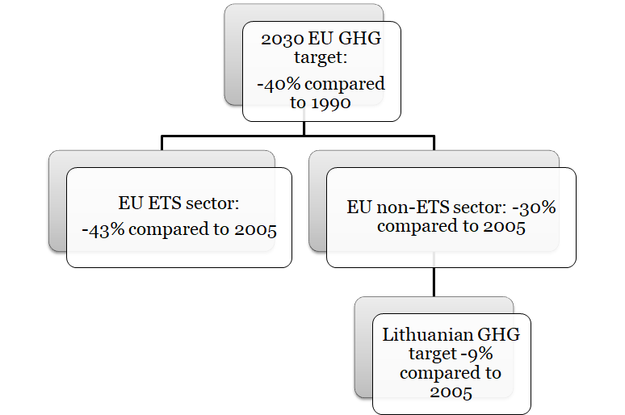
Lithuania signed and ratified the Paris Agreement in 2016. Under the Paris Agreement, Lithuania, jointly with the EU and its Member States, made a binding commitment to meet the target of at least a 40% domestic reduction in economy-wide GHG emissions by 2030 compared to 1990. Lithuania’s stationary installations (around 90 installations) and 1 aircraft operator, jointly with the EU Member States operators participating in the EU ETS, will deliver a reduction of GHG emissions by 43% compared to 2005 levels. Lithuania’s binding national 2030 target for GHG emissions reduction in the non-ETS sectors is 9% compared to 2005, whereas the annual binding limits will be set under Efforts Sharing Regulation. Where applicable, other national objectives and targets consistent with the Paris Agreement and the existing long-term strategies will be set in the updated Strategy for the National Climate Change Management Policy (national long-term low carbon development strategy) to be approved by 2020.
The Strategy for the National Climate Change Management Policy by 2050 covers adaptation and mitigation policies and sets binding short-term (by 2020), indicative medium-term (by 2030 and 2040) and long-term (by 2050) climate change mitigation and adaptation goals and objectives in the following economy sectors of Lithuania: energy, industry, transport, agriculture, households, environmental protection and rational use of national resources (forestry, ecosystems, biodiversity, landscape), spatial planning and regional policy, health care, research and development, education and provision of information to the public, and international co-operation. The results of the measures implemented in accordance with the Inter-institutional Action plan will form the basis for the updates of the targets and objectives of the Strategy for the National Climate Change Management Policy. The Strategy is planned to be updated, in line with the approved EU legal acts on the implementation of the EU climate and energy targets till 2030 and the long term goals of the Paris Agreement, by the end of 2019.

Renewable energy
      - The elements set out in point (a)(2) of Article 4
According to point (a)(2) of Article 4 the indicative trajectory of the share of energy from renewable sources in the gross final consumption of energy in 2030:
Table 2.1.2.1. RES share in gross final consumption
 | 2020 | 2022 | 2025 | 2027 | 2030
RES share in gross final consumption, % (pessimistic case) | 23 | 27 | 28 | 38 | 45
RES share in gross final consumption, % (optimistic case) | 26 | 33 | 34 | 39 | 45
A reference point of the total increase in the share of energy from renewable sources between the respective Member State's binding 2020 national target, and its contribution to the 2030 target, % |  | 18 | 43 | 67

      - Estimated trajectories for the sectoral share of renewable energy in final energy consumption from 2021 to 2030 in the electricity, heating and cooling, and transport sector
The final energy consumption of 2016 for electricity was 16.4%, DHS supply - 16.3%, and direct fuel consumption - 67.3%. In the forecast period, the growth of electricity needs in all sectors is projected to be relatively high, based on the goal to modernize the country's economy and simultaneously to reduce the gap between Lithuania and developed EU countries. The share of electricity in the period up to 2030 will increase to 19.8%, the share of DHS supply will decrease to 13.7%, and the share of direct consumption of fuel will hardly change and in 2030 it will increase to 66.5%
Heating. The share of DHS RES (including waste) will be 70% by 2020 and 90% by 2030. The development of high-efficiency solid biomass CHP plants will continue, and both non-recyclable municipal waste non-hazardous industrial waste that have an energy value will be effectively used for energy production.
After creating a favourable regulatory environment, households with independent heating will gradually switch to clean, zero GHG technologies and the share of RES in households will reach 70% by 2020 and 80% by 2030.
Table 2.1.2.2. RES by sectors
 | 2021 | 2022 | 2025 | 2027 | 2030
RES-district H&C, % | 70 | 74 | 79 | 83 | 90
RES-households H&C, % | 70 | 72 | 75 | 77 | 80
RES-E, % | 26 | 33 | 34 | 39 | 45
RES-T, % | 7 | 8 | 10 | 12 | 15

Figure 2.1.2.1. Estimated trajectories for the sectoral share of renewable energy in the final energy consumption,%

Figure 2.1.2.2. Estimated trajectories for the sectoral share of renewable energy in the final energy consumption,%

      - Estimated trajectories by renewable energy technology that the Member State projects to use to achieve the overall and sectoral trajectories for renewable energy from 2021 to 2030 including expected total gross final energy consumption per technology and sector in Mtoe and total planned installed capacity (divided by new capacity and repowering) per technology and sector in MW
Table 2.1.2.3. Estimated trajectories for the renewable energy technologies in the electricity sector:
 | 2021 | 2022 | 2025 | 2027 | 2030
RES-E, ktoe | 248 | 304 | 402 | 454 | 555
Wind power plant, ktoe | 130 | 148 | 211 | 245 | 310
Wind power plant total capacity, MW | 602 | 684 | 947 | 1046 | 1182
Hydro power plant, ktoe | 50 | 50 | 50 | 50 | 50
Hydro power plant total capacity, MW | 128 | 128 | 128 | 128 | 128
solar power plant, ktoe | 27 | 38 | 76 | 96 | 135
Solar power plant total capacity, MW | 310 | 431 | 860 | 1088 | 1530
Biomass power plant, ktoe | 56 | 56 | 54 | 53 | 51
Biomass power plant total capacity, MW | 150 | 149 | 144 | 142 | 137
Biogas power plant, ktoe | 13 | 12 | 11 | 10 | 9
Biogas power plant total capacity, MW | 34 | 33 | 29 | 28 | 24

Figure 2.1.2.3. RES in the final energy consumption

Heating. The dynamics of the fuel used in the DHS supply.
Table 2.1.2.4. Estimated trajectories for the renewable energy (including waste) technologies in DHS:
 | 2021 | 2022 | 2025 | 2027 | 2030
RES-E, ktoe | 632 | 635 | 643 | 649 | 657
Non-recyclable municipal waste and non-hazardous industrial waste, ktoe | 116 | 116 | 116 | 116 | 116
Waste fired CHP plants total capacity, MW | 180 | 180 | 180 | 180 | 180
Solar power and heat pumps, ktoe | 7 | 14 | 35 | 37 | 40
Solar power and heat pumps total capacity, MW | 15 | 30 | 76 | 88 | 105
Biomass, ktoe | 496 | 492 | 481 | 485 | 491
Biomass CHP plants and boilers total capacity, MW | 1778 | 1801 | 1842 | 1869 | 1909
Biogas, ktoe | 13 | 12 | 11 | 10 | 9
Biogas CHP plants total capacity, MW | 34 | 33 | 29 | 28 | 24

In 2016, a total of 8.9 TWh of heat energy was produced and supplied to the networks. It is estimated that as the number of district heating customers grows, accompanied by rapid investments in more efficient energy consumption, by 2020 district heating systems will supply 8.9 TWh, by 2030 – 8.5 TWh of heat energy. At the end of 2016, biofuel units with condensing economisers used by heat supply companies and independent heat producers accounted for a total of 1589 MW of heat power. The peak demand for DHS systems in 2016 was 3212 MW, lowest – 379 MW. Our forecast for 2030 is that about 3000 MW DHS systems capacity is needed. Excluding measures financed from 2014-2020 EU structural funds, additional 200 MW capacity from RES and heat storage facilities are needed to achieve 2030 target.

Table 2.1.2.5. Estimated trajectories for the renewable energy technologies in the transport sector.
 | 2021 | 2022 | 2025 | 2027 | 2030
RES-T, Mtoe | 9 | 12 | 16 | 19 | 24
Electricity, Mtoe | 0 | 1 | 3 | 4 | 6
I generation biofuels, Mtoe | 9 | 9 | 10 | 11 | 12
II generation biofuels, Mtoe | 0 | 0.3 | 1 | 4 | 6

Figure 2.1.2.4. Estimated trajectories for the renewable energy technologies.

      - Estimated trajectories on bioenergy demand, disaggregated between heat, electricity and transport, and on biomass supply by feedstocks and origin (distinguishing between domestic production and imports). For forest biomass, an assessment of its source and impact on the LULUCF sink
Lithuania has undertaken, according to Directive 2009/28/EC on the promotion of the use of energy from renewable sources, to increase the renewable energy sources (RES) share in the final national energy consumption up to 23% by 2020 and to increase the share of RES in all modes of transport up to at least 10% of the final consumption in the transport sector. The Law on Energy from Renewable Sources contains sectoral objectives: to increase the share of electricity produced from RES up to at least 20% of the final national consumption, to increase the share of centrally supplied heat energy, produced from RES, up to at least 60%, of the heat energy balance, and to increase the share of RES used in households up to at least 80% of the total energy consumption balance.
According to the Lithuanian Department of Statistics, Lithuania has already reached the 23% target: in 2014, the share of RES in the total energy balance of the country exceeded one fifth, accounting for 23.66 %. In 2015, the share of RES in the total energy balance of the country reached up to 25,86 % (a 2.2 % increase compared with 2014): electricity sector 15.55 % (+ 1.85%), heating and cooling sector 46.17 % (+ 5.54%), and transport sector 4.56 % (+ 0.23%).
The majority of renewable energy in Lithuania is from biomass. The amount of biomass per capita in Lithuania is one of the highest in the European Union and it is estimated that in 2020 Lithuania will take the lead in the EU according to the quantity of available biomass for energy needs. In 2015 use of biomass for power and heat generation presented below :
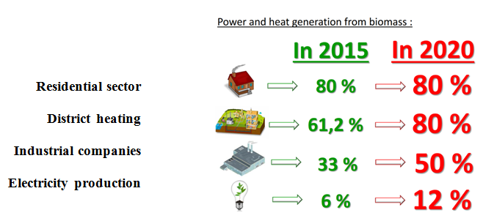

The goal to increase the amount of harvest residuals (logging waste) and small non-merchantable wood used for bioenergy production was set in the National Forestry Development Program for 2012 - 2020. It was indicated that 500 thousand m3 of such biomass supply should be reached by 2020. According to the study on biomass supply and demand for bioenergy purposes, the potential annual amount of woody biomass for bioenergy uses is 5.8 Mm3 or 1 Mtoe (projected up to 2020 - 2025), which includes the biomass not only from forest harvesting but also wood products waste, suitable for bioenergy purposes. It was identified, that forest biomass potential for bioenergy uses is 3.5 Mm3, where more than 1 Mm3 of which is still unused. According to the abovementioned study, the unused biomass potential from forest basically contains residuals of thinning of young stands, timber of negligible value wood stands and logging waste.
Due to the fact that all the biomass potential advised to use for bioenergy demands is already included in the LULUCF GHG emissions inventory through the measurements of growing stock volume changes, the impact of the increased use of logging and thinning waste to the LULUCF sink is insignificant. On the contrary, if timber use from negligible value wood stands is significantly increased it could result in slightly decreasing LULUCF sink due to the respectively decreasing growing stock volume, however, the exact impact is uncertain.
      - Where applicable, other national trajectories and objectives, including those that are long term or sectoral (e.g. share of renewable energy in district heating, renewable energy use in buildings, renewable energy produced by cities, energy communities and self-consumers, energy recovered from the sludge acquired through the treatment of wastewater)
To increase the share of electricity production from RES in the final electricity consumption up to 30% in 2020, 45% in 2030 and 80% in 2050:
- By 2020, the share of RES in the final electricity consumption will grow to 30% and will constitute no less than 3TWh. From the perspective of the technology development trends, it is estimated that electricity produced from wind will become the main source of RES energy and by 2020 might reach up to 44%, biomass – up to 26%, hydropower – up to 19%, energy produced in solar power plants – up to 6%, and biogas – up to 5% of all RES-generated electricity consumed.
- A lot of attention will be paid to the production of decentralised electricity from RES. The number of electricity consumers who can generate electricity for their own needs will be gradually increased. By 2020, after creating a favourable investment environment, there will be at least 34 thousand electricity consumers using a prosumer scheme.
- By 2030, no less than 45% of electrical power consumed in Lithuania will be produced from RES and will constitute no less than 7 TWh. With technology development trends in mind, it is estimated that the majority of electricity – no less than 53% – could come from wind power, 22% – from solar energy, 16% from biofuel energy produced in highly efficient co-generation power plants, and 8% – from hydropower. Biogas could generate about 1% of electrical power.
- By 2050, electricity generated from RES will constitute no less than 100% of power consumed in Lithuania, and the amount of energy produced from RES will be no less than 18 TWh.

To maximise the share of RES for district heating consumers, households with independent heating and non-household consumers with independent heating:
- Up until 2020, RES consumption will continue to increase as compared to district heat consumption and in independent heating in households.
- The share of DHS RES (including waste) will be 70% by 2020 and 90% by 2030. The development of high-efficiency biofuel CHP plants will continue, non-recyclable municipal waste non-hazardous industrial waste that have energy value will be effectively used for energy production.
- After creating a favourable regulatory environment, households with independent heating will gradually switch to clean, zero GHG technologies and the share of RES in households will reach 70% by 2020 and 80% by 2030. GHG producing technologies will be replaced by clean, clean-air technologies that do not impair the quality of air.

Dimension energy efficiency
      - The elements set out in point (b) of Article 4
In pursuit of the energy efficiency improvement objectives, set in the National Energy Independency Strategy, aim will be to:
- ensure the implementation of the EU requirements for energy efficiency improvement in Lithuania by 2020 (i.e. total energy savings of 11.67 TWh) and the financing of compliance with these requirements;
- by 2030, ensure that primary and final energy intensity is 1.5 times lower in 2030 than in 2018;
- by 2050, ensure that primary and final energy intensity is about 2.4 times lower than in 2018.
- To promote integrated renovation of multi-apartment and public buildings (prioritizing renovation in quarters) and to save about 2.6–3 TWh of energy in the renovated multi-apartment and public buildings by 2020 and 5–6 TWh by 2030 (by adding up savings in each year).

      - The indicative milestones for 2030, 2040 and 2050, the domestically established measurable progress indicators and their contributions to the Union's energy efficiency targets as included in the roadmaps set out in the long-term renovation strategies for the national stock of residential and non-residential buildings, both public and private, in accordance with Article 2a of Directive 2010/31/EU
According the JESSICA Holding Fund from 2005 till 2016 2 354 multi-apartments have already been renovated (in 2016 were renovated 784 multi-apartments). It is foreseen to incentivize comprehensive modernization of multi-apartment and public buildings (priority giving for the quartered renovation) and to renovate 25% of buildings stock till 2020 (2.6-3 TWh saving of energy) and 50% of buildings stock till 2030 (5-6 TWh saving of energy). The Energy Efficiency Fund provides investments in energy efficiency projects using the loans for the modernization of central government buildings. Up to 65.16 million EUR provided for the modernization of central government buildings until 2030.
In the updated Building Technical Regulation (2016) the additional rating definitions of low energy buildings, which are applicable to buildings of energy efficiency class B, A and A+ and nearly zero energy buildings as A++ class buildings had been introduced. All new buildings starting from 2021 shall fulfil nearly zero-energy buildings (NZEB) requirements and all new public buildings starting from 2019 shall fulfil NZEB requirements.
The energy performance requirements for the energy performance class are not obligatory for existing buildings (renovating them), but some of home-owners choose to implement Renovation (modernization) projects in their multi-apartment buildings achieving class A. Therefore, it is planned to add the option with energy efficiency class A in the Investment Plans of the Modernization projects for Multi-apartment buildings.
      - Where applicable, other national objectives, including long term targets or strategies and sectoral targets, and national objectives in areas such as energy efficiency in the transport sector and with regard to heating and cooling
The National Program on the Development of Transport and Communications for 2014-2022 sets on of the objectives to increase energy efficiency in transport and reduce the adverse impact of transport on the environment.
An increase in energy efficiency in transport could be achieved and the negative impact on the environment could be reduced by upgrading the transport infrastructure, implementing the dedicated impact reduction measures, modernizing the public transport fleet, and using alternative energy sources. To achieve this goal the following objectives will be pursued: promote a more efficient use of energy resources and energy in the transport sector by economic and administrative measures; develop a sustainable mobility culture, encourage the public to sparingly use energy in transport, and develop the requisite skills; increase energy efficiency – promote the use of alternative energy sources (fuel) in transport, establish the requisite infrastructure, and upgrade the public transport fleet.

Dimension energy security
      - The elements set out in point (c) of Article 4
The only in the Baltic States Mazeikiu Oil Refinery Plant and Butinge oil terminal. ORLEN Lietuva (former Mazeikiu NAFTA) facilities at Butinge, Lithuania, can handle an annual throughput of 8 million tons of crude oil in the exporting mode and 5 to 6 million tons in the import mode. Facilities include a 90 cm, 7.5 km offshore pipeline; 56 cm pipeline to oil tankage; three 50,000-cubic-meter oil tanks; pump stations; and a single-point mooring terminal. Since July 2006, the Butinge oil terminal is the only way to supply ORLEN Lietuva with oil, because the Russian partner, state-controlled Lukoil corporation, has cut off the supply through the Druzhba pipeline from Russia.
The crude oil single-point mooring (SPM) catenary anchor leg mooring facility was designed to accommodate tankers of up to 80 000 metric tons dead weight. It is connected to shore by means of a 90 cm diameter, 7.5-km-long submarine pipeline.
Onshore terminal storage facilities contain three 50 000-cubic-meter floating roof tanks for crude oil, as well as fixed roof tanks for storing diesel fuel and slop oil. The facilities also include a pump for loading tankers and for transferring product between the Butinge terminal and the Mazeikiu Oil Refinery Plant some 91.5 kilometres away.
A 56 cm diameter crude oil pipeline transports crude between the refinery itself and the tank storage facilities nearby. A pump station allows crude transfer to the terminal.
There is a system of oil pipelines, which includes two pump stations near Birzai and another near Joniskis, crude oil pipelines to the Mazeikiai Refinery and Butinge Terminal, a crude oil pipeline leading to Ventspils, and a products pipeline supplying diesel fuel to Ventspils.
The Mazeikiu Refinery and Birzai Pump Station, located on the main crude oil pipeline section (stretching from the oil fields of Western Siberia and the Western Urals via Polotsk, Byelorussia), are connected by the 70 cm diameter pipeline, with the annual capacity 16.2 million tons of crude oil. Until July 2006, Russian crude oil was delivered to Lithuania by two crude oil pipelines via Novopolotsk (Byelorussia) to Biržai, from where one 175-km section runs to the Mažeikiu Refinery, the other section — to Ventspils.
Currently there are about 500 km of the crude oil and petroleum product pipelines in Lithuania:
- Lithuanian section of crude oil pipeline Polotsk – Ventspils — 87.384 km;
- Lithuanian section of product pipeline Polotsk – Ventspils — 87.384 km;
- Lithuanian section of crude oil pipeline Polotsk – Mazeikiai — 225.514 km;
- Crude oil pipeline Mazeikiai – Butinge — 91,5 km.

Involvement of State-owned enterprises. The energy sector represents a significant part of the Lithuanian economy, and some state-owned energy enterprises and facilities have a strategic significance for the national security of Lithuania, ensuring reliable energy supply and opportunities for the development of an efficient energy market. In order to ensure the achievement of this objective, state control in these strategic energy enterprises will be maintained, while allowing reliable private capital in order to enhance the transparency and efficiency of such enterprises and to attract private capital to participate in strategic energy projects.
The security of the state energy sector will be ensured observing the following principles:
- Physical and cyber-security of energy infrastructure based on risk assessment;
- Ensuring the compliance of investments in the energy sector with national security criteria;
- Protection of the activities and personnel within the energy sector.
To improve the resilience of the information infrastructure managed by the energy sector companies to cyber-attacks an approach based on risk assessment will be established where the used cyber security measures are proportional to curb the identified risk, correspond to the importance of information and the risk posed to it. Special attention will be given to the planning of assurance of continuity of the operation of information infrastructure of the energy sector, to regulation, to practical testing of cyber incidents and activity continuity plans during training and exercises.
In order to ensure the highest level of transparency in the management and operation of the energy sector companies, their efficiency and professionalism, special attention should be paid to the following key management principles:
- Resistance to corruption;
- Transparency of operations;
- Professionalism, knowledge development and preparation of necessary specialists, capacity building of employees and managers in energy technology, cyber security and energy economics;
- Effective management and implementation of innovative technologies;
- Active engagement of the public by observing the operation of state and municipality managed and controlled companies which provide public services, by putting forward suggestions with regard to more transparent and more efficient activities of such companies, the lowest energy generation and transmission costs, and the lowest energy prices to consumers.
Increasing the reliability in different national energy sectors. The security and competitiveness of state, economic growth, and the welfare of the country’s citizens depends on the reliable supply of energy. Lithuania is a part of the European north–south energy corridor being developed, which stretches from Finland to the Central European countries. The energy security is assured by the fact of being a part of the European Union’s energy infrastructure, markets and systems, the availability of the required electricity-generating sources and alternative sources of gas supply. The country’s energy reliability and security shall be ensured as follows:
By synchronizing Lithuania’s electricity system with the electricity system of the Continental Europe. It is a strategic priority of the country’s security, so the synchronization of Lithuania’s electricity system with the electricity system of the Continental Europe shall be implemented by 2025. Prior to the completion of the synchronization with the electricity system of the Continental Europe, adequate high-availability generating capacities will be ensured in the most cost effective and non-discriminatory way.
By the completion of the Gas Interconnection Poland–Lithuania (GIPL), which will connect the Baltic states and Finland with the common gas market of the EU, improve supply security and diversification in the region, increase regional market liquidity and competition among suppliers, and allow for more effective use of the liquefied natural gas (LNG) terminal in Klaipeda.
The development of a safe infrastructure of Lithuania’s energy sector will strengthen the cyber resilience capabilities of the energy sector, will create the culture of cyber security, and will promote cooperation between the private and public sectors as well as international cooperation.
The outcomes of the improvement of the country’s energy reliability and security shall be as follows:
- The Lithuanian electricity system will reliably operate in a synchronized mode with the electricity system of the Continental Europe.
- Electricity imports will be replaced by local electricity generation: it is planned that in 2020 electricity generation in Lithuania will account for 35% of total final electricity consumption (65% imported), in 2030 – 70% (30% imported), and in 2050 – 100%;
- Following a cost-benefit assessment, capacity development technologies and solutions will be selected that will provide the necessary reservation and balancing services through market mechanisms;
- The natural gas transmission system will be connected to the EU gas transmission system via Poland, while the Klaipeda LNG terminal will meet the regional LNG needs;
- The risk assessment-based approach towards the assurance of cyber security will prevail in the energy sector, and cyber security will meet the organizational and technical requirements set by the Government of the Republic of Lithuania.

      - National objectives with regard to increasing: the diversification of energy sources and supply from third countries; for the purpose of increasing the resilience of regional and national energy systems
Major strategic projects and energy reforms in the electricity and gas sectors have been implemented (e.g., the NordBalt and LitPol Link projects, which linked the Lithuanian power system to the Swedish and Polish systems; LNG import terminal in Klaipeda and the capacity enhancement of the Klaipeda-Kiemenai gas pipeline), or are in the process to be implemented (e.g., Baltic States’ electricity systems synchronous operation with continental European networks; GIPL – gas interconnection between Poland and Lithuania). These allow to substantially increase the energy security situation and decrease dependency on imports from third countries, together with a gradual shift towards more efficient energy production and greater use and production of renewable energy.
      - Where applicable, national objectives with regard to reducing energy import dependency from third countries, for the purpose of increasing the resilience of regional and national energy systems
In 2016, Lithuania produced a total of 3.97 TWh of electricity. Half of all electricity produced in the country was generated by power plants using renewable energy sources. About 0.45 TWh of electricity was generated by hydropower plants (excluding Kruonis PSPP), 1.13 TWh – by wind turbines, and about 0.44 TWh was produced by solar, biomass and biogas fired power plants. The remaining amount of electricity was produced by conventional fuel-fired power plants. The largest share of electricity consumed in the country (about 72% of total electricity consumption or 68% of total electricity demand) was imported in Lithuania during 2016. Most of it (37%) was imported from Latvia and Estonia, (27%) – via NordBalt interconnection with Sweden, (5%) – via LitPol Link interconnection with Poland, and the rest (31%) – from third countries. In pursuit of the strategic objective of the electricity sector, the electricity needs of the domestic consumers will be satisfied by using energy generation technologies that are competitive on the electricity market, and for the purposes of ensuring energy security, priority will be given to RES technologies and other technologies that have zero GHG and air pollutant emissions. Thus, the aim set in the updated National Energy Independence Strategy will be to achieve that:
- by 2020, 35% of the total final electricity consumption of the country consists of domestic electricity generation;
- by 2030, 70% of the total final electricity consumption of the country consists of domestic electricity generation;
- by 2050, 100% of the total final electricity consumption of the country consists of domestic electricity generation, marking the start of RES-generated electricity as the main source of electricity, as compared to the total final electricity consumption of the country.

      - National objectives with regard to increasing the flexibility of the national energy system, in particular by means of deploying domestic energy sources, demand response and energy storage
Lithuania’s electricity market is vastly dependent on power imports. In 2009, Lithuania retired its last nuclear reactor, which accounted for 77% of domestic electricity production and abruptly switched from an exporter of electricity to an importer of electricity.
It is generally stated that the legal and regulatory conditions in Lithuania are not opposed to the use of load management measures and that controllable loads form part of the balancing energy market.
The National Control Commission for Prices and Energy plans to lay down the technical modalities for Demand Response measures, including the consumer access to such measures and participation of providers of Demand Response measures in the electricity market.
Distributed electricity generation is still not very well developed in Lithuania except the launch of a campaign on solar photovoltaic power which took place between 2012-2014 and resulted in about 30 MW of total photovoltaic power capacity established by the government using the feed-in tariff obligation which was 3 times bigger compared to the retail electricity price. Hence becoming a cost-ineffective measure. On the other hand, the distribution of heat production by solar collectors and heat pumps combined with district heating option in public and residential buildings, seems to be much more promising. Energy savings deriving from Demand Response of distributed consumers by energy aggregators are still absent in Lithuania.
Concerning the storage of energy, network regulation and tariffs do not prevent network operators or energy retailers making system services for Demand Response measures, demand management and distributed generation on organized electricity market. Lithuanian electricity system includes Kruonis Hydropower storage, which was coupled to work with Ignalina NPP (decommissioned in 2010).
Dynamic pricing for Demand Response measures offered by networks or retail tariffs such as time-of-use tariffs and real time pricing are present in Lithuania. Electricity prices for consumers are state regulated. The DSO offers about 6 to 8 plans for consumers, which take into account: real time of consumption, 1 or 2 time-zones and minimum amount consumed with corresponding discount.
Critical peak pricing and peak time rebates are not yet available.

Figure 2.3.1. Development of local resources utilization

In November 2012, according to Regulation 994/2010 concerning measures to safeguard gas supply, Lithuania adopted the National Preventive Action Plan and National Emergency Plan (in 2016 these Plans were updated). National Preventive Action Plan includes: gas market review, risk assessments, preventive measures, obligations for public authorities, enterprises and non-household gas consumers, cooperation mechanisms, information about ongoing and planned gas transmission system interconnection with the European Union gas transmission systems. Main objective of this Plan is to ensure the security of gas supply in the Republic of Lithuania.
Also this Plan indicates list of Gas Infrastructure Development Projects: a) Gas interconnection between Poland and Lithuania (GIPL) (2021-2022), b) Improvement of interconnection between Latvia and Lithuania (2020).
Emergency Plan includes: measures and actions to be taken in order to minimize potential disruptions of gas supply for non-household customers using gas for electricity and heat energy production, detailed procedures and measures to be followed for each crisis level, market and non-market based measures, which would be implemented in case of emergency, pre-defined actions to be taken to ensure the gas supply in the event of emergency. Main objective of this Plan is to ensure the security of gas supply in the Republic of Lithuania and it applies for management of possible emergencies in the gas sector.

Dimension internal energy market

Electricity interconnectivity
      - The level of electricity interconnectivity that the Member State aims for in 2030 in consideration of the electricity interconnection target for 2030 of at least 15%, with a strategy with the level from 2021 onwards defined in close cooperation with affected Member States, taking into account the 2020 interconnection target of 10% and the following indicators of the urgency of action:
(1) Price differential in the wholesale market exceeding an indicative threshold of EUR 2/MWh between Member States, regions or bidding zones;
(2) Nominal transmission capacity of interconnectors below 30% of peak load;
(3) Nominal transmission capacity of interconnectors below 30% of installed renewable generation.
Each new interconnector shall be subject to a socioeconomic and environmental cost-benefit analysis and implemented only if the potential benefits outweigh the costs
The October 2014 European Council called for achievement of interconnection of at least 10% of installed electricity production in the Member States by 2020, endorsed the 15% target by 2030 and underlined that they will be both attained via implementation of Projects of Common Interest.
Due to historical factors, Lithuania's high voltage electricity transmission grid is directly interconnected with the high voltage grids of Latvia, Belarus and the Kaliningrad Region of Russia. These interconnections allow extensive exchanges of power with those neighbouring systems. However, the core objective of Lithuania's and of all Baltic states' energy strategies is the integration of their energy systems into the common European electricity market and to begin synchronised operations with the European Continental Power Network.
New interconnection lines with Sweden (NordBalt – 700 MW) and Poland (LitPol Link – 500 MW), the constituent parts of the integration of the Baltic electricity market into the common European electricity market, were installed and launched at the end of 2015/ beginning of 2016. Together with the Estlink I (350 MW) and Estlink II (650 MW) between Finland and Estonia total ammount of Baltic States transfer capacity with other member states is 2200 MW, and this constitutes ~23% interconnectivity level. For 2030 interconnerctivity level of 23% for electricity is planned. It exceeds goal of 15% set for 2030 by 8%.

Energy transmission infrastructure

      - Key electricity and gas transmission infrastructure projects, and, where relevant, modernisation projects, that are necessary for the achievement of objectives and targets under the five dimensions of the Energy Union Strategy
Interconnectivity and synchronization of Baltic States with European networks until 2025. For full-scale Lithuanian energy sector integration into EU, it is needed not only to ensure infrastructure and markets integration but also integration of system management. At present, due to historical circumstances, the Baltic eletricity transmission system is working in synchronous mode with IPS/UPPS power system, together with Russia and Belarus power systems. Baltic power system is dispatched centrally by coordination of Russia. Such a management system and market operation is hindering implementation of the Baltic market integration into common European electricity market objectives and does not meet state’s energy independence objectives. Therefore, a comprehensive Lithuania and the Baltic states integration to the European Union markets will be ensured only when the Baltic power system will work syncronously with European electricity system.
Lithuania, Latvia and Estonia, as far as electricity transmission system is concerned, still remain a part of the huge Russian IPS/UPS system. Current geopolitical situation in the region shows the increasing threats of such dependency.
Furthermore, as the rules and regulations of the European grid operators are created in the light of the shared European values of mutual respect and democracy and are gradually adopted in the form of EU Network Codes, there is no trusted information about the condition of the electricity grid in Russia and Belarus, nor about the future development plans of those grids. Some major accidents in the past years indicate the signs of lack of security of the system and obvious failures of maintenance. Depending on these systems further means very unpredicted situation to the Baltic countries.
Therefore, Baltic States share a common position that the electricity systems of the Baltic region must operate synchronously with European Networks.
Synchronization of Baltic States with European networks will not only ensure security of supply to the region, but will contribute to the implementation of Integrated European Energy Market, the core element of the Energy Union concept.
The importance of synchronisation is also recognised in the framework of EU energy policy. This project is included within the European Energy Security Strategy and the EU Energy Union as a Project of Common Interest and of critical importance to the EU energy security. The goal of implementing the Baltic States' synchronisation with the continental European networks by 2025 is also included in a reinforced BEMIP. The synchronisation project is a major challenge politically, technically and financially. All related issues are being discussed in the special working group created under the framework of BEMIP, which is chaired by Commission representatives and in which all related Member States participate.
Years 2015-2016 were crucial period for Lithuania regarding integration to EU electricity markets. Accomplishment of NordBalt and LitPol Link projects enabled diversification of imported electricity flows thus security of supply was increased as well as lower priceses of the electricity market for consumers were ensured.
In the end of 2015, LitPol Link” interconnection (capacity of 500 MW) started to operate. This interconnection for the first time in history connected electricity networks of Lithuania and Poland as well as Baltic countries with continantal Europe’s energy system in that way eliminating Baltic’s countries status of energy island. Interconnection is one of main elements on purpose to synchronise Baltic countries electricity transmission systems with Europe’s eletricity system.
In the beginning of 2016, “NordBalt” interconnection was put in operation (capacity of 700 MW).
During year 2016, average electricity price “Nord Pool” in Lithuania’s trading zone was the lowest in the whole power exchange history and constituted 36,5 EUR/MWh. Previous year electricity price in market was 13 % lower than 2015 ant lower by quarter in comparison with years 2014 and 2013.
During year 2016, “LitPol Link” was available for market 96 % time per year, while “NordBalt” – 78 % time per year. International interconnections between Latvia and Estonia, which has not sufficient capacity untill new interconnections had the main influence on price differences in Estonia, Latvia and Lithuania trading zones, were loaded less by quarter in comparison with year 2015.
During year 2016 imported electricity quantities from third coutries decreased in comparison with year 2015. During year 2016 30 % of all imported electricity was imported from third countries, while 2015 this part was around 44 %/ Main part from third countries is importing from Kaliningrad region, only 2 % was imported from Belarus and only 1.4 % of electricity during 2016.
Few times per previous year “LitPol Link” interconnection was used for ensuring system reliability by Lithuania and Poland. “Litgrid” (Lithuanian PSO) used interconnection as emergency reserve 141 hours, while Poland system operator PSE used interconnection as reserve 18 hours in total.
Regarding gas transmission infrastructure, the main objective is to ensure a technically secure and diversified supply of natural gas to the users at competitive prices. For that purpose following national strategic initiatives are foreseen:
- to ensure a long-term access to the global LNG market;
- full integration to common European gas martket by construction of the gas interconnector between Poland and Lithuania (GIPL project) and implementation of the EU gas network codes;
- creation of a regional natural gas market in the Baltic Strates (with the possibility to expand to Finland) to increase market’s liquidity, competitiveness and more efficient use of the existing infrastructure in Lithuania;
- to develop Lithuania’s position as the regional LNG supply and competence hub, technology, innovations and business models for LNG application in transport, energy and maritime sectors;
- improvement of interconnection between Latvia and Lithuania;
- modernisation of the natural gas transmission and distribution infrastructure
- facilitating access for biogas to the transmission system.

      - Where applicable, main infrastructure projects envisaged other than Projects of Common Interest (PCIs)
Potential expansion of Klaipeda’s LNG reloading station long-term if LNG market trends continue to be positive. Currently its storage capacity for onshore reloads and bunkering is 5.000cm, is designed to be expanded up to 10.000cm.

Market integration
      - National objectives related to other aspects of the internal energy market such as increasing system flexibility, in particular related to the promotion of competitively determined electricity prices in line with relevant sectoral law, market integration and coupling, aimed at increasing the tradeable capacity of existing interconnectors, smart grids, aggregation, demand response, storage, distributed generation, mechanisms for dispatching, re-dispatching and curtailment, and real-time price signals, including a timeframe for when the objectives shall be met
Lithuania has no national targets that stand out from the European context. Country is already part of united European electricity market and further steps comply with the European integration aims and deadlines.
According to the Baltic Energy Market Interconnection Plan (BEMIP), one of the key steps in the integration of the Baltic and Nordic electricity markets is the total balance of the electricity market, acting in accordance with agreed principles and balancing with coordinated pricing rules creation. It is important that the new rules and principles are in line with ENTSO-E Network Code on balancing power requirements and are compatible with the Nordic model. Lithuania is actively engaged in the foreseen implementation of common Baltic Balancing market, which started operation in January 2018.
      - Where applicable, national objectives related to the non-discriminatory participation of renewable energy, demand response and storage, including via aggregation, in all energy markets including a timeframe for when the objectives are to be met
Lithuanian TSO Litgrid together with Lithuanian DSO ESO were carrying out a feasibility study on assessing the technical potential of demand side response in Lithuania and establishing technical requirements for providing such services. During the project investigation was performed by conducting a survey to estimate willingness of market participants to provide potential DR services. Meetings and workshops with the most promising customers and groups of consumers, which can be aggregated, aggregators were carried out investigating their technical characteristics and technical requirements. This investigation was supposed to provide potential capacities of DR services including cost-benefits analyses for the most promising providers. Final results of the case studies were scheduled to be completed by the end of 2018.
      - Where applicable, national objectives with regard to ensuring that consumers participate in the energy system and benefit from self-generation and new technologies, including smart meters
This part to be defined in more detailed way in the final version of the Plan.
As set in the updated National Energy Independence Strategy in the long-term perspective, electricity consumers will become proactive participants in the market and will be given the opportunity to use energy generated from RES for their own needs to receive a reward for surplus energy supplied to the network in line with the market conditions. Such consumers will account for at least 2% of all consumers by 2020, at least 30% of all consumers by 2030 and at least 50% by 2050. These customers will be able to participate in the market through service providers in the energy sector. The active participation of local energy communities in investing in co-owned RES equipment will be encouraged.
      - National objectives with regard to ensuring electricity system adequacy, as well as for the flexibility of the energy system with regard to renewable energy production, including a timeframe for when the objectives are to be met
Lithuania aims to ensure participation of any group in the market, further support and encouraging demand side resources such as Demand Response to participate alongside supply in wholesale and retail markets.
      - Where applicable, national objectives to protect energy consumers and improve the competitiveness of the retail energy sector
As set in the updated National Energy Independence Strategy, it is sought for energy prices to be formed in an effective market, which will be common with the other Member States of the EU. The country’s energy infrastructure will be used effectively, ensuring that the share of the cost of the infrastructure in the final energy price does not exceed the average for the EU Member States, while tariff patterns provide conditions for industrial investments. As an outcome, final electricity and natural gas prices in Lithuania are sought to be: for industry – the lowest in the region (compared to other Baltic, Scandinavian and Central and Eastern European countries), for citizens – a decreasing share of energy expenditure compared to the average income.

Energy poverty
      - Where applicable, national objectives with regard to energy poverty including a timeframe for when the objectives are to be met
According to the EU Survey on Income and Living Conditions 31.1% of inhabitants of Lithuania could not afford to keep their house adequately warm (second highest indicator among the EU countries after Bulgaria) and 17% reported to live in housing affected by dampness, draughts and leaks in 2015.
Lithuania performs worse than the EU average on this household-reported indicator, inability to keep home adequately warm (31.2% compared to 11.2% in 2016).
Lithuania is also worse than the EU average for the expenditure-based indicators; 21.4% of households spend more than twice the median on energy, and 21.2% spend so little on energy that they live in hidden energy poverty.

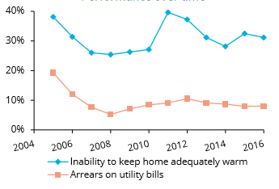
Figure 2.4.4.1. Performance over time

Disaggregated data of the household-reported indicators suggest that energy poverty in Lithuania is particularly a problem for households living in urban areas. In addition, data points to households living in apartments as being particularly susceptible to energy poverty.

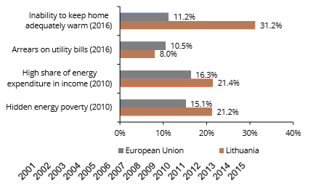
Figure 2.4.4.2. Performance relative to EU average

In Lithuania, the percentage of households unable to keep the home adequately warm is significantly higher than households in arrears on utility bills. This might be because households underspend on energy, which is also illustrated by the high amount of hidden energy poverty (see figure above).

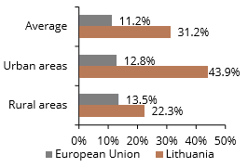
Figure 2.4.4.3. Inability to keep home adequately warm (2016)

There are no separate measures among national objectives for energy poverty reduction, it is considered only as part of poverty in general among social policies present, also LRAs can provide heating compensations. Some 30.1 % of Lithuania's residents were at the poverty line in 2016, which is one of the bigger indicators across Europe, shows the information from Eurostat. The percentage was up 1.8 % points since 2008.

Dimension research, innovation and competitiveness

      - National objectives and funding targets for public and, where available, private research and innovation relating to the Energy Union including, where appropriate, a timeframe for when the objectives are to be met
Overall, the innovation performance of Lithuania remains moderate. European Innovation Scoreboard (EIS) 2016 ranked the country 24th in EU. Despite some improvements, Lithuania's innovation performance therefore remains among the lowest in the EU. Lithuania faces numerous challenges to improve its innovation performance. In particular, the low efficiency of the public R&D system, the need to incentivise the commercialisation of research results, and the urgency to foster a governance system and a policy mix that are supportive of innovation.

Figure 2.5.1. Number of patent applications filed at the European Patent Office from Lithuania from 2005 to 2017

National Smart Specialisation program serves as the guidelines for public investment to research, development and innovation (RDI). The Ministry of Economy has a set of financial measures that are designed to support RDI and all of them are targeted towards the activities or entities that fall under the regulation of Smart Specialisation Strategy, including the priority “Energy and sustainable environment”.
In 2020, it is expected that Smart Specialization program, adopted in 2013, will be implemented, and as a result:
- Investmens in RDI in Lithuania will increase to 1.9 % (from 1.04% of GDP in 2015);
- The number of patent applications will double (2020 – 150 applications);
- The number of small/medium companies introducing a new product or process (2020 – 40%) will increase twice;
- The number of innovative small/medium companies will double (2020 – 35%).

The aim of the development of public electric vehicle charging infrastructure for the creation and development of public charging network in Lithuania with a purpose to promote the usage of electric vehicles in order to reduce consumption of petroleum products in the transport sector and to mitigate the environmental impact of transport.
The development of infrastructure will contribute to the achievement of the recommended indicator developed in a recent Feasibility Study - by 2020, all registered electric vehicles in Lithuania should make 5% of all new cars sold per year, and 10 % by 2025. In order to achieve the objective of infrastructure development, it is envisaged:
- to install by 2020 at least 19 public high-power charging points next to roads belonging to the Trans-European transport network and next to other roads of national importance, and by 2022 - not less than 28%;
- to install at least 100 public charging points in cities and suburban agglomerations of Lithuania with more than 25 thousand inhabitants of the population by the end of 2020.

      - Where available, national 2050 objectives related to the promotion of clean energy technologies and, where appropriate, national objectives including long term targets (2050) for deployment of low-carbon technologies, including for decarbonising energy- and carbon-intensive industrial sectors and, where applicable, for related carbon transport and storage infrastructure
Ministry of Economy and Ministry of Education and Science are the main institutions responsible for the formation and implementation of innovation policy in Lithuania:
- the Ministry of Economy is responsible for the policy of the development of innovation environment;
- the Ministry of Education and Science is responsible for the policy of research and development.

The fundamental strategic document setting guidelines for innovation policy in Lithuania is Innovation Development Program 2014–2020. There are plans in future to update it until 2050.
      - Where applicable, national objectives with regard to competitiveness
Goals for innovation of different economy sectors (energy systems, industry, transport, agriculture) are included in the general framework of the innovation policy.
As one of the outcomes of Lithuania’s Progress Strategy “Lithuania 2030” and the National Progress Program for 2014-2020, the Lithuanian Innovation Program 2014-2020 was approved to create a legal model for strengthening innovation potential of business sector, as well as for more effective policy making and innovative public sector and joint activity among business, science and education institutions. One of the measures laid down in the implementation plan of the Lithuanian Innovation Program 2014-2020 aims to support eco-friendly, energy saving green R&D and innovation activities producing and realizing high added-value products. Moreover, energy and sustainable environment related area is also supported through pre-commercial procurement aiming at creating innovative products in this field.
The potential of Lithuanian science and study institutions and businesses in the solar energy field is relatively high. The institutions carry out fundamental and contract-based research in collaboration with Lithuanian and foreign companies and research institutions; highly qualified specialists are being trained. Research related to solar energy, optimisation of combustion processes, energy efficient materials, efficient lighting, industrial biotechnologies, biofuel production, hydrogen technologies and other relevant studies are carried out in Lithuania.
Still, despite the effort to support R&D activities in the solar energy area, there is still no systemic commercialisation of results of the research. Hopefully, this gap will be closed by the successful implementation of the Priority. Implementation of the Priority would be strongly supported by the strengthening and concentration of R&D resources in such thematic R&D areas as physical sciences (physics and chemistry), technological sciences (energy and thermal engineering, vacuum engineering, environmental engineering, structural and mechanical engineering of buildings, chemical engineering, materials engineering).
Aleksandras Stulginskis University in collaboration with Norwegian, Latvian and Estonian experts has prepered the Lithuanian Bioeconomy Development Feasibility Study. The study assessed the potential of bioeconomy in Lithuania, set out the main directions of development of the sector, provided the recommendations on the measures to promote innovation in the bioeconomy sector. The study also identified the bioeconomy sectors, where Lithuanian and Norwegian business cooperation has the greatest potential, and proposed the measures for promotion of bilateral cooperation.
To ensure Lithuania’s timely participation in the processes of the Fourth Industry Revolution the Ministry of Economy has taken active steps to implement the industry digitisation initiative in Lithuania. The establishment of the national industry digitisation platform “Pramonė 4.0” is to be considered among the major industry digitisation initiative implementation objectives.
To increase the value added generated by the industry sector, to accelerate the introduction of digitalisation of industry, to ensure the competitiveness of the Lithuanian industry at international level and to add to more rapid growth of the Lithuanian economy the creation of favourable conditions for close cooperation of industry, business, the academic community and public authorities is to be firstly considered the objectives of the “Pramonė 4.0” platform, which is formed in mid-2017. Secondly, it is necessary to ensure that every company in Lithuania could make full use of the benefits offered by digital innovation in the field of product improvement, process optimisation and adapting the existing business models to the needs of the digital era.
The introduction of digital processes in companies will lead to the efficient use of resources, reduced quantities of waste and reduced air pollution.

POLICIES AND MEASURES

Dimension decarbonisation

GHG emissions and removals
      - Policies and measures to achieve the target set under Regulation (EU) 2018/842 as referred in point 2.1.1 and policies and measures to comply with Regulation (EU) 2018/841, covering all key emitting sectors and sectors for the enhancement of removals, with an outlook to the long-term vision and goal to become a low emission economy and achieving a balance between emissions and removals in accordance with the Paris Agreement
In this section we describe policies and measures in the different economic sectors and policy areas that will help to reach objectives and targets as outlined above.
Climate change mitigation goals are interlinked with the goals defined in National Energy Independence Strategy (NEIS), the National Renewable Energy Resources Development Strategy, and the Strategy on Dwellings of the Republic of Lithuania, the law on energy from renewable sources and the Energy Efficiency Action Plan 2017–2019.
Further we highlight the policies and measures covering non – ETS and LULUCF sectors which had been implemented to reach the 2020 targets and which will be continued mostly with more ambitious GHG emission reduction targets by 2030. According to the national GHG projections it was determined that Lithuania might face difficulties to reach non-ETS targets due to a projected GHG emissions increase in the transport and agriculture sectors. Thus, additional measures were planned for the period 2021–2030 to increase GHG emission reduction capacities. Further in this section PAMs are grouped and presented according to each sector.
Transport sector. In the transport sector there is need to change the old car fleet (currently the average age of passenger cars in Lithuania is 15 years) into a newer and more efficient one, as well as to introduce vehicles driven by alternative fuels, promote innovative transport technologies, zero-emission vehicles and electromobility in all modes of transport. The National Program on the Development of Transport and Communications for 2014–2022 has, among others, objectives to increase the mobility of goods and passengers, to improve the corridors of the EU Trans-European Transport Networks as well as their connections with national and local transport networks, to increase the energy efficiency of transport, to reduce the adverse impact of transport on the environment and to improve the safety and security of traffic. It contains an analysis of the potential future development of road, rail, maritime, inland waterways and air transport.
The program also identifies the main goals for the development of infrastructure for alternative transport energy sources, including electricity. In the Lithuanian fleet, around 15,000 electric cars are anticipated by 2025, of which there are expected to be 6,000 in 2020. Lithuania also has in place strategic documents that consider longer-term time frames; for example, according to the NEIS, the energy intensity of transport shall be reduced by 2.4 times in comparison with the current level in the transport sector by 2050.

Table 3.1.1.1. The summary table of policies and measures adopted and under implementation in the transport sector.
Measures | Objectives | Implementation period | Entities responsible for implementing the policy | GHG mitigation effect, ktCO₂eq. | Planned budget^{1,2,3}, MEUR
Adopted and under implementation measures
T1. Promotion of the RES use in the transport sector | Increase the share of RES in all modes of transportation in comparison with the final consumption of the energy in the transport sector | 2018 – 2030 | Ministry of Energy  Ministry of Transport | 423 | x
T2. Electrification of railways | Increase the electricity use as fuel in railways | 2018–2027 | Ministry of Transport | 1115 | x
T3. Improvement of road infrastructure | To improve the existing road infrastructure and increase the share of asphalt roads in the network of state roads. | 2018–2020 | Ministry of Transport  Municipalities | - | x
T4. Promote energy efficiency consumption in the transport sector | To assess the impact of tax measures on fossil fuel consumption | 2014–2030 | Ministry of Energy  Ministry of Transport | - | x
T5. Sustainable mobility plans | The measures provided in the Sustainable Mobility Plans of municipalities are promoting the use of alternative modes of transportation: walking, cycling, public transport and identifies the need for infrastructure for these types of transport, encouraging the use of renewable fuels. | 2018–2030 | Ministry of Transport  Municipalities | 1524 | x
T6. Promoting alternative fuel use in urban public transport vehicles | The support from EU funds to municipal administrations for purchasing low-emission urban public transport vehicles (EU-funded instrument for 2014-2020, which should be continued) | 2015–2027 | Ministry of Transport  Municipalities | 2 | 200¹
Total adopted: |  |  |  | 3064
Planned/provisional measures
T7. Formation and promotion of eco-driving skills | Decrease of fuel consumption in due to changing in driving skills. | 2021–2030 | Ministry of Transport | 204 | x
T8. Promoting the purchase of low-emission vehicles | Planning to provide financial incentives for persons who transferred its property rights to a waste handler. It is planned to be flat-rate compensation which could be used to pay for public transport services in electronic ticketing systems or to purchase a used or new passenger car that meets low levels of emission criterion. | 2020–2030 | Ministry of Environment | 135 | 30²
T9. Promoting alternative fuel use in intercity public transport vehicles | To promote the use of clean and energy-efficient public transport. | 2021–2027 | Ministry of Transport | 4 | x
T10. Implementation of E-tolling for freight transport | To apply differentiated the "user pays" and "polluter pays" principles to freight transport. | 2021–2027 | Ministry of Transport | 18 | 130¹
T11. Implementation of incentives for the use of combined freight transport. | Providing incentives for carriers of intermodal units instead of transporting intermodal units by road to choose combined transport. | 2021–2027 | Ministry of Transport | 2021 | x
T12. Promoting the use of LNG in transport. | Installation of liquefied natural gas refueling points on motor roads. | 2018–2025 | Ministry of Energy  Ministry of Transport | - | x
Total planed: |  |  |  | 2382
Total: |  |  |  | 5446
¹financing from EU funds
²financing from budget
³other sources

Figure 3.1.1.1. The comparison of projected the transport GHG emissions WEM and WAM scenarios and the distribution of evaluated effects of additional measures in transport sector for 2021-2030.

Industrial and industrial processes sector. The Program for Investment Incentives and Industry Development for 2014–2020 aimed at more efficient use of energy and increased use of RES. The implementation of this program is financed by the EU structural funds. According to the NEIS the promotion of low energy intensive industry subsectors and the application of eco-innovative technologies are expected to save around 620 GWh of electricity consumption by 2025.
Lithuania implements the control of volatile organic compound emissions resulting from the storage of petrol and its distribution from terminals to service stations through a law adopted in 2000 and revised in 2016 implementing the EU legislation in this area. Lithuania also has in place F-gas regulations, which aim at cutting total EU emissions from F-gases by two thirds by 2030 compared with the 2014 level. It prohibits placing F-gases on the market in certain circumstances where alternatives are available. Between 2018 and 2020, quotas for legally placing HFCs on the EU market were reduced to 63% of the 2015 levels. Lithuania implements the EU F-gas regulation through four domestic orders released by the Minister of Environment. Lithuania also amended its Administrative Infringement Code in 2016 to establish more stringent responsibilities for breaching the requirements of handling F-gases.

Table 3.1.1.2. The summary table of policies and measures adopted and under implementation in IPPU sector.
Measures | Objectives | Implementation period | Entities responsible for implementing the policy | GHG mitigation effect, ktCO₂eq. | Planned budget^{1,2,3,} MEUR
I1. IPPC permits and pollution permits | Direct application to combustion plants with a rated thermal input equal to or greater than 1 MW and less than 50 MW | Since 2015 | Ministry of Environment | - | X²
I2. Supporting the implementation of the best available production (BAT) methods | Reduce the GHG emissions released during the cement production process by changing manufacturing technologies. | 2021–2027 | Ministry of Economy  Ministry of Environment | - | X¹
I3. Promoting green procurements | Promoting the environmental management system in the manufacturing sectors as well as strengthening ability of enterprises to organise green procurements. | Since 2011 | Ministry of Environment | - | X²
I4. Implementing the Regulation of Fluorinated Greenhouse Gases | Aimed at cutting total EU emissions from F-gases by two thirds by 2030 compared to 2014 levels. It prohibits the placing of F-gases on the market in certain circumstances where alternatives are available. | 2015–2030 | Ministry of Environment | - | X²
I5. Limits on emissions of volatile organic compounds (VOC) | To reduce the direct and indirect impact of VOC emissions (released by paints, solvents, adhesives and other products) |  | Ministry of Environment | - | X²
I6. Promotion of energy efficiency in the industry | To promote eco-innovative technologies in the industry sector. | 2018–2029 | Ministry of Energy | 992 | X¹
I7. Implementation of the Kigali Amendment | Reduction of HFC consumption. | 2019–2032 | Ministry of Environment | - | X²
Total adopted: |  |  |  | 7192
¹financing from EU funds
²financing from budget
³other sources

Agriculture. In the agriculture sector the main focus is on the more effective and precise use of mineral nitrogen fertilizers and the education of farmers. The Lithuanian Rural Development Program for 2014 – 2020 promotes the growth of the agriculture sector based on technologies that are territorially and environmentally balanced, climate-friendly, resilient, competitive and innovative. It also promotes sustainable farming (25 000 ha), keeping organic farming areas (110 000 ha), crop rotation, rational use of the synthetic fertilizers, and their replacement with organic fertilizers. The total program budget was 1.978 billion EUR. 36% of all funds were allocated for climate change mitigation (this amount includes the previous programming period). Since 2014, Lithuania has produced biogas from livestock holdings. Another important mitigation action is the protection of waters against nitrate pollution (such as the implementation of the EU nitrates directive and its latest amendment (1137/2008)), which contributes to reducing N₂O emissions. For the period of 2021-2027 Lithuania will prepare draft National Common Agriculture Policy Strategic Plan, which will contain at least the messages provided below in the Table 3.1.1.3.

Table 3.1.1.3. The summary table of policies and measures adopted and under implementation in agriculture sector by 2030.
Measures | Objective | Implementation period | Entities responsible for implementing the policy | GHG mitigation effect, ktCO_{2eq.} | Planned budget^{1,2,3}, MEUR
Adopted and under implementation measures
A1. Implementation of the Nitrates directive | Reduced water pollution and the emissions of N₂O | 2014 – 2030 | Ministry of Environment  Ministry of Agriculture | 1700 | X²
A2. Reduction of the release of nitrogen compounds into the Baltic Sea | Reduction of nitrogen compounds released into the Baltic Sea compared with the inflow of reference (1997-2003) period. | 2014 – 2030 | Ministry of Environment  Ministry of Agriculture | 136 | X²
A3. Financial support to sustainable farming development | Increase of sustainable farming, crop rotation, rational and regulated use of synthetic fertilizers and replacement of synthetic fertilizers with organic fertilizers. Expansion of perennial meadows in order to improve biodiversity and reduce GHG emissions. Support for investments in to manure handling storages and manure and slurry spreading equipment. | 2014–2020 | Ministry of Agriculture | - | X¹
A4 Promoting growth of protein crops | Incentivise farmers to grow protein crops. | 2014–2027 | Ministry of Agriculture | - | X¹
Total adopted: |  |  |  | 1836
Planned/ provisional measures
A5 Preparation of Good Agriculture practice (GAP) guidelines | Increase farmers knowledge for the purpose of applying advanced agro technologies and farming solutions which helps to reduce GHG emissions | 2021–2030 | Ministry of Agriculture | - | 0.01¹
A6. Provide financial support to farmers who apply environmentally friendly agro technologies. | The objectives:  - to increase more effective fertilization of crops with mineral fertilizers (according to the actual needs of the plants and ensuring all the qualitative parameters of the soil)  - application of environmentally friendly technologies (slurry acidification, slurry injection in to the soil during fertilization, threatening of biotechnological products (probiotics)). | 2021–2027 | Ministry of Agriculture | 47 | 50¹
A7. To disseminate knowledge to farmers and provide advice on environmental and climate-friendly activities. | By the use of adviser services increase farmers knowledge for the purpose of applying advanced agro technologies and farming solutions which helps to reduce GHG emissions. | 2021–2027 | Ministry of Agriculture | - | 4¹
A8. Provide investment support to farmers who invest into eco-efficient equipment and technologies | Allow farms to obtain technology (biogas instalments, slurry direct injection equipment and etc.) for reducing GHG emissions. | 2021–2027 | Ministry of Agriculture | 420 | 100¹
A9. Provide compensatory support to farms on an annual basis (new ECO scheme) for favorable activities related with the mitigation of climate change. | Increase the areas where environmentally friendly actions are being implemented. | 2021–2027 | Ministry of Agriculture | 399 | 100¹
A10. Development of organic farming | Increase the areas under organic farming activity. | 2021–2027 | Ministry of Agriculture | 436 | 230¹
A11. Modification of compulsory requirements for manure and slurry application. | Modify requirements of manure and slurry application in order to reduce GHG emissions from manure when manure is spread out in fields. | 2019–2030 | Ministry of Environment Ministry of Agriculture | 317 | X¹
A12. Animal feed change | The animal feed rations will be more rational and effective and led to use less protein per animal unit. | 2021–2027 | Ministry of Agriculture | - | X¹
A13. Amendment of mandatory requirements for the use of mineral nitrogen fertilizers | Creating a system of fertilization which allows using mineral fertilizers more efficient and less. | 2021–2027 | Ministry of Agriculture | 111 | 75¹
Total planned: |  |  |  | 1730 | 559.01
Total: |  |  |  | 3566
¹financing from EU funds
²financing from budget
³other sources

Figure 3.1.1.2. The comparison of projected transport GHG emissions WEM and WAM scenarios and the distribution of evaluated effects of additional measures in the agriculture sector for 2021–2030.

Waste management. One of the National Waste Management Plan’s for 2014–2020 (thereinafter – the Plan) objective is to minimize GHG emissions in the waste sector. By 2020, the reuse and recycling of waste materials such as paper, metal, plastic and glass from households, and from other sources where waste streams are similar to those from households, shall be increased to a minimum of 50%, by weight, of overall waste. Also, recycling and other recovery of municipal waste shall be increased to a minimum of 65%, by weight, of total amount of municipal waste. By 2020, municipal biodegradable waste disposed of in landfills shall make up no more than 35% of municipal biodegradable waste generated in 2000. This Plan is scheduled to be updated by the middle of 2020 and will cover 2021–-2027.
Table 3.1.1.4. The summary table of policies and measures adopted and under implementation in Waste management sector by 2030.
Measures | Objective | Implementation period | Entities responsible for implementing the policy | GHG mitigation effect, ktCO_{2eq} | Planned budget^{1,2,3,}, MEUR
Adopted and under implementation measures
W1. To reduce the quantity of waste disposed of in landfills – develop a rational recovery of material and energy resources of waste | By 2020, recycling or other recovery of municipal waste shall be at least 65% by weight | 2015 – 2020 | Ministry of Environment | - | X^{1,2,3}
 | To ensure that by 2020, municipal biodegradable waste disposed of in landfills shall make up no more than 35% of municipal biodegradable waste generated in 2000 | 2013 – 2020 | Ministry of Environment | 3766 | X^{1,2,3}
 | Recovery of CH₄ gas from landfills for energy production | 2013 – 2020 | Ministry of Environment | 1940 | X^{1,2,3}
 | Incineration plants (Klaipėda, Vilnius and Kaunas) | Klaipėda is in operation from 2013.  Vilnius and Kaunas will be in operation from 2020. | Private investor |  | X^{1,3}
Total adopted: |  |  |  | 6359
Planned/provisional measures
W2. Minimization of the amount of landfilled waste | 60% of municipal waste (by weight) planned to be recycled by 2030 | 2021 – 2030 | Ministry of Environment | 865 | 1.5
W2. Minimization of the amount of landfilled waste | Reducing the amount of food waste per capita | 2021 – 2030 | Ministry of Environment | 33 | X^{1,3}
Total planned: |  |  |  | 3518
Total: |  |  |  | 9877

¹financing from EU funds
²financing from budget
³other sources

LULUCF. The National Forest Area Development Program 2012–2020 aims to increase forest coverage to 34.2% of the territory by 2020 through afforestation of abandoned lands and by providing financial incentives for forest regeneration. In the period of the Rural Development Program 2007–2013, an area of 17,200 ha was afforested, and 8,400 ha were afforested in the period 2014–2016. The Forest Law, amended in 2011, provides that changing forest land to any other land is allowed only in exceptional cases. Aiming to promote sustainable forest management and increase LULUCF sector absorption potential a draft of the National Forest Programme for 2021-2030 envisage to be developed by the end of 2020.

Table 3.1.1.5. The summary table of policies and measures adopted and under implementation in LULUCF sector.
Measures | Objective | Implementation period | Entities responsible for implementing the policy | GHG mitigation effect, ktCO₂eq. | Planned budget^{1,2,3}, MEUR
L1. Restoration of forestry potential and introduction of prevention actions | Support restoration of forests damaged by fires and other natural disasters. | 2007–2020 | Ministry of Environment  Ministry of Agriculture | - | X¹
L2 Promotion of planting of short rotation coppices | The support for planting of short rotation coppices with an aim to produce biomass as a source of energy which partially replaces imported fossil fuels (oil, gas, coal). | 2014–2020 | Ministry of Agriculture  Ministry of Energy | - | X¹
L3. Afforestation and damaged forest restoration | Provide support for afforestation/reforestation activities and restoration of degraded forest land areas. | 2021–2030 | Ministry of Environment  Ministry of Agriculture | 741 | 80¹
L4. Promoting the use of biomass for energy production | Additional wood biofuel production from cutting residues. | 2021–2030 | Ministry of Environment | 256 | 45¹
Total adopted: |  |  |  | 997 | 125
¹financing from EU funds
²financing from budget
³other sources

RES measures listed in Tables 3.1.2.1 and 3.1.2.2 as well as energy efficiency measures listed in Chapter 3.2 and Table 3.2.1 will contribute towards GHG emission reduction substantially.

      - Where relevant, regional cooperation in this area
Regional cooperation in the field of climate change. The implementation of the Paris Agreement and the EU climate and energy targets till 2030 are being periodically discussed in different committees of the Baltic Assembly, which is represented by members of Parliament of Estonia, Latvia and Lithuania, Summits of Prime Ministers, the Baltic Council of Ministers and senior official group meetings, as well as the forums for the implementation of the European Union Strategy for the Baltic Sea Region (EUSBSR).

      - Without prejudice to the applicability of state aid rules, financing measures, including Union support and the use of Union funds, in this area at national level, where applicable
In 2015 conducted Study for the evaluation of the effects, benefits and costs for Lithuania by implementing the EU climate and energy policy targets till 2030estimated that the total needed investment under a cost-efficient scenario for the implementation of GHG emissions reduction, EE and RES targets in the period of 2021–2030 might amount to 7 569 million EUR, and the total quantity of the reduced GHG emissions would be 1 382.7 kt CO₂eq.
Lithuania’s national target implementation, reducing GHG emissions by 9%, compared to 2005, in non-ETS sectors till 2030, might cost at least 4.8 billion EUR, from which aproximately 1.89 billion EUR would be allocated for agriculture sector and 2.96 billion EUR for transport sector.
The implementation of Lithuania’s climate and energy targets till 2020 comprise almost 80% of the financial resources from the EU structural and investment funds, therefore EU financial instruments and the EU level policy measures in different economy sectors related to the achievement of more stringent GHG emissions reduction targets will be of utmost importance in the period from 2021 till 2030.

Renewable energy
      - Policies and measures to achieve the national contribution to the binding 2030 Union target for renewable energy and trajectories as referred to in point (a)(2) Article 4, and, where applicable or available, the elements referred to in point 2.1.2, including sector- and technology-specific measures
Lithuania implements PaMs that aim to increase the share of electricity and district heating produced from RES and promote the use of RES in industry and in households. The law on energy from renewable sources adopted in 2011 and updated in 2015, established targets for 2020 (see Chapter 1.1 Table 3.1.2.1.). Some of the RES targets were overachieved before 2020: the share of RES in total final energy consumption was 25.8% in 2017.

Table 3.1.2.1. Policies and measures to achieve the national contribution to the binding 2030 Union target for renewable energy
Measures | Objectives | Implementation period | Entities responsible for implementing the policy | GHG mitigation effect, ktCO₂eq | Expected result | Planned budget^{1,2,3}, MEUR
RES in electricity sector
To increase RES electricity production by applying feed-in premium granted by auction procedures | To increase the share of RES in the total energy balance at least by 45% by 2030 | 2019-2030 | NCC,  Ministry of Energy | 1244 | Increase in the  production of  electricity from  renewable  energy sources, at least by 2,5 TWh by 2030
To carry out explorations for RES development possibilities in the Baltic sea |  | 2018-2020 | Lithuanian energy agency,  Ministry of Energy | 1244 | The share of explorations, 100% by 2020
To increase self-consumer development by applying financial support for self-consumers (for individual households and for multi-apartment buildings) |  | 2018-2030 | Ministry of Energy,  Ministry of Environment | 1244 | Increase in the  production of  electricity from  renewable  energy sources, by 1,6 TWh by 2030
To reduce administrative procedures for self-consumers (for individual households and for multi-apartment buildings) |  | 2018-2019 | Ministry of Energy | 1244 | Decrease in the  documents and procedures, 90% by 2020
To establish a favorable regulatory environment for trade of guarantee of origin |  | 2020-2030 | Ministry of Energy, LITGRID AB | 1244 | Participation in the market of guarantee of origin by RES producers, 100% by 2030
To establish a favorable regulatory environment for repowering |  | 2020-2030 | Ministry of Energy | 1244 | Repowered RES power plants, 50% by 2030
To apply PSO exemption for consumers who buy electricity directly from RES producers |  | 2020-2030 | Ministry of Energy | 1244 | Increase in the  production of  electricity from  RES without support, 2,9 TWh by 2030  energy sources
To apply financial engineering measures for small-scale power plants |  | 2022-2025 | Ministry of Energy | 1244 | Increase in the production of electricity from RES, 0,03 TWh by 2025
To promote of ESCO activities in area of self-consumers |  | 2019-2020 | Ministry of Energy | 1244 | Increase in the share of self-consumers who use services of ESCO, 5% by 2020
To prepare and confirm of plans for municipalities to  promote the use of renewable energy sources | To increase the participation of municipalities in RES development, 100% by 2030 | 2019-2021 | Municipalities, Ministry of Energy |  | Confirmed municipalities plans, 60 by 2022
To establish a favorable regulatory environment for renewable energy communities to participate in the auctions |  | 2020-2030 | Ministry of Energy, Municipalities |  | Increase in the  production of  electricity from  renewable  energy sources, by 0,002 TWh by 2022
To establishing an information system about renewable energy |  | 2019-2030 | Municipalities, Ministry of Energy |  | Participation of municipalities in informing system of RES, 5 by 2022
RES in H&C sector
To implement projects of RES cogeneration power plants (priority for Vilnius and Kaunas) | To increase the share of RES in the district heating and cooling sector by 90% by 2030 | 2018-2023 | Ministry of Energy; Ministry of Finance; Ministry of Environment; Lietuvos Energija, UAB |  | Increase in the  nominal thermal capacity of high efficiency cogeneration, 439 MW by 2030
To modernize or replace of biomass boilers with other RES technologies |  | 2018-2030 | Ministry of Energy |  | The nominal thermal capacity of the replaced equipment, 600 MW by 2030
To promote to use of biomass in the sector of district heating |  | 2018-2023 | Ministry of Energy |  | Additional capacities of RES power plants, 70 MW by 2030
To promote to use of RES in the sector of district heating and to evaluate possibilities of use of solar energy technologies, heat pumps and heat storage |  | 2021-2030 | Ministry of Energy |  | The nominal thermal capacity of the new equipment, 200 MW by 2030
To replace of inefficient boilers with other RES technologies or to connect to district heating system | To promote to use of RES in the sector of heating for households | 2019-2022 | Ministry of Energy, Ministry of Environment |  | Decrease in the  Energy consumption in the households, 14 ktne by 2030
RES in transport sector
To promote production of I generation biofuels | To increase the share of RES in the transport sector by 15% by 2030 | 2019-2030 | Fuel suppliers,  Ministry of Energy, Ministry of Environment, Ministry of Transport and Communication |  | Increase in the  production of  I generation biofuels, 7% by 2030
To promote production of II generation biofuels |  | 2019-2030 | Ministry of Energy |  | Increase in the  production of  I generation biofuels, 3,5% by 2030
To provide financial support for biomethane used in transport |  | 2019-2030 | Ministry of Agriculture, Ministry of Environment, Ministry of Energy |  | Increase in the  consumption of  biomethane in transport, 52,4 ktne by 2022
To provide financial support for biodiesel produced from used cooking oil |  | 2019-2022 | Ministry of Energy |  | Increase in the  consumption of  biodiesel in transport, 16 ktne by 2022
To obligate to blend biomethane to gas |  | 2020-2030 | Ministry of Energy |  | Increase in the  consumption of  biomethane  in transport, 1% by 2030
To establish a favorable regulatory environment for trade of guarantee of origin |  | 2018-2030 | Ministry of Energy |  | Increase in the biogas producers registered in the register of guarantees of origin, 100% by 2030
To development infrastructure of biomethane |  | 2019-2030 | Municipalities, Ministry of Transport and Communication, Ministry of Energy
¹financing from EU funds
²financing from budget
³other sources
      - Where relevant, specific measures for regional cooperation, as well as, as an option, the estimated excess production of energy from renewable sources which could be transferred to other Member States in order to achieve the national contribution and trajectories referred to in point 2.1.2
Not applicable.
      - Specific measures on financial support, where applicable including Union support and the use of Union funds, for the promotion of the production and use of energy from renewable sources in electricity, heating and cooling, and transport
Seeking to promote the production and use of energy from renewable sources in electricity, heating and cooling sector Ministry of Energy implements following measures financed from 2014-2020 EU structural funds which will contribute to the achievement of 2030 target:
- “Promotion of high efficiency biofuel cogeneration in Vilnius“ – 94.5 MEUR;
- “Promotion of small capacity biofuel cogeneration“ – 12 MEUR;
- “Promotion of use of biofuel for heat energy generation” – 17 MEUR;
- “Replacement of old biofuel boilers with new ones“ – 10 MEUR.
Ministry of Agriculture in 2014-2020 allocates 45.2 MEUR for the measure Support for the production of biogas from agriculture and other wastes. Farmers, small and micro enterprises engaged in livestock or poultry farming are able to receive support for the production of renewable energy from biogas.
Ministry of Economy in 2014-2020 plans to allocate 10 MEUR for the development of RES in industry (micro, small, medium and large enterprises).

      - Where applicable, the assessment of the support for electricity from renewable sources that Member States are to carry out pursuant to Article 6(4) of Directive (EU) 2018/...
This part to be defined in the final version of the Plan.
      - Specific measures to introduce one or more contact points, streamline administrative procedures, provide information and training, and facilitate the uptake of power purchase agreements
This part to be defined in the final version of the Plan.
Summary of the policies and measures under the enabling framework Member States have to put in place pursuant to Article 21(6) and Article 22(5) of Directive (EU) 2018/... to promote and facilitate the development of renewable self-consumption and renewable energy communities
This part to be defined in the final version of the Plan.
      - Assessment of the necessity to build new infrastructure for district heating and cooling produced from renewable sources
This part to be defined in more detailed way in the final version of the Plan.
In 2016, a total of 8.9 TWh of heat energy was produced and supplied to the networks. It is estimated that as the number of district heating customers grows, accompanied by rapid investments in more efficient energy consumption, by 2020 district heating systems will supply 8.9 TWh, by 2030 – 8.5 TWh of heat energy. At the end of 2016, biofuel units with condensing economisers used by heat supply companies and independent heat producers accounted for a total of 1589 MW of heat power. The peak demand for DHS systems in 2016 was 3212 MW, lowest – 379 MW. Our forecast for 2030 is that about 3000 MW DHS systems capacity is needed. Excluding measures financed from 2014-2020 EU structural funds, additional 200 MW capacity from RES and heat storage facilities are needed to achieve 2030 target.
      - Where applicable, specific measures on the promotion of the use of energy from biomass, especially for new biomass mobilisation taking into account:
– biomass availability, including sustainable biomass: both domestic potential and imports from third countries
– other biomass uses by other sectors (agriculture and forest-based sectors); as well as measures for the sustainability of biomass production and use.
Biomass is one of the major primary energy sources especially in DHS sektor. To ensure stable supply of biomass and reasonable pricing, the following measures will be applied:
- Maintain the competitiveness of the biomass market by reducing barriers to import biomass from third countries;
- Spreading of Biomass Exchange platform to other countries;
- Iincreasing the sales of the lower biomass quality by providing support to biomass suppliers for the equipment of biomass harvesting residues;
- Increase the usage of the forest felling residues and small-scale non-liquid wood.

Other elements of the dimension
      - Where applicable, national policies and measures affecting the EU ETS sector and assessment of the complementarity and impacts on the EU ETS
All policies and measures listed in Section 3.1.1 to some extent affect the operators of stationary installations and aircraft operators participating in the EU ETS. In 2017, 89 installations and 1 aircraft operator from Lithuania carried out activities that fall under the scope of the EU ETS. Most of these installations are small district heating units.
In 2016 the EU ETS emissions in Lithuania amounted to 6.16 kt CO₂eq. and constituted 35% of total GHG emissions in Lithuania (excluding LULUCF). The EU level mechanisms in the ETS sector, such as the market stability reserve, and the innovation and modernization funds, will affect the EU and Lithuania’s ETS operators, and encourage them to invest to the modernization of production by installing new energy efficient technologies or switching to RES.
As the main measures in the ETS sector are a fuel switch from conventional (gas, oil ect.) to RES (biomass mostly), energy efficiency (building renovation and other) is affected by the targets and objectives set in the National Energy Independence Strategy (2018). Electricity savings in industry will amount to 1 TWh by 2030. Intended energy efficiency measures would allow saving 35 TWh of energy and would lead to the reduction of GHG emissions by 1 144 kt CO₂ eq. in a 10 year period. It is estimated that a 45 % use of RES would increase from 1 102 ktoe in 2012 to 1 860 ktoe in 2030. This would decrease the use of natural gas by 960.6 ktoe in the energy sector. A summary of policies and measures in the energy and industry sectors related to EU ETS is presented in Section 3.1.1.

      - Strategies, plans and measures on adaptation to climate change

The Strategy for National Climate Change Management Policy for 2013 – 2050 is an integrated Strategy, which covers both adaptation to climate change and climate change mitigation policies. The strategic goal of Lithuania's climate change adaptation policy as determined by the Strategy is to reduce vulnerability of natural ecosystems and domestic economic sectors by implementing measures for maintaining and increasing their resilience to climate change and ensuring favourable conditions for social life and economic activities. The specific short-term by 2020 climate change adaptation goals and objectives are set in the following sectors: agriculture, soil; forestry, ecosystems, biodiversity, landscape; water resources; energy, transport, industry; public health. Indicative medium-term (by 2030 and 2040) and long-term (by 2050) adaptation to climate change goals and objectives are the following:
The first goal is related to continuous monitoring and survey of the most vulnerable economic sectors and ensuring resilience of such sectors, especially agriculture, to climate change. This goal will be reached implementing the following objectives:
- ensuring continuous monitoring of climate change sensitive sectors and effective implementation of measures reducing climate change effects;
- ensuring the resilience of the engineering infrastructure to climate change;
- monitoring, investigating and assessing the impact of climate change on the agricultural sector and, in the context of changes, adapting agricultural production to climate change;
- organising proper selection and implementation of measures increasing resilience of agricultural and other sensitive sectors to climate change;
- ensuring sparing use of such natural resources as water, biodiversity and soil.

The second goal is related to promotion of cooperation with other countries in relation to climate change adaptation. In order to attain the goal these objectives are set:
- ensuring long-term effective management of financial and technical resources and implementation of measures in third countries;
- continuous support for preparation and implementation of pilot climate change adaptation projects in developing countries in order to increase their resilience to climate change.

Following guiding principles of the Strategy sectorial ministries, municipal and other institutions within their remit are responsible for mainstreaming climate goals and objectives into sectoral strategies and programmes and implementing related measures in Lithuania.
Update of the Strategy aiming to set legally biding adaptation to climate change goals and objetives for the period 2021 – 2030 is planned by the end of 2019.

Table 3.1.3.1. The summary table of adaptation policies and measures in different sectors in 2021 – 2030.
Measures | Objectives | Entities responsible for implementing the policy | Planned budget^{1,2,3}, MEUR
Cross-cutting measures
- Ensure continuous improvement of the meteorological and hydrological monitoring network | Regular update of the meteorological and hydrological observation system | Ministry of Environment (Lithuanian Hydrometeorological Service) | 15.81¹
- Improvement of the geological monitoring network | Regular update of the surface and underground water monitoring system – to supplement it with indicators from studies on climate change effects | Ministry of Environment (Lithuanian Geological Service) | X¹
- Modernize the weather forecast and warning system to Multi-hazard Impact-based Services | In 2022, modernize the weather forecast and warning system to Multi-hazard Impact-based Services | Ministry of Environment (Lithuanian Hydrometeorological Service) | 0.15^{1,2}
- Improvement of the Climate scenarios and adaptation options | Regular update the climate scenarios and climate adaptation measures. | Vilnius university, Geoscience institute | X³
- Improvement of risk management plans | By 2030, prepare national and local plans for the recognition of climate risks and adaptation | Ministry of Interior  Ministry of Environment, Municipalities | 0.1³
- Participation in international cooperation | Constantly Participate in the international cooperation for climate adaptation and in the development of an international climate adaptation policy | Ministry of Environment | 0.1²
- Improvement of the warning system | Regular update and strengthen capability to respond to the consequences of extreme natural phenomena caused by climate change | Ministry of Interior | X¹
- Improvement of national building standards | By 2030, national building standards should be developed keeping in mind that infrastructure projects need to withstand the current and future impacts of climate change. | Ministry of Environment | 0.1¹
- Counselling of the business sector on adaption to climate change | By 2023, develop an information and consultation infrastructure for business. | Ministry of Economy | X¹
- Improvement and upgrading ICT infrastructure | Improvement and upgrade ICT (the telecommunication network and its elements such as terrestrial cables, submarine cables, wireless antennas, satellite networks, towers, telecom offices, data centres and customer premises equipment) infrastructure to adapt to the effects of climate change | Communications Regulatory Authority of the Republic of Lithuania | X¹
- Improvement of power generation infrastructure, energy distribution networks and energy storage | Improvement and upgrade of power generation infrastructure, energy distribution networks and energy storage to adapt to the effects of climate change | Ministry of Energy | X¹
- Improvement of waste infrastructure | Improvement of waste infrastructure to adapt to the effects of climate change | Ministry of Environment | X¹
Total cross-cutting measures:
Public health
- Improvement of the phenological observations and pollen monitoring and forecasting system | By 2025, improve the phenological observations and pollen monitoring and forecasting system. | Ministry of Environment (Lithuanian Hydrometeorological Service), Ministry of Health, Šiauliai university | X^{2,3}
- Improvement of the climate change and health indicators system | Regular improvement and update of the climate change and health indicators system | Ministry of Health | 0.15²
- Raising awareness about the risks on health posed by climate change | Organization of regular workshops to health care and public health specialists | Ministry of Health | 0.06²
- Creation of a working group on Health in Climate Change | Regular review of the heat plan and the prepared national plan for Health in Climate Change by 2022, covering cold, heat, ultraviolet radiation, pollen and other extreme events that have an impact on human health | Ministry of Environment  Ministry of Health | 0.05²
Total public health:
Agriculture, soil
- Counselling of the agriculture sector on adaption to climate change | By 2027, develop an information and consultation structure for farmers and municipality specialists on how to adapt to climate change | Ministry of Agriculture | X¹
- An integrated control system for plant protection from harmful organisms | Regular use of IOC principles encourages the cultivation of healthy plants, with the least possible disturbance to agricultural ecosystems | Ministry of Agriculture | X^{1,2}
- Promotion of crop, animal and plant insurance | Provide partial (up to 65 %) support for farmers annually to offset the crop, animal and plant insurance costs | Ministry of Agriculture | X^{2,3}
- Selection of agricultural plant species resilient to climate change and their breeding | Constantly ensure the selection of agricultural plant species resilient to climate change and promote their breeding. | Ministry of Agriculture | X^{1,2}
- Exploration of agrochemical properties of soil | To implement a continuous monitoring system to monitor soil conditions and improve farming methods in order to ensure the reduction of useful soil loss by 2030. | Ministry of Agriculture | X^{1,2}
- Ensure continuous improvement of the agrometeorological monitoring network and forecasting system | Regular improvement and update of agrometeorological observations and implementation of agrometeorological forecasting by 2025. | Ministry of Environment (Lithuanian Hydrometeorological Service) | X^{1,2}
Total agriculture, soil:
Forestry, ecosystems, biodiversity and landscape
- To continue the protection of protected species and the regulation of invasive species | To continue the research of the condition of protected and invasive species. By 2025 to draw up protection documents and documents regulating their abundance and to implement measures for protecting protected and invasive species and for regulating their abundance; | Ministry of Environment?? | X¹
- Protection of protected areas and the natural framework | By 2025, develop the system of protected areas and the natural framework to recover and proliferate natural landscape elements in these areas;  Regularly conduct the planning of protected territories, to modernize and upgrade the framework, and to strengthen the monitoring system and territory management capabilities | Ministry of Environment (State Service for Protected Areas) | X¹
- To draw up nature management plans | By 2030 draw up nature management plans for habitats and territories important for animals' protection, where species and natural habitats of EU significance, which are most susceptible to climate change and are most vulnerable, can be found | Ministry of Environment (State Service for Protected Areas) | X¹
- Implementation of biodiversity conservation projects | To stabilize the loss of biodiversity caused by climate change in Lithuania and in the Baltic biogeographical region by 2030 | Ministry of Environment (State Service for Protected Areas) | X¹
- Increase of the ecological sustainability of forest ecosystems | To promote major logging in state-owned and private forests based on the principles of sustainable development by 2020 | Ministry of Agriculture  Ministry of Environment | X¹
- Increase of environmental and landscape stability of forest ecosystems | Regularly restore the forestry potential and implement prevention measures in forests affected by fires, natural disasters, pests, diseases and climate change-related incidents | Ministry of Agriculture  Ministry of Environment | X^{1,3}
- Improvement of the forest fire protection system | Regular update the forest fire protection system, paying particular attention to the adaptation of forest infrastructure | Ministry of Environment | X^{1,3}
Total Forestry, ecosystem, biodiversity and landscape:
Water resources
- To ensure the implementation of the water supply and wastewater management system | By 2030, to modernize the run-off rain water treatment infrastructure and ensure its development in urbanized areas in order to protect urbanized areas against risks posed by excess water and prevent the release of pollutants into the environment (surface waters) | Municipalities | X^{1,3}
- To ensure the implementation of the flood risk assessment and management system, | Regular update all flood managing and forecasting system | Ministry of Environment (Environmental Protection Agency) | X^{1,2}
- Create drainage systems and reclamation ditches | To create and improve conditions for surplus (spring floods or summer rains) water draining from fields by 2030 | Ministry of Agriculture | X^{1,2}
- To reduce the negative effects of the rising water level and of extreme weather phenomena on the quality of the surface water and groundwater | Regular improvement of water resources management and enhancement of water quality | Ministry of Environment (Environmental Protection Agency) | X^{1,2}
Total water:
Transport
- To decrease the impacts of extreme weather on the transportation infrastructure elements and road surfaces. | Improvement of the road infrastructure by 2030 | Ministry of Transport | 500¹
- Ensure continuous improvement of the Road Weather Information System | Regular improvement and update of the Road Weather Information System | Ministry of Transport | X¹
- To decrease the impacts of extreme weather on the airport infrastructure | Improvement of the airport infrastructure by 2030 | Ministry of Transport | X¹
Total transport:

¹financing from EU funds
²financing from budget
³other sources

Guidance for the Lithuania’s municipalities on mitigation and adaptation to climate change was developed in 2018.
The municipalities are responsible for coordinating the regional adaptation work and supporting local actors in their adaptation work. Several municipalities developed adaptation action plans to improve adaptive capacity and infrastructure resilience.
National Risk Assessment, performed in 2013 and coordinated by The Fire and Rescue Department under the Ministry of Interior comprises the evaluation of all threats in Lithuania, including the threats caused by climate change. An updated Risk Assessment was carried out in 2015.
      - Policies and measures to achieve other national targets, where applicable
In 2014, a study on the “Naming of environmentally harmful subsidies, and determination of their common values in the tax system setting. Methodology for evaluation of environmentally harmful subsidies was carried out in Lithuania. The study has identified 37 environmentally harmful subsidies in Lithuania, composing of 79% of the National budget subsidies and 22% of EU support subsidies. The study proposed to review the tax subsidy incentives, which are related to natural resources, mobile pollution sources and energy products gradually abandoning them.
      - Policies and measures to achieve low emission mobility (including electrification of transport)
Policies and measures to achieve low-emission mobility (including electrification of transport), under implementation and planned, are described in the Section 3.1.1.
      - Where applicable, national policies, timelines and measures planned to phase out energy subsidies, in particular for fossil fuels
This part to be defined in the final version of the Plan.

Dimension energy efficiency
According to the updated National Energy Independence Strategy, energy efficiency contributions’ improvement in Lithuania will continue to be carried out in accordance with the following principles:
- Economic feasibility;
- Proactive training and education of energy consumers;
- Competition.

The main directions for achieving energy efficiency target:
- To promote integrated renovation of multi-apartment and public buildings (prioritizing renovation in quarters) and to save about 2.6–3 TWh of energy in the renovated multi-apartment and public buildings by 2020 and 5–6 TWh by 2030 (by adding up savings in each year).
- To quickly develop low-energy-intensive industries and industries increasing energy efficiency, the deploy and acquire the most up-to-date and environmentally-friendly technologies and equipment.
- To increase energy efficiency in the transport sector by renovating the fleet, switching to modern and efficient public transport, optimizing the infrastructure for the use of transport and alternative fuel by electrifying or using alternative fuels.

Energy Efficiency Action Plan for 2017-2019 approved by Order No 1-181 of 7 July 2017 of the Minister of Energy of the Republic of Lithuania. The Action Plan describes energy efficiency improvement policies:
- taxes on fuel;
- renovation of apartment buildings;
- increasing the energy efficiency of public buildings;
- energy audits in industry;
- agreements with energy suppliers on consumer education and counseling;
- agreements with energy companies on energy saving;
- replacement of boilers in households

Table 3.2.1. The summary table of policies and measures adopted and under implementation in EE sector.
Measures | Objective | Implementation period | Entities responsible for implementing the policy | GHG mitigation effect, ktCO₂eq | Planned budget^{1,2,3,} MEUR
EE1. Renovation (modernization) of multi-apartments | Increase energy savings in old multi-apartments. | 2020 – 2030 | Ministry of Environment | 250 | 1800^{2,3}
EE2. Public buildings renovation | Increase energy efficiency of old public buildings | 2018 – 2020 | Ministry of Energy | 28 | X¹
EE3. Implementing Directive 2010/31/EU (nearly zero- energy buildings) | As of 2020 new buildings should be of A++ energy efficiency class. | From 2020 | Ministry of Environment | 44 | X³
EE4. Implementing Directive 2010/31/EU (nearly zero- energy public buildings) | As of 2019 new public buildings should be of A++ energy efficiency class. | From 2019 | Ministry of Environment | 130 | X³
EE5. Promote energy efficiency in buildings | Promoting consumers to use energy more efficiently (awareness raising and financing of projects). | 2018–2029 | Ministry of Energy | 14 | X¹
Total: |  |  |  | 466
¹financing from EU funds
²financing from budget
³other sources

      - Energy efficiency obligation schemes and alternative policy measures under Articles 7a and 7b of Directive 2012/27/EU and to be prepared in accordance with Annex II
According to the new Energy efficiency directive, the mandatory energy savings for the Republic of Lithuania is 25,003 TWh. This amount is equal to 2021. 1 January by 2030 1 January each year, energy savings will be achieved, according to the statistical information provided by the Lithuanian Department of Statistics corresponding to 0.8% of the average final energy consumed from 2016-2018.
The energy efficiency improvement policies and measures foreseen till 2030:
  - renovation of apartment buildings;
  - increasing the energy efficiency of public buildings;
  - energy audits in industry;
  - agreements with energy suppliers on consumer education and counseling;
  - agreements with energy companies on energy saving;
  - replacement of boilers in households
  - Support ennergy efficiency in high intensity industry
  - Taxes on fuel.

Taking into account the amount of fuel (gasoline, diesel and liquefied petroleum gas) sold in Lithuania and the demand elasticity and taking into account the experience of other countries (Sweden, Spain, Germany and Estonia) in calculating the impact of tax energy efficiency improvement measures on fuel consumption, it is estimated that in 2030 5,4 TWh of energy was saved on higher fuel taxes and excise taxes.
Renovation of multi-apartment buildings. By the end of 2030, the cost of thermal energy (fuel) in multi-apartment buildings constructed in accordance with the technical norms of the building regulations up to 1993 should not be less than 20 % after renoavtion a and by the end of 2030 should be renovated about 5 000 multi-apartament buildings and 6 TWh of enenrgy saved. It is planned that each around 500 buildings will be renovated.
Renovation of public buildings. In order to renovated annually at least 3% the Government of the Republic of Lithuania, by approving the Public Buildings Program, has set the following objectives for the state owned and used heating and / or cooling public buildings owned and used by it to renovate up to 330 000 m2 by 2030 of public buildings and save about 2 TWh of energy.
Energy audits in industry. In Lithuania, there is foreseen support industrial enterprises seeking to carry out energy audits and implement energy efficiency improvement measures recommended in the audit report through European Union structural and budget funds. It is planned that around 2 TWh of energy will be saved after implementation of energy efficiency measures.
Agreements with energy suppliers on consumer education and counseling. The Law on Efficiency regulates agreements with energy suppliers on consumer education and counseling. Under this law, energy suppliers are obliged to enter into agreements with the Ministry of Energy of the Republic of Lithuania (hereinafter - the Ministry of Energy) on consumer education and consulting.
Agreements on consumer education and advice must include:
sets out the scope of consumer education and counseling and a timetable for counseling;
- the procedure for reporting on the scope of consumer education and counseling (form of report, submission periods);
- information on consumer education and counseling tools;
- the duration of the agreement and the procedure for its extension.
- Energy providers will ensure the implementation of the volume and means of education and counseling provided by the agreements among themselves or through other persons. Newly established energy suppliers must sign, within 6 months from the date of their establishment, agreements with the Ministry of Energy on consumer education and counseling. It is planned that around 5 TWh of energy will be saved by this measure.

Agreements with energy companies on energy saving. The Law on Efficiency regulates energy savings agreements legally. Under this law, the electricity and gas transmission system and distribution network operators, which the state directly or through its controlled companies owned at least 1/2 of votes at the general meeting of shareholders of the shares (hereinafter - State controlled operators) an obligation to the Ministry of Energy publicly available agreements for energy savings. Other energy companies can also enter into energy saving agreements with the Ministry of Energy.
The amount of energy saved to energy companies shall be determined in proportion to the final energy delivered to the customers in the preceding years.
Energy savings agreements specify:
the energy savings and / or greenhouse gas savings required by the energy company and a timetable for saving this amount;
- the procedure for submission of reports on the amount of energy saved (report form, submission periods);
- information on energy efficiency improvement measures that ensure mandatory energy savings;
- Financial indicators of investments in energy efficiency improvement measures and their calculation methods;
- the duration of the agreement and the procedure for its extension.
- Energy companies are required to save on energy savings agreements with the energy levels (itself or through other persons) of the introduction of cost-based energy efficiency measures in final energy users facilities (facilities, equipment, transport). It foreesen that this measure will save about 6 TWh by the 2030.

Replacement of boilers in households. The implementation of the measures provided for in the plan will achieve the main goal - by 2030 9000 biofuel boilers will be installed in households, other heat-utilizing energy efficiency measures will be installed, which will save at least 100 GWh per year or 5,5 TWh till 2030.
The measure will compensate up to 30%. the costs of households not connected to a centralized heat supply system would be incurred by replacing inefficiently using biomass individual boilers into individual boilers using more efficient technologies.
Support ennergy efficiency in high intensity industry. The support mechanism, which will stimulate the implementation of energy efficiency measures (recommended in energy efficiency audit reports) in all the largest Lithuanian industry companies. The companies will get compensation for implementation of energy efficiency measures. It is planned that around 5 TWh of energy will be saved.

      - Long-term renovation strategy to support the renovation of the national stock of residential and non-residential buildings, both public and private, including policies, measures and actions to stimulate cost-effective deep renovation and policies and actions to target the worst performing segments of the national building stock, in accordance with Article 2a of Directive 2010/31/EU
The 2020 target set in Programme of Public building renovation is to renovate area of 700 000 m² of the public buildings by saving 60 GWh of the annual primary energy and to reduce GHG emissions by 14 ktCO₂eq. It is planned to renovate public buildings by reaching C class of building energy performance. At present there are no renovation and modernization strategies approved beyound 2020. However, in Recommendations on the main Lithuania’s Republic energy strategic directions, approved by the Order No 1-1314 of Minister of Energy on 24 November 2016, it is foreseen to incentivize comprehensive modernization of multi-apartment and public buildings (priority giving for the quartered renovation) and to renovate 25% of buildings stock till 2020 (2.6-3 TWh accumulative saving of energy) and 50% of buildings stock till 2030 (5-6 TWh accumulative saving of energy).
According to the Building Technical Regulation STR 2.01.02:2016 „Design and Certification of Energy Performance of buildings“ additional rating definitions of low energy buildings, which are applicable to buildings of energy efficiency class B, A and A+, and nearly zero energy buildings as A++ class buildings are introduced. All new buildings starting from 2021 shall fulfill nearly zero energy buildings requirements. All new public buildings starting from 2019 shall fulfill nearly zero energy buildings requirements. The energy performance requirements for the energy performance class are not obligatory for existing buildings, but it is planned to add the option of energy efficiency class A in the Investment plans of the Modernization Projects of Multi-apartment Buildings.
In aiming for better maintenance of the existing housing (public) stock and insurance of its longer exploitation period existing legislation has to provide favourable conditions for modernization and maintenance of the existing buildings stock and to encourage the private sector and also various financial institutions to participate in these activities.
The Ministry of Environment is responsible and preparing draft Comprehensive Plan of Territory of the Republic of Lithuania for 2030 and guidelines for 2050. The main Plan’s goals to promote sustainable low carbon, climate resilient Lithuania‘s economy development will ensure an efficient use, maintenance, renovation and modernization of existing housing and public buildings, as well as efficient energy performance. The conditions of the existing housing stock and public buildings will improve, with its value being preserved and increased where possible, the dwellings will be adjusted to the new needs of households. Using legal, public awareness raising and educational measures, awareness of the housing owner and the capacity to duly manage and maintain their real estate will be developed.

      - Description of policy and measures to promote energy services in the public sector and measures to remove regulatory and non-regulatory barriers that impede the uptake of energy performance contracting and other energy efficiency service models
Barriers to regulation that may restrict energy efficiency in Lithuania:
- Every year, state or municipal budget institutions (in other words, actual users of public buildings) receive funds from the budget. Appropriations from the state or local budgets are transferred to the accounts of those bodies (namely wages) or suppliers (namely specific expenses), within the limits of the annual appropriations or other programs implemented limits. The State Treasury Department transfers appropriations to state budget institutions directly to suppliers paid for goods, works and services provided to budgetary institutions. Thus, in most cases, state or municipal budgetary institutions have no right to use the annual appropriations freely, and unused appropriations must be returned to state or municipal budgets. In this situation, actual users of public buildings are not financially motivated to participate in contracts using energy performance contracts.
- The Law on Public Procurement is not suitable for concluding long-term energy efficiency service contracts. Pursuant to Article 18 of the Law on Public Procurement, the term of a procurement contract may not exceed 3 years, except for exceptions regulated by specific legal acts. However, the agreement on energy efficiency (Eng. Energy performance contract) concluded on the basis of public-private partnership requires a long and complex procedures, the Public Procurement Office on the award of the contract extension to be regarded as an exceptional measure, as well as energy efficiency projects (public renovation of buildings, renovation of street lighting in the area) are not included in current or long-term programs approved by the Public investment program, so there is currently no legal preconditions to create the energy efficiency of procurement services for more than 3 years.
- The Law on Public Procurement complicates the procurement of several objects (goods, works, services), the number of potential participants in the joint procurement is limited. Contracting authorities intending to participate in the purchase of several items may have to prove that it was not possible to prevent the purchase of several items. The current legal regulation does not contain a single definition of a universal or public procurement contract for energy efficiency.

      - Other planned policies, measures and programmes to achieve the indicative national energy efficiency contributions for 2030 as well as other objectives referred to in point 2.2 (for example measures to promote the exemplary role of public buildings and energy-efficient public procurement, measures to promote energy audits and energy management systems, consumer information and training measures, and other measures to promote energy efficiency)
In order to achieve environmental benefits, such as more accurate material ordering leading to less waste to landfill and optimized simulation of energy analysis leading to lower energy demands from the built environment, introduction, specification and use of Building Information Modelling (BIM) for public estate and public construction projects is planned.
      - Where applicable, a description of policies and measures to promote the role of local energy communities in contributing to the implementation of policies and measures in points i, ii, iii and iv

With the view to contribute to the achievement of the indicative national energy efficiency target for 2030 Lithuania is being implemented following measures financed from 2014-2020 EU structural funds:
- “Renovation of public buildings belonged to central government“ – ~29 MEUR;
- “Replacement of old depreciated boilers in households with more efficient technologies using RES for heat energy“ – 32 MEUR;
- “Modernization and development of heat distribution network“ – 69.5 MEUR;
- “Modernization and development of electricity distribution network” – 20.3 MEUR.

Additionally, in 2015 Lithuania established Energy Efficiency Fund, which will seek to encourage investment in energy efficiency projects using the following financing tools: loans for the modernization of central government buildings and guarantees for loans from commercial banks for the modernization of street lighting projects. Fund manages 79,65 million Euro.
It is also planned to invest about 40 MEUR the EU structural funds to smart metering projects being implemented at the level of final consumers.

      - Description of measures to develop measures to utilise energy efficiency potentials of gas and electricity infrastructure
This part to be defined in the final version of the Plan.
      - Regional cooperation in this area, where applicable
This part to be defined in the final version of the Plan.
      - Financing measures, including Union support and the use of Union funds, in the area at national level
This part to be defined in the final version of the Plan.

Dimension energy security
      - Policies and measures related to the elements set out in point 2.3
Regarding policies and measures Lithuania will follow the objectives of the EU’s energy policy which are as follows:
- Completion of the EU’s internal energy market. After having been isolated from the EU’s internal energy market and networks for a long time, Lithuania supports the EU’s infrastructural, regulatory, and financial measures aimed at further integration into the EU’s internal energy market, while taking advantage of the benefits it offers in respect to increased energy security, competitiveness, and sustainable development. A fully integrated and effectively functioning internal energy market of the EU is a priority objective of Lithuania.
- Assurance of energy security in the Baltic region. The aim will be to implement, as quickly and fully as possible, the provisions of the European Energy Security Strategy and to ensure that the results of the implementation of the measures of this Strategy are regularly reviewed at the EU level.
- Implementation of the targets of the EU’s climate change and energy policy. The balanced development of EU’s renewable energy sources and energy efficiency improvement will be encouraged. Obligations related to the development of local and renewable energy sources and energy efficiency improvement after 2020 shall be based on the burden sharing principle, which ensures the respective contribution of each EU Member State in the pursuance of the objectives relating to renewable energy sources and energy efficiency improvement on the EU level by 2030.
- Adequate EU’s long-term financing programming policy. The aim will be to ensure the continuity of the financial instruments of the EU for energy infrastructure and decommissioning of the Ignalina NPP and adequate funding in order to alleviate the financial burden on Lithuanian consumers
- Strengthening of the EU’s external energy policy. The strengthening of the EU’s external energy policy, coordinated actions of the EU Member States and their solidarity in cases of crises also enhance Lithuania’s security. Therefore, reinforced EU’s dialogue with the key energy resource suppliers, especially with the US, Canada, Norway, and Australia will also be pursued.
      - Regional cooperation in this area
Lithuania is participating in European Union BJRS platform which is represented by Baltics States. Currently process of the effective regional market for natural gas of the Baltic countries establishment is taking place.
After the Gas Interconnection Poland–Lithuania (GIPL), which will connect the Baltic states and Finland with the common gas market of the EU, is completed, it improves supply security and diversification in the region, increase regional market liquidity and competition among suppliers, and allow for more effective use of the liquefied natural gas (LNG) terminal in Klaipėda.
The vital prerequisite for RES development is the assurance of the required adequacy of capacities of the Lithuanian energy system. Taking into consideration the required capacity, the state will ensure the availability of reservations and other system network services by creating an appropriate regulatory environment, while the responsibility for balancing will be borne by the RES-generated electricity producers in line with the EU guidelines. Regional and international cooperation will be gradually promoted in order to reduce the costs of developing RES.
      - Where applicable, financing measures in this area at national level, including Union support and the use of Union funds
This part to be defined in the final version of the Plan.
  - Dimension internal energy market

Electricity infrastructure
      - Policies and measures to achieve the targeted level of interconnectivity as set out in point (d) of Article 4
Currently the Estlink 1 and 2 connections between Estonia and Finland, the LitPol Link connection between Lithuania and Poland and the Nordbalt connection between Sweden and Lithuania have raised the interconnectivity of the Baltic States with the EU electricity market to approximately 23%. The Baltic Energy Market Interconnection Plan (BEMIP), under which the LitPol Link and Nordbalt were planned, and which was reinforced in 2015 aims to further integrate the Baltic States' energy markets.
New interconnection lines with Sweden (NordBalt – 700 MW) and Poland (LitPol Link – 500 MW), the constituent parts of the integration of the Baltic electricity market into the common European electricity market, were installed and launched at the end of 2015/ beginning of 2016. Together with the Estlink I (350 MW) and Estlink II (650 MW) between Finland and Estonia total ammount of Baltic States transfer capacity with other member states is 2200 MW, and this constitutes ~23% interconnectivity level
      - Regional cooperation in this area
BEMIP’s sides are European Commission, Dernmark, Germany, Estonia, Latvia, Lithuania, Poland, Finland and Sweden. The Memorandum of Understanding on BEMIP initiative covering two flagship projects (one on market integration and one on infrastructure development) was signed by the eight participating Member States on 17 June, 2009 in the margins of the European Council.
The new Memorandum of Understanding on reinforced BEMIP, declaring clear need to enhance Baltic regional energy cooperation initiatives, strengthen and broaden this cooperation with a view to achieve fully integrated markets, strengthen energy security, and promote the use of renewable energy resources and the demand for energy was signed in the margins of the Energy Council on 8 June 2015 in Luxembourg.
The implementation of BEMIP’s Action Plan is regularly discussed in different level working groups.
• a high (political and operational) level group and
• a technical level, constituted by working groups on: infrastructure; internal energy market; security of supply; renewables; energy efficiency; nuclear energy; and various aspects of the integration of the Baltic States' electricity network into the continental European network, including their synchronous operation. These meetings are chaired by European Commission.
Moreover, 3 Baltic States cooperate actively on energy issues, in particular related to joint projects of electricity generation, synchronization and operation of electricity market in the framework of the Baltic Council of Ministers of Senior Officials on Energy.
      - Where applicable, financing measures in this area at national level, including Union support and the use of Union funds
Private loans, Public service obligations, TEN-E fund (2007-2013), CEF (2014-2020), European Energy Programme for Recovery (2007-2013).
While the implementation of main strategic projects (electricity connections between Lithuania and Poland and between Sweden and Lithuania) were financed from above mentioned sources, strengthening of internal electricity transmission grids is being financed from 2014-2020 EU structural funds. In this regard, about 69 million euros are planned for modernization and development of internal electricity transmission networks. 53 million euros are allocated for the gas transmission networks.

Energy transmission infrastructure
      - Policies and measures related to the elements set out in point 2.4.2, including, where applicable, specific measures to enable the delivery of Projects of Common Interest (PCIs) and other key infrastructure projects
The importance of synchronisation is recognised in the framework of EU energy policy. This project is included within the European Energy Security Strategy and the EU Energy Union as a Project of Common Interest and of critical importance to the EU energy security. The goal of implementing the Baltic States' synchronisation with the continental European networks by 2025 is also included in a reinforced BEMIP.
Regarding gas transmission infrastructure, following national strategic initiatives are foreseen:
- Purchase of the floating storage and regasification unit (FSRU) “INDEPENDENCE” (FID yet to be taken in 2018 based on the CBA results);
- Construction of the gas interconnector between Poland and Lithuania (GIPL project);
- Implementation of the EU gas network codes;
- Creation of the single entry-exit zone in the Baltic States, with single balancing zone, virtual trading poiny, harmonized tariff regime and inter-TSO compensation, market area manager (on “one-stop-shop” principle)
- LNG supply and competence hub, technology, innovations and business models for LNG application in transport, energy and maritime sectors;
- improvement of interconnection between Latvia and Lithuania;
- modernisation of the natural gas transmission and distribution infrastructure.

      - Regional cooperation in this area
The implementation of BEMIP’s Action Plan is regularly discussed in different level working groups.
  - a high (political and operational) level group and
  - a technical level, constituted by working groups on: infrastructure; internal energy market; security of supply; renewables; energy efficiency; nuclear energy; and various aspects of the integration of the Baltic States' electricity network into the continental European network, including their synchronous operation. Thse meetings are chaired by European Commission.

Moreover, 3 Baltic States cooperate actively on the energy issues, in particular related to joint projects of electricity generation, synchronization and operation of electricity market in the framework of the Baltic Council of Ministers of Senior Officials on Energy.
      - Where applicable, financing measures in this area at national level, including Union support and the use of Union funds
See (part related to EU structural funds) presented in 3.4.1. iii

Market integration
      - Policies and measures related to the elements set out in point 2.4.3
Agreement on the creation of the regional gas market model in the Baltic states and common entry-exit tariff regime.
Regional Gas Market Coordination Group (RGMCG) established in 2015 under the BEMIP initiative involves representatives of FI, EE, LV and LT Ministries, NRAs, TSOs, LNG terminal operators, SSOs. RGMCG engagement in development of regional gas market plays an important role to achieve goals set in BEMIP framework. RGMCG in its work has achieved many milestones in short-term and mid-term measures for improving functioning of the Eastern-Baltic Sea regional gas market in period of January 2015 till now.
Lithuanian NRA is taking lead of the RGMCG task force, i.e. TF for gas transmission services pricing and inter-TSO compensation mechanism application in the region.
In the framework of the above-mentioned TF, following the analysis of the current requirements for issuing gas supply licenses in the Baltic States the concrete proposals to harmonize licensing requirements in Estonia, Latvia and Lithuania have been prepared that are being laid in the draft amendments of relevant laws that govern the energy sector. The aim is to remove licensing of the supply companies and to replace it with the requirement to register.
The study on the development of Finnish-Baltic regional gas market has been finished. Results of the study were considered for further actions of RGMCG. These actions were embedded in Regional Gas Market Development Action Plan for the next 3-4 years. This Action plan sets out the necessary measures for ensuring functioning of the Eastern-Baltic regional gas market until 2020, i.e.:
- Single market (entry-exit) zone will be created.
- Single virtual trading point will be established.
- Single balancing zone will be established.
- Single tariff regime that minimizes distributional impacts has to be agreed on.

RGMCG also works on creation of coordinated balancing zone for the regional gas market and model for a virtual trading hub that are necessary for creation of single market zone.
Unified trading platform for regional gas market. On 1 July 2017 the natural gas TSOs of the Baltic states began using the implicit capacity allocation model so that it would be easier to allocate short-term natural gas transmission capacities at the interconnection points between the Baltic states.
Capacity Allocation Mechanism (CAM) and congestion management procedures (CMP) NC. Some of the NC CAM and CMP provisions are implemented in Amber Grid rules for access to the natural gas transmission system, which are adjusted and approved by the Lithuanian NRA constantly.
Balancing (BAL) NC. Some of the NC BAL provisions are implemented in the Amber Grid Balancing rules, which are adjusted and approved by the Lithuanian NRA constantly.
Interoperability (IO) NC. In the process of implementation of IO NC, Lithuanian NRA received an Interconnection agreement and is in charge to ensure its compliance with IO NC.
Tariffs (TAR) NC. In accordance with NC TAR publication requirements, the information which was indicated in Article 29 should be published before the annual yearly capacity auction. Since Lithuanian TSO does not apply the auction practice, the mentioned information should not be published in Lithuanian case.
The information which has been provided in Article 30 shall be published before the tariff period in accordance with the requirements set out in Articles 31 and 32 by the NRA or the TSO(s), as decided by the NRA. As Lithuanian NRA decided, the TSO should publish mentioned information till the 1st of January 2018.
Common Baltic Nordic balancing market - Baltic–Nordic Coordinated Balancing Area 2018. Baltic TSOs in with the goal to create common Baltic Manual Frequency Restoration Reserve (mFRR) balancing market and harmonize electricity balancing principles in Baltic States, in 2016 – 2017 prepared and consulted with Baltic market players principles for common Baltic mFRR balancing market and Baltic Harmonized Imbalance Settlement Model (hereinafter – Model). NCC taking into account the Model, launched public consultation (till November 2nd, 2017) on the amendment of NCCs Methodology on Balancing Energy Price Regulation, and following made amendments to the Methodology enabling common Baltic Harmonized Imbalance Settlement Model application in Lithuania. Common balancing market of Baltic States started operating from January 2018. Barrier for the entry to Baltic balancing market is reduced by lowering the minimum bid volume to 1 MW.
Electricity NC and guidelines implemented - National implementation. Majority of NCs, especially the terms, conditions or methodologies applicable at European level, are being approved/implemented on the level of Energy regulators forum (ERF). Afterwards national decisions are taken on the terms, conditions or methodologies prescribed by NCs. The rest of NCs implementation is being coordinated on the Baltic Capacity Calculation Region (CCR) level, where national decisions by each country’s regulator has to be taken as well. The memorandum of understanding (MoU) between Lithuanian, Latvian, Estonian, Swedish, Finnish and Polish NRAs on the work on implementing NCs at regional Baltic CCR level has been signed on 16 October 2017. The information on NCs implementation at national level is published on Lithuanian NRA website.
      - Measures to increase the flexibility of the energy system with regard to renewable energy production such as smart grids, aggregation, demand response, storage, distributed generation, mechanisms for dispatching, re-dispatching and curtailment, real-time price signals, including the roll-out of intraday market coupling and cross-border balancing markets
This part to be defined in the final version of the Plan.
      - Where applicable, measures to ensure the non-discriminatory participation of renewable energy, demand response and storage, including via aggregation, in all energy markets
From 2018 Lithuania along with neighboring Latvia and Estonia launched common Baltic mFRR balancing market.
Lithuania is a part of first wave intraday market coupling XBID project foreseen to go Live in 2018.
      - Policies and measures to protect consumers, especially vulnerable and, where applicable, energy poor consumers, and to improve the competitiveness and contestability of the retail energy market
There is aim in National Energy Independence Strategy to gradually abandon the regulation of retail electricity prices. To achieve that the regulation of retail electricity prices by applying social tariffs in line with certain requirements will only be possible in exceptional cases, thus protecting socially vulnerable electricity consumers and not increasing energy poverty in the country.
      - Description of measures to enable and develop demand response including those addressing tariffs to support dynamic pricing
For demand side response implementation and to enable demand load regulation, bonus system for consumers can be applicable. For consumer’s load regulation, corresponding to demand in the electric system premiums would be paid for such option. However, consumer could respond according to market prices and use electricity when there is favorable price in the market.

Energy poverty
      - Where applicable, policies and measures to achieve the objectives set out in point 2.4.4
In Lithuania, specific research and policies on energy poverty have yet to be developed. Until summer 2018, Lithuania has only been analysed in the context of regional studies of Eastern Europe. An important instrument to address energy poverty in Lithuania is heating compensation, which provides financial assistance to households who cannot afford sufficient heating.
In addition, some general energy policies could be potentially beneficial for energy poor households.
Some government-sponsored programs target energy efficiency improvements in apartment buildings. More than 400 apartment buildings have been renovated since 2013.
Another program aims to replace inefficient biomass boilers with more energy efficient alternatives, with funding available for a east 9 000 households. Another interesting measure in Lithuania requires energy suppliers to establish an agreement with the national government, whereby the suppliers commit to educating and advising households on energy efficiency measures.
The European project Students Achieving Valuable Energy Savings 2 (SAVES2) is also active in Lithuania. It aims to catalyse sustainable energy behaviours among university students to help them reduce their exposure to energy poverty.

Table 3.4.4.1. Measures to reduce energy poverty in Lithuania
Selected measures | Type of measure | Organisation | Target groups
Programs for renovation of apartment building | Building insulation, heating system | National government | Apartment buildings
Heating compensation | Energy bill support | National government, local government | Low-income household
Program to replace boilers | Heating system | National governement | No specific target group
Agreements on energy education and consultation for energy consumers | Information and awareness | National government, energy suppliers | No specific target group

Dimension research, innovation and competitiveness

      - Policies and measures related to the elements set out in point 2.5
Lithuania seeks to make its R&D and innovation system more effective and ensure that Innovation policy is purposeful. According to that in 2014, Lithuania adopted the Smart Specialisation Strategy, which offers important opportunities for closer business and science cooperation in the field of R&D and innovation. The overall aim of this strategy is to develop policy instruments that would include both horizontal and subject measures necessary to achieve a substantial breakthrough in the six priority fields that Lithuania had identified as main areas for R&D and innovation. Energy and sustainable environment is among these fields. There is a task to promote those R&D and innovation activities which would enable a greater diversification of energy sources, the lowering of energy prices, economical and effective use of energy, sustainable change in ecosystems, in particular, efficient waste management, air and water pollution control will be implemented through this priority field.
In 2017, the first report of “Science and innovation policy priority system development and implementation” was presented. The report shows that despite challenges, the project is going in the right direction. The report submitted only the project progresses, so clear conclusion could be drawn later.
Lithuania Smart Specialization program`s one of the priority areas are “Energy and environmental sustainability”.
The total amount allocated to the Smart Specialization programme is 679 million euro.
398 million euro is administrered by the Ministry of Economy of which 68 million euro allocated to Energy and environmental sustainability. It is 20.7% of all Smart Specialization programme managing by the Ministry of Economy.
Allocation of money according to 4 Energy and environmental sustainability priorities:
  - smart systems for energy efficiency, diagnostic, monitoring, metering and management of generators, grids and customers – 20.4 million euro.
  - energy and fuel production using biomass/waste and waste treatment, storage and disposal – 16.8 million euro.
  - technology for the development and use of smart low-energy buildings – digital construction – 22.2 million euro.
  - solar energy equipment and technologies for its use for the production of electricity, heat and cooling – 23.1 million euro.

The Smart Specialization period is associated with the EU structural support period (2014-2020). In 2018, is planning Smart Specialization intermediate discussion of the implementation strategy and, if necessary, will be made appropriate corrections of priorities and actions plans. In 2020, will be formed final report of the programme. And then decisions will be taken on the further life of the program or new program guide.
Also, it is planned that private business R&D investments will reach about 260 million euro.
Currently The Green Industry Innovation Programme funded under the Norwegian Financial Mechanism 2009-2014 was implemented is being implemented by the Ministry of Economy until 2017. Innovation Norway, which is a business agency in Norway, is was a donor partner to the Programme. The Programme total value makes EUR 9.4 million.
The overal Programme objective – increased competitiveness of green enterprises, including greening of existing industries, green innovation and green entrepreneurship. The Programme funds are were used for the implementation of business projects related to innovative environmental technologies and green products. The initiative also seeks to strengthen bilateral cooperation between Lithuania and Norway. Also, one of the main objectives of the Programme was to strengthen bilateral relations between Lithuania and Norway, and take advantage of Norwegian experiences and its technological base, as Norway is one of European leaders in the sustainable development.
After the implementation of the projects, 20 new environmental technologies were successfully developed, 2 new environmental technologies were commercialized, 13 technologies were adapted for use in new areas and 10 new green products were developed.
The introduction of green technologies and new products into the production improved environmental indicators of the activity of enterprises that had implemented the projects. The amount of used raw materials by companies was reduced, energy efficiency of the companies was increased, and the amount of waste forming in production by companies was lowered. At the same time the results of the economic activity of the enterprises had improved - higher labour productivity was achieved, production costs were reduced, additional 99 new jobs were created and EUR 11.9 million of additional (private) investment were attracted.
The programme was one of the first instruments of financial support in Lithuania focused on the promotion of green innovation in business. The implementation of this progamme offered to the Lithuanian business a better understanding of the benefits derived from green innovation and enabled to implement joint projects, to share knowledge and experience with the Norwegian business. Moreover, the implementation of this programme was the basis for developing new measures of the Ministry of Economy promoting the creation and use of green technology.
The Lithuanian Energy Institute is a technical research centre dealing with energy related research in the analysis of security of energy supply, the development of energy planning methods, fuel cells and hydrogen, renewable energy, thermal physics and fluid mechanics, nuclear safety, structural integrity assessment of components and structures and the simulation of complex energy systems. Furthermore, it has long-term experience in the analysis of energy systems operations as well as the development and mathematical modelling of energy systems development scenarios, environment impact analysis, energy policy, and in the preparation of action plans on the national and municipal level. The Institute has extensive experience in international projects, including work for IAEA, Horizon 2020, FP5, FP6, FP7, Phare, Intelligent Energy Europe, COST, Eureka, Leonardo da Vinci, INTERREG III, Baltic Sea Region 2007-2013 programme, South Baltic Cross-border Co-operation Programme 2007-2013 and the Nordic Energy Research Programme.
At the moment there are 2 tax exemptions for companies investing in research and experimental development and 1 incentive for companies seeking technological advancement:
  - R & D tax relief (Article 171 (1) of the Income Tax Law).
  - Accelerated amortization of fixed assets used in R & D (Article 171 (2) of the Law on corporation tax).
  - Investment project incentive (Article 461 of the Law on corporation tax of the Republic of Lithuania).

National science programme Future Energy was adopted by Ministry of Education and Science in 2010. This Programme, which was implemented from 2010 till 2014, addressed 2 challenges:
- Development and research of Lithuania's energy security and development models;
- The creation of a scientific base for the generation, supply and efficient use of energy.

The results of the program can be used by institutions of science and studies, ministries, agencies, municipalities, business enterprises (such as Lithuania’s DSO) and other interested parties in the field of science.

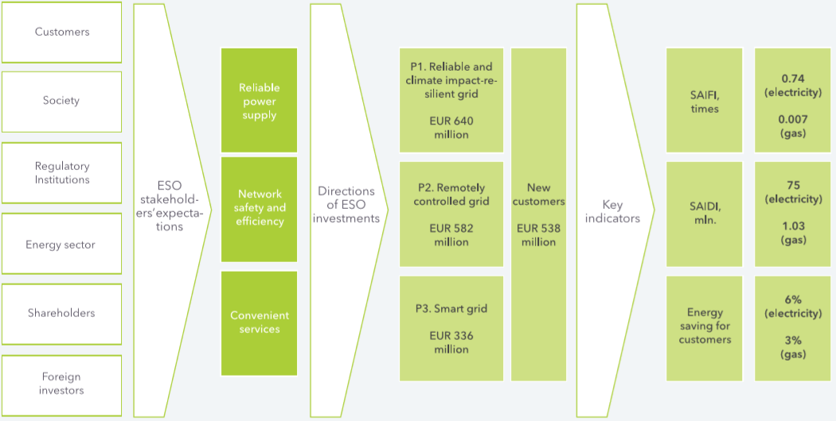Figure 3.5.1. Map of Lithuania’s DSO stakeholders, their expectations and investment programs, sums for 2018–2027, indicators for 2027

Currently implemented measures to promote the development of electric vehicles:
- Establishing legal base for special status of EVs in the traffic. Since 19 January 2013, the concept of electric vehicle was introduced in the Road traffic regulations, and three new signs related to electric vehicles appeared: indicating the place of charging, cases where traffic restrictions are not valid for electric cars, and parking places for these vehicles. Also, opening of the bus ("A") lane: electric vehicles are allowed to use public transport lane marked "A".
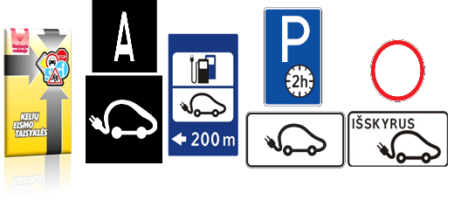
- Free parking of electric vehicles in major cities of Lithuania
- Issuement of special license plates (letters “EV” and four digits) for environmentally friendly vehicles;
- The first public high-power charging point was installed on the road A1, according to the public charging points plan set out in the Annex of the Guidelines.
- For the development of electric vehicle charging infrastructure and the installation of charging points on roads of national importance and on local roads of municipalities, Ministry of Transport and Communications allocated almost 3 million EUR of 2014-2020 EU structural assistance funds.

      - Where applicable, cooperation with other Member States in this area, including, where appropriate, information on how the SET Plan objectives and policies are being translated to a national context
Lithuanian Energy Institute actively participates in various international projects, such as Horizon 2020, Euratom, IAEA and others.
      - Where applicable, financing measures in this area at national level, including Union support and the use of Union funds
The total amount allocated to the Smart Specialization programme is 679 million EUR. 68 million EUR are allocated to priority Energy and environmental sustainability by the Ministry of Economy.
Energy and environmental sustainability will be accomplished by implementing the following R&D and innovation priorities:
  - smart systems for energy efficiency, diagnostic, monitoring, metering and management of generators, grids and customers – 16.8 million EUR.
  - energy and fuel production using biomass/waste and waste treatment, storage and disposal - 13.7 million EUR.
  - technology for the development and use of smart low-energy buildings – digital construction - 18.5 million EUR.
  - solar energy equipment and technologies for its use for the production of electricity, heat and cooling - 19 million EUR.

SECTION B: ANALYTICAL BASIS

CURRENT SITUATION AND PROJECTIONS WITH EXISTING POLICIES AND MEASURES,

Projected evolution of main exogenous factors influencing energy system and GHG emission developments
      - Macroeconomic forecasts (GDP and population growth)
In the latest years (2012-2016), GDP growth was moderate, reaching 3% value on average. Strong household consumption, supported by robust real wage growth, investment and increasing exports are the main GDP growth drive. Lithuania has reached decoupling emissions from economic growth. In the period 1990-2016 GDP increased by 41% and GHG emissions were reduced by 58%.
In the Figure below GDP and GHG emission index alteration is shown since 1990 to 2016.

Figure 4.1.1. GDP and GHG emission index of Lithuania in 1990-2016

In the first quarter of 2017, as compared to the same period of the previous year, Lithuania’s GDP growth accelerated to 4.1% and reached EUR 9.2 billion at current prices.
At the beginning of 2017, the estimated resident population of Lithuania amounted to 2 847.9 thousand, i.e. by 40.7 thousand (1.4%) less than at the beginning of 2016. In 2005–2016, the resident population declined by 507.3 thousand, or 15.1%. The decline in the resident population is caused by negative net international migration and the natural decrease.
      - Sectoral changes expected to impact the energy system and GHG emissions
Lithuanian energy institute performed Lithuanian energy sector development analysis with MESSAGE by IIASA model in 2014.
The main scenario defined in the study assumes successful implementation of energy efficiency initiatives, RES goals, increase in use of co-generation of heat and electricity. It would result that final energy consumption in industry would increase by 0.9% up to 2030 and by 0.7% after the year 2030. Same tendencies were applied for construction sector. Energy consumption in residential sector would increase by 0.7% yearly up to 2035. In Commercial/Institutional sector the increase would result in a yearly 0.9% up to 2030 and 0.7% up to 2035.
Agricultural, forestry and fisheries sectors final energy consumption would remain the same as in 2014. Fuel demand for house heating will decline due to the increased fuel efficiency, renovation of residential and public buildings and modernization of heating systems and combustion equipment’s.

Figure 4.1.2. Projected final energy consumption in Lithuania

Compared to 2014 the GHG emissions will overall increase in all sectors except in Residential sector were buildings renovation program is currently taking place. It was estimated that increased energy consumption efficiency and use of biomass will decrease the use of fossil fuel and final energy consumption by 13.7% in 2035 which will lead to decrease in GHG emissions in this sector.
In energy sector GHG emissions are estimated to reach a total of 6 574.3 kt CO₂ eq. in 2035. Most of the GHG will originate from Public electricity (31.9%), Petroleum refining (29.2%) and Manufacturing industries (20.2%). Manufacture of solid fuels and other energy industries and Agriculture/Forestry/Fishing sectors are still expected to remain the smallest GHG emissions of energy subsectors.
      - Global energy trends, international fossil fuel prices, EU ETS carbon price
According to European Commision report the world fossil fuel price projections have under gone substantial revisions of key assumptions compared to the previous Reference scenario exercise: “Trends to 2030 –Update 2009” including on reserves notably of shale gas and other unconventional hydrocarbons, world economic developments and the reflection of Copenhagen/Cancun pledges. Prices are projected to develop along new trajectories rather different from the past ones, particularly for gas
ETS allowances prices are endogenously derived so as the cumulative ETS cap is met; the continuously decreasing number of available allowances combined with the significant allowance surplus which is only projected to decrease after 2020 suggest that the ETS price will follow only a slowly increasing trend until 2025 and stronger increases thereafter; it is projected to reach 10€’10/tCO₂ in 2020, 35€’10/tCO₂ in 2030 and 100€‘10/tCO₂ in 2050. The PRIMES model simulates emission reductions in ETS sectors as a response to current and future ETS prices calculation However, in Lithuanian energy system development analysis in the scenario with existing national and EU policies and measures it was assumed that the EU ETS carbon price will remain at the same level as in 2014 (6.37 EUR/tonne CO₂ eq.).
With the current and projected low level of the ETS prices, the ETS emissions target for 2020 is achieved as there is also a large amount of additional policies implemented, particularly RES support policies but also the EED, which influence also the ETS sectors, and because the economic crisis substantially reduced the industrial production as well as power demand and thus GHG emissions. The projection of ETS prices is based on the assumptions that actors are risk-averse and have strong trust in the continuation of the ETS legislation; should this not to be the case, ETS prices would drop considerably below the projected levels in the short term. In the longer term, the trend of very low carbon prices is reversed; beginning in 2030 and throughout the period to 2050, the level of the ETS price is increasing significantly. This is the consequence of decreasing allowances supply following the implementation of the linear reduction factor that reduces the cap substantially over time and a combination of energy supply factors, namely of the delayed technology developments of CCS, public acceptance problems with nuclear energy and CO₂ storage, the updated offshore wind cost assumptions and phasing out of RES support as well as the trends in world fuel prices, where a decoupling of oil and gas prices takes place, with gas prices remaining in the longer term at relatively stable levels.
      - Technology cost developments
This part to be defined in the final version of the Plan.

Dimension Decarbonisation

GHG emissions and removals
      - Trends in current GHG emissions and removals in the EU ETS, effort sharing and LULUCF sectors and different energy sectors
In 2016, the total GHG emissions released into the atmosphere in Lithaunia constituted of 19 953 kt of CO₂eq. In the EU ETS setors GHG emissions comprised 6 160 kt CO₂eq. or 35% of total GHG emissions and in non EU ETS sectors 13 793 kt CO₂eq. or 65% of total GHG emissions in 2016.
The composition of GHG emissions by sector in 2015 is presented in Figure.

Figure 4.2.1.1. The composition of Lithuania’s GHG emissions (CO₂ eq.) by sectors (excl. LULUCF) in 2016

A significant decrease in 1992 was caused by the collapse of the Soviet economy, which led to the transition from a centrally-planned economy to a market-based economy by restructuring manufacturing industries, energy industries and agriculture. During its independence from the Soviet Union in 1990, after 50 years of annexation, Lithuania inherited an economy with high energy intensity. A blockade of resources, imposed by USSR during 1991-1993 led to a sharp fall in economic activity, as reflected by the decrease of the GDP in the beginning of the nineties. The economic situation improved in the middle of the last decade and GDP has been increasing until 1999 (during 1999-2000, GDP decreased due to the economic crisis in Russia) and GDP continued to increase from 2001 to 2008.

Figure 4.2.1.2. Emission trends for aggregated GHG in 1990-2016

In the beginning of 1990s, mostly fossil fuel was combusted in manufacturing industries, energy industries and agriculture. A comparison of annual general fuel balances in the period of 1990-2015 shows a significant decrease of use of fuel oil (e.g. from about annual quantity of 57 800 TJ in 1990-1991, to 19 307 TJ in 1992, to about 17 200 TJ in 1993-1994 and 13 126 TJ in 1995, to less than 600 TJ since 2008 ), also a decrease of use of coal, petrol, natural gas, but increase of use of wood. Decrease of use of fuel oil first of all was influenced by environmental requirements: since 1 January 2004 consumption of sulphurous fuel oil was forbidden and it was followed with the stricter requirements since 2008. As elimination of sulphur from fuel oil was not economically efficient for companies, these requirements led to the shift of fuel oil to other fuel types (e.g. natural gas), resulting in a considerable decrease in annual GHG emissions.
In Lithuania the non ETS sector takes a bigger share of GHG emission than in ETS sector. In 2016 this share was 69% of total GHG emissions (Fig x.x).

Figure 4.2.1.3. Emission trends for aggregated GHG in 1990-2016 divided by the ETS and non-ETS sectors

      - Projections of sectoral developments with existing national and Union policies and measures at least until 2040 (including for the year 2030)
We are providing GHG projections based on an analysis done in 2017, where the base year was 2014. In 2019 we are planing to update Lithuania’s GHG projections, including the base year 2016. Thus, the results of the last GHG projection analysis shows that CO₂ emissions will continue to grow in the transport sector, as this sector is rapidly developing and meanwhilethe vehicle fleet is getting outdated. The road transport emissions account for 90%, from which 80% come from passenger cars. In the agriculture sector, GHG emissions increased from 47% to 53% from the cultivation of organic soils in 2015 compared with 2014. The dynamics of GHG emissions in the agriculture sector depend on the areas of arable land, the quantity of synthetic nitrogen fertilizers used, and the number of cattle. Based on the projections, the distribution of pollution sources will not change in the agriculture sector until 2030. Organic soils will account for 56% of total GHG emissions, due to nitrogen suboxide emissions and methane emissions from enteric fermentation in cattle which will make up 36%. The detailed information on methodologies and assumptions is available in Chapter 4.8 of the Report of Lithuania pursuant to Article 12, 13 and 14 of Regulation (EU) No 525/2013

Energy. As described in Section 4.1 ii.) according to the Lithuanian energy sector development analysis, the average electricity demand will increase by 2.0% leading up to 2030, and thereafter, by 1.5% leading up to 2035, finally reaching a total of 13.545 GWh by 2035, which may produce a slight increase in GHG emissions in the energy sector.

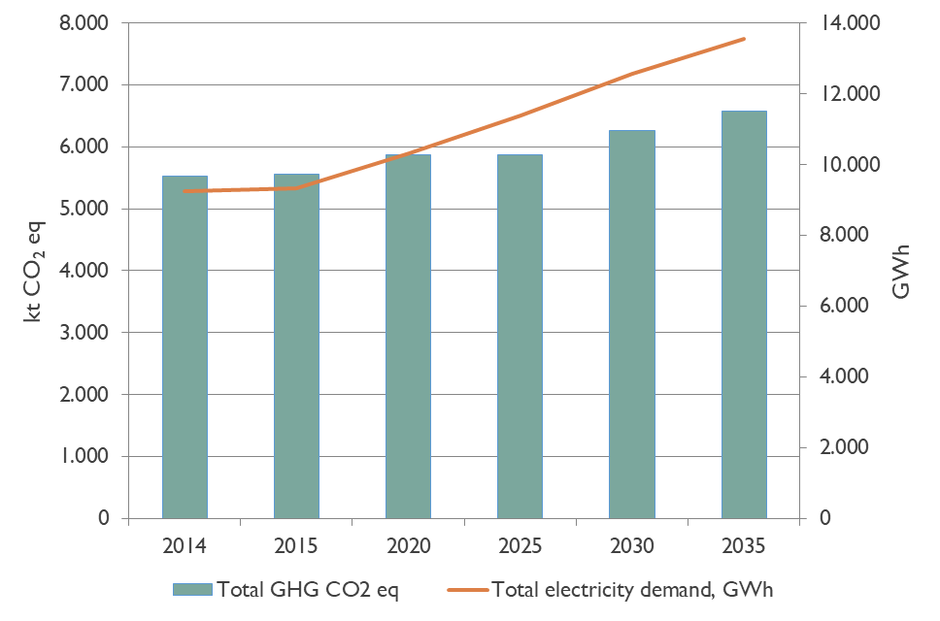
Figure 4.2.1.4. Projected total electricity demand and GHG emissions in the energy sector (excluding the transport sector)

It is estimated that the public electricity and heat production sectors, and the manufacture of solid fuels and residential sectors will remain the main sources of GHG emissions in the energy sector.
Historical and projected GHG emissions in 1990-2035 from the energy subsectors, kt CO₂eq. (excluding transport sector).
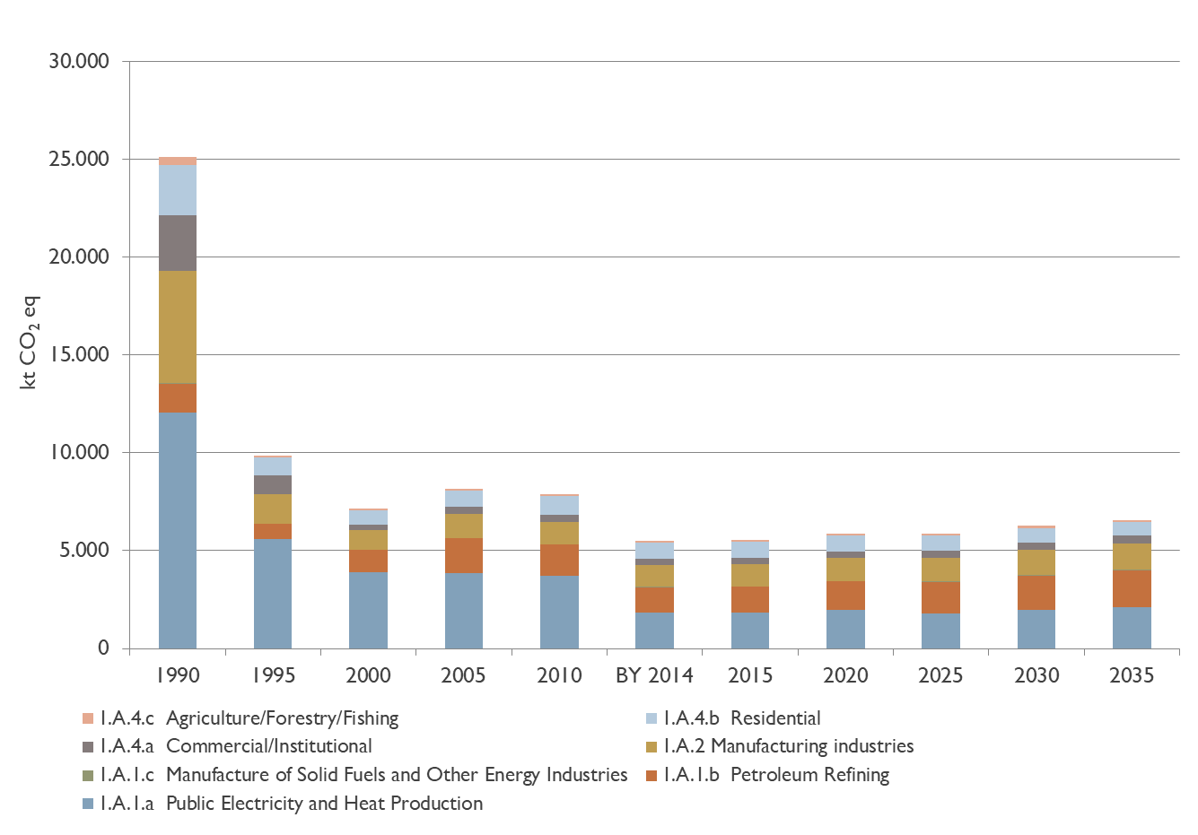
Figure 4.2.1.5. Historical and projected GHG emissions, kt CO₂eq. (excluding transport sector)

Compared to 2014, the GHG emissions will increase overall in all sectors, except in the Residential sector were the building renovation program is currently taking place. It was estimated that the increased energy consumption efficiency and the use of biomass will decrease the use of fossil fuels and the final energy consumption by 13.7% in 2035, which will lead to a decrease in GHG emissions in this sector.

Industrial processes and product use. The GHG emissions projections from industrial processes and product use with existing policies and measures were estimated using projected production levels data (activity data) for 2035, provided by the main emitters in this sector: clinker, lime, glass, ammonia and nitric acid producing companies. Emissions from these industries covered up to 83% of total industrial processes and product use sector emissions in 2014.
The GHG emissions in the industry sector are determined by technology processes, where notable emissions reduction per production output is hardly possible. Therefore, it is expected that GHG emissions will grow together with increasing industrial production. The projected emissions from industrial processes and product use are presented in the figure below:
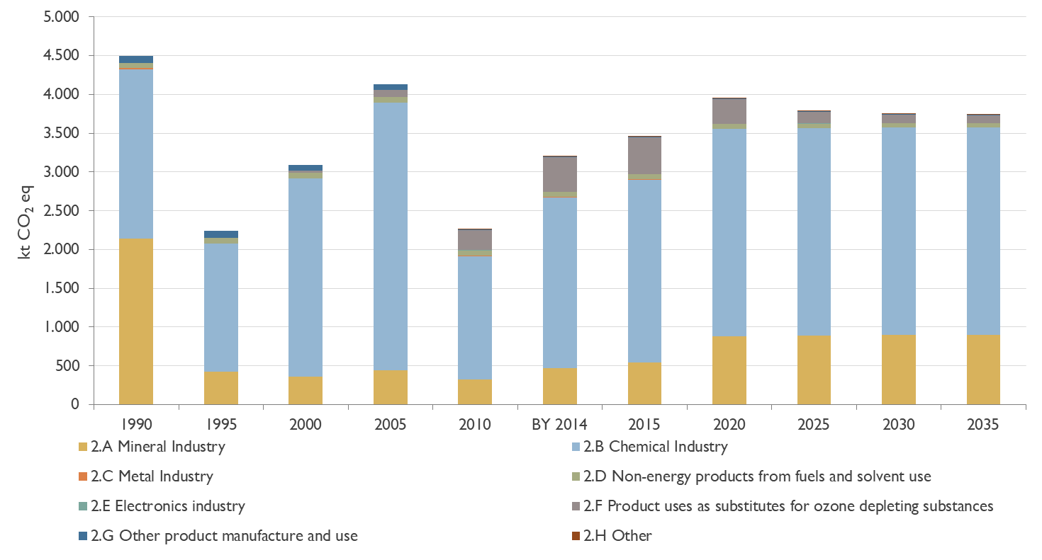
Figure 4.2.1.6. GHG projections in the industrial processes and product use sector

The main source of GHG emissions in industrial processes and the product use sector remains nitric acid and ammonia production. Based on the data from manufacturing companies, the GHG emissions trend will remain stable in the period of 2020-2035 due to constant production capacity.
The projections on F-gas emissions for most sub-categories were based on the 1990-2014 emissions trend by taking into account growth rates for the different sectors, by including relevant technological improvements, and taking into account the impacts of the F-gases Regulation (EU) No 517/2014 implementation (introduced restrictions/controls of the use and introduction of quotas for placing on the market hydrofluorocarbons).
Emissions from domestic refrigeration equipment are expected to decline in 2020–2035 due to EU wide measures and technical changes resulting in decreased leakage. Due to the ban on HFCs with GWP of 2 500 and above to service or maintain refrigeration equipment in domestic refrigerators and freezers, the use of (and thus emissions from) HFCs in domestic refrigeration will be phased out gradually, and mainly emissions from disposal will occur. Implementation of the F-gases quota system will reduce amount of HFCs placed on the market by 79% between 2015 and 2030. Taking into account these assumptions, it is predicted that in 2035 emissions from commercial and industrial refrigeration sectors will account for only 11%, compared to F-gases emissions in these sectors in 2015. The emissions from mobile air-conditioning will decrease, due to the implementation of the EU MAC Directive, which prohibits the use of F-gases with GWP of more than 150 in new types of cars and vans introduced from 2011, and in all new cars and vans produced from 2017. Emissions from foam blowing are expected to decrease due to reduced use, and emissions from metered dose inhalers will decline due to decrease of population.
Agriculture. Projections of GHG emissions from the agriculture sector with existing policies and measures (WEM) are based on forecasted livestock population, main harvested crops and area harvested, the amount of sold limestone materials, consumption of inorganic N fertilizers and application of urea.
Livestock populations. It is projected that the dairy cattle population will decrease by 22% from 315 thousand heads in 2014 to 236 thousand heads in 2030. This decrease is mainly associated with increasing productivity (increase in milk yield).
The population of non-dairy cattle will be constantly increasing: from 2014 to 2015 by 4%; during the period of 2015-2020 by 20%, and from 2020 to 2030 – by 16%. For the period 2031-2035, the average annual growth of 1.5% was applied (1.5% increase represents average non-dairy cattle population increase during the period 2025-2030 each year).
The population of swine will be decreasing during the whole period. The swine population from the year 2014 (base year) to 2020 will decrease by 14%. From 2020 to 2030, the swine population will decrease by 1%. The poultry population will increase by 6% in 2020 compared to 2014. From 2020 to 2030, it is projected that the poultry population will increase by about 5%.
Taking into account livestock population developments, it is projected that CH₄ emissions from enteric fermentation during the 2014–2035 period will increase by about 5%. A slight decrease of CH₄ emissions from enteric fermentation can be seen from 2014 to 2020. It is projected that emissions from enteric fermentation could decrease by 1.2% in 2020 compared to the base year.
In 2014 the majority of these emissions were comprised of dairy cattle enteric fermentation – 60%. It is projected that the share of non-dairy cattle CH₄ emissions from enteric fermentation will be increasing from 36% in 2014 to 53% in 2035.
It is projected that CH₄ emissions from manure management during the 2014-2035 period will vary slightly. The decrease of CH₄ emissions from manure management can be up to 7% in 2020 compared to 2014. From 2020 to 2030, it is projected that CH₄ emissions will increase by 4%, and by 2% in 2035. It is projected that total direct and indirect N₂O emissions from manure management will increase by 2% in 2020 compared with 2014. From 2020 to 2035, emissions will increase by 3.2%.
Crop residue projections. It is projected that crop yield will increase by reducing crop cultivation in less fertile areas and by implementing intensive growth technologies in specialized, more efficient (fertile) soil farms. Crop yield will also increase due to the concentration of farms in the lands of middle Lithuania, the rise of farming culture, and the implementation of new technologies and the best farming practices of the EU.
There will be an increase of direct and indirect N₂O emissions from agricultural soils by 5.7% from 2014 to 2015, by 13% from 2015 to 2020, and from 2020 to 2035 the expected increase in N₂O emissions from agricultural soils is about 0.7% every 5 years.
Inorganic N fertilizer projections. The projections of inorganic N fertilizer consumption was based on the projected harvest of the crops.
Consumption of inorganic N fertilizers will be increasing during the projected period. The biggest increase is expected in 2014-2020 period where the inorganic N fertilizer consumption will increase by 60%. Afterwards, a slight increase in the inorganic N fertilizer consumption is projected. The increase of inorganic N fertilizer consumption is strongly related with an increase in crop yield. The urea application projection is related to the projection of inorganic N fertilizers (estimated as the average (2010-2014) percentage of urea in the total amount of inorganic N fertilizers).
It is projected that emissions from urea application will increase 1.7 times in 2020 compared to the 2014. From 2020, CO₂ emissions from urea application will increase slightly by 1% every 5 years.
Liming materias projections. Consumption of limestone and dolomite will be increasing during the 2014-2035 period. Due to the fact that currently about 66.5% of soil is acidic, consumption of limestone and dolomite will increase by 28% and 48%, respectively, in 2035 compared to the base year (2014).
It is projected that CO₂ emissions from liming will increase 1.7 times by 2020 compared to the 2014, as more than half of the soil in Lithuania is acidic. After 2020, CO₂ emissions from liming will decrease by 10%, by 24% in 2030, and a slight increase (0.6%) of CO₂ emissions in 2035 could be observed.
Total GHG emissions from the agriculture sector will increase by 3.1% from 2014 to 2015, and afterwards, will increase– by 7% from 2015 to 2020, by 1% in 2025 and 2030, and by 1.3% in 2035. The largest source of GHG emissions is agricultural soils, particularly direct soils emissions. The figure below represents the GHG emissions trend during the historical and projected period, covering 35 years.
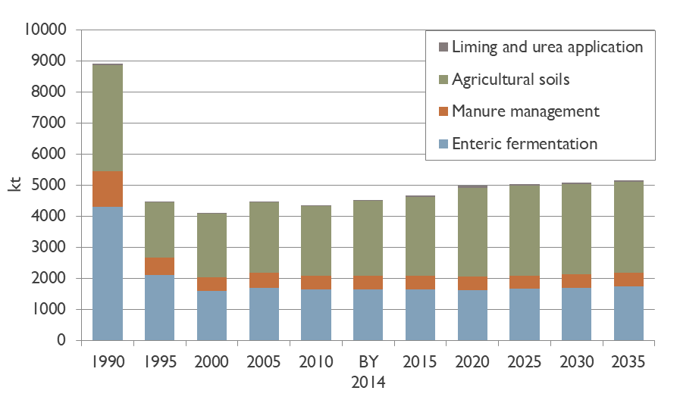
Figure 4.2.1.7. Historical and projected GHG emissions from the agriculture sector by categories

LULUCF
The LULUCF sector is expected to act as a net sink until 2035 according to the projections, with the main sink remaining as forest lands (GHG removals in biomass) and a projected stable carbon sink in harvested wood products and grassland mineral soils (in the event of the conversion from croplands to grasslands). The main sources of GHG emissions in the LULUCF sector is the cropland category, especially emissions from mineral soils after their conversion to arable land, as well as the wetland category, where emissions mainly come from peat extraction sites. GHG emissions from croplands and wetlands are projected to remain similar as in 2014: 4 385 kt CO₂eq. and 892 kt CO₂eq., respectively. It is expected that approximately 8 000 kt CO₂eq. could be removed in the LULUCF sector annually, whereas the sector’s GHG removals are not projected to increase with the existing measures compared to the GHG removals in 2014.

Figure 4.2.1.8. Historical and projected GHG emissions and removals from the LULUCF sector key categories

The implementation of the 2013 Wetlands Supplement results in a significant decrease of total projected GHG emissions under the WEM scenario. Anaverage annual GHG removal in the LULUCF sector key categories will comprise only half of the removals, compared to the projections without the 2013 Wetlands Supplement impact – 4 669 kt CO₂eq.

Figure 4.2.1.9. Historical and projected GHG emissions and removals from the LULUCF sector key categories with the implementation of the 2013 Wetlands Supplement

WASTE. The projected amount of generated municipal solid and biodegradable waste (MSW) for the period 2015-2020 is provided in the National Waste Management Plan for 2014-2020. The projections on industrial, biodegradable and sewage sludge generation are provided for the period 2015-2035 by the Ministry of the Environment. Municipal solid waste and biodegradable MSW generation during the period 2021-2035 was calculated following the increase during the period 2015-2020. Results are shown in the figure:

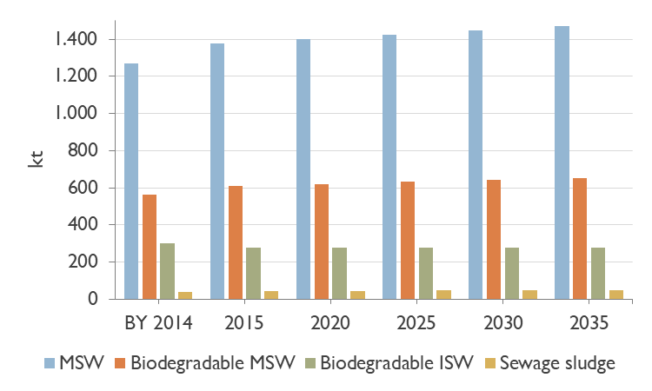
Figure 4.2.1.10. Projected amount of generated waste

GHG emissions projections are provided in four subsectors: disposal in landfills, composting, incineration of waste, and wastewater treatment and discharge. Compared with 2014 emissions from the waste sector, there will be a decrease of emissions by 57% in 2025 and by 62% in 2035. Historical and projected GHG emissions from the waste sector are presented below:
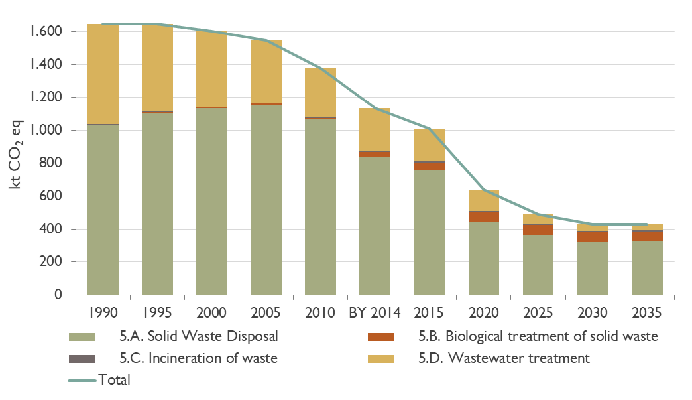
Figure 4.2.1.11. Historical and projected GHG emissions from waste sector

Moreover, GHG emissions are inseparable from the long-term development analysis of the economic sectors that meet human needs. The GHG emissions projection suggests that an increasing demand in energy will result in an increase of GHG emissions. Existing measures will lessen this increase. Total historic and projected GHG emissions in Lithuania are presented in the figure below.

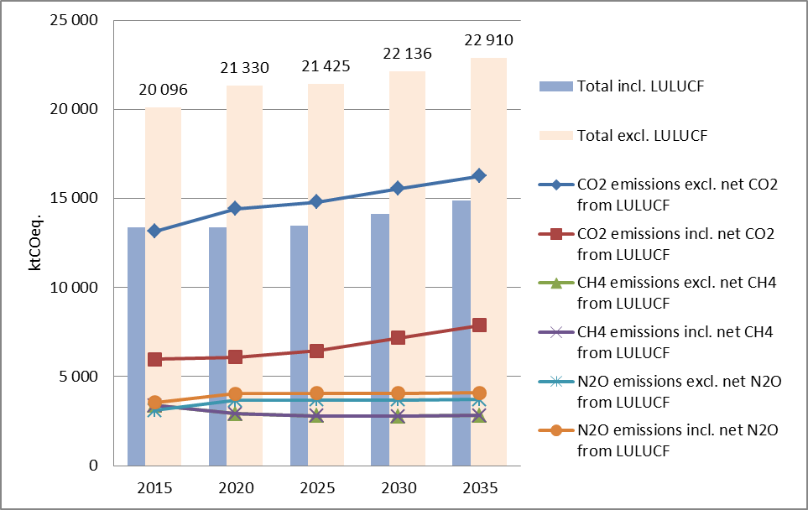
Figure 4.2.1.12. Projected agregated GHG emissions (WEM scenario), kt CO₂eq

Renewable energy
      - Current share of renewable energy in gross final energy consumption and in different sectors (heating and cooling, electricity and transport) as well as per technology in each of these sectors
Lithuania is focused on reducing the environmental impact of its energy production and its use. It is determined to move towards a sustainable and a low‑carbon economy by modifying its energy mix and methods of generating energy. Lithuania has begun to shift towards more efficient energy production and a greater use of renewable energy.

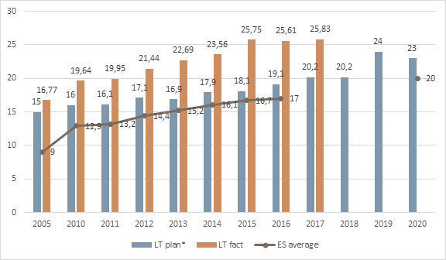
Figure 4.2.2.1. Share of renewable energy in the gross final energy consumption,%
*an estimated trajectory of energy from RES minus estimated surplus for the cooperation mechanism provided in the National Renewable Energy Action Plan
Source: Eurostat; Statistics Lithuania, Lithuanian National Renewable Energy Action Plan

In the last decade, the use of cleaner energy sources in Lithuania has increased significantly. Lithuania has already reached its goal of having a 23 per cent. share for renewable energy in its total energy consumption by 2020. In 2017, the share of renewable energy sources in the total consumption of energy was 25.83 per cent.
In October 2017 Lithuania was the first Member State to sign the Cooperation agreement with Luxembourg, transferring its renewable energy statistics.
According to Article 4 (1) of Directive 2009/28/EC, targets for the share of energy from renewable sources in 2020 were set out in the following sectors:
  - heating and cooling;
  - electricity;
  - transport.

Accordingly, the consumption of electricity from RES was about 17%, total heat consumption – about 46%, and in the transport sector—about 4%. A significant share of resources in energy production comes from wind and biofuels.

Heating and cooling
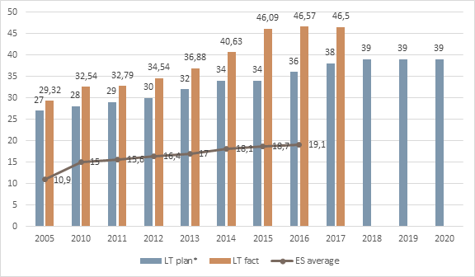
Figure 4.2.2.2. RES shared distribution in heating and cooling sector, %. Source: Eurostat; Statistics Lithuania, Lithuanian National Renewable Energy Action Plan

Electricity
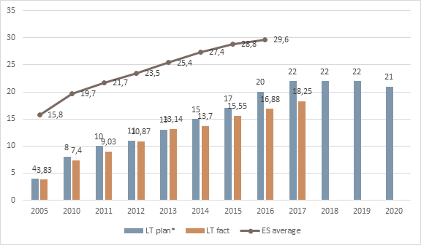
Figure 4.2.2.3. RES share distribution in electricity sector, %. Source: Eurostat; Statistics Lithuania, Lithuanian National Renewable Energy Action Plan

Transport
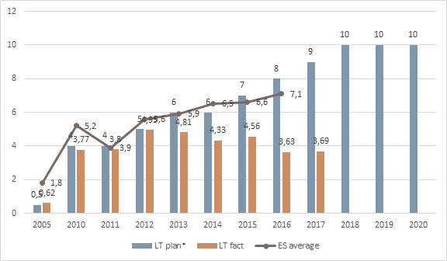
Figure 4.2.2.4. RES share distribution in transport sector, %.

According to the study on biomass supply and demand for bioenergy purposes, the potential annual amount of woody biomass for bioenergy use is 5.8 Mm3 or 1 Mtoe, which includes the biomass not only from forest harvesting but also from wood product waste, which are suitable for bioenergy purposes. It was identified that forest biomass potential for bioenergy use is 3.5 Mm3, of which more than 1 Mm3 is still unused – a potential to increase forest biomass use for bioenergy production. The goal to increase the amount of harvest residuals (logging waste) and small non-merchantable wood used to produce bioenergy was already set in the National Forestry Development Program for 2012 - 2020. The goal was set taking into account the implementation of sustainable forest management principles without any additional subsidization from the state. Main measures to reach the goal to increase biomass production for bioenergy purposes are: information for forest owners on the economic profit from biomass production, increasing biomass production in state forest enterprises using the potential of mature residues tree stands, and increasing the use of negligible value stand wood for biomass production (improving legal preconditions).

      - Indicative projections of development with existing policies for the year 2030 (with an outlook to the year 2040)
Electricity sector. By 2050, electricity generated from RES will constitute no less than 100% of power consumed in Lithuania, and the amount of energy produced from RES will be no less than 18 TWh.
The vital prerequisite for RES development is the assurance of the required adequate capacities of the Lithuanian energy system. Taking into consideration the required capacity, the state will ensure the availability of reservations and other system network services by creating an appropriate regulatory environment, while the responsibility for balancing will be borne by the RES-generated electricity producers in line with the EU guidelines. Regional and international cooperation will be gradually promoted in order to reduce the costs of developing RES.
Electricity self-consumers will account for at least 50% by 2050. These customers will be able to participate in the market through service providers in the energy sector. The active participation of local energy communities in investing in co-owned RES equipment will be encouraged.
Transport sector. By 2050, 50% of energy consumption in the transport sector will be from RES and there will be 100% less use of cars running on traditional fuel (petroleum and diesel) in cities.

Dimension Energy efficiency
      - Current primary and final energy consumption in the economy and per sector (including industry, residential, service and transport)
In 2010-2015, the energy intensity of the country’s economy consistently decreased (primary energy – 32%, final energy – 31%), and in 2015 was the smallest among the three Baltic States at 205 kgoe/1000 EUR (in Latvia – 207 kgoe/1000 EUR, Estonia – 358 kgoe/1000 EUR). Lithuania is still behind (by about 70%) the EU average (120 kgoe/1000 EUR).
In 2015 primary energy consumption of the economy was equal to 7137,6 ktoe, final energy consumption – 4863,1 ktoe. Final energy consumption in different sectors:
- Industry – 945.5 ktoe;
- Residential – 1359.7 ktoe;
- Services – 515.4 ktoe;
- Transport – 1844.4 ktoe;
- Agriculture – 97,9 ktone;
- Construction – 37.9 ktoe.

      - Current potential for the application of high-efficiency cogeneration and efficient district heating and cooling
In 2016, 3.6 TWh of heat energy was generated in CHP plants. It accounted for about 41% of the total heat energy produced in the DHS system. The installed electric capacities of biofuel and waste fired CHP plants are 79 MW. In implementing the National Programme for Heat Sector Development in 2015–2021, approved by the Government of the Republic of Lithuania on 18 March 2015 by Resolution No. 284 “On the approval of the National Programme for Heat Sector Development in 2015-2021”, high-efficiency biofuel- and municipal waste-fired Vilnius CHP plant with a heat capacity of 229 MW and an electricity capacity of 92 MW, and a waste-fired Kaunas CHP plant with a heat capacity of 70 MW and an electricity capacity of 24 MW power plant by 2020 Kaunas waste heat generating power plant burning waste are expected to be built. These CHP plants are expected to satisfy around 40% of Vilnius and Kaunas district heat needs.
The centralised cooling network in Lithuania is not developed. Residential and commercial premises are cooled independently, using electricity. The preliminary annual cooling demand in Lithuania ranges from 5 to 6 TWh. The need was determined based on the assumption that the cooling demand in Lithuania, given its climatic conditions, is ~60 kWh/m2 per year. However, in order to develop this sector, one should consider the fact that it would only be useful to do this when connecting to the network buildings that already have a centralised (common mechanical) ventilation system, such as offices, supermarkets and new high energy class multi-apartment buildings, as investments in old multi-apartment buildings to take advantage of centralised cooling supply would be unreasonably high. In this case, the annual cooling demand would be reduced to 2-3 TWh.
      - Projections considering existing energy efficiency policies, measures and programmes as described in point 1.2.(ii) for primary and final energy consumption for each sector at least until 2040 (including for the year 2030)
This part to be defined in the final version of the Plan.
      - Cost-optimal levels of minimum energy performance requirements resulting from national calculations, in accordance with Article 5 of Directive 2010/31/EU
This part to be defined in the final version of the Plan.

Dimension energy security
      - Current energy mix, domestic energy resources, import dependency, including relevant risks

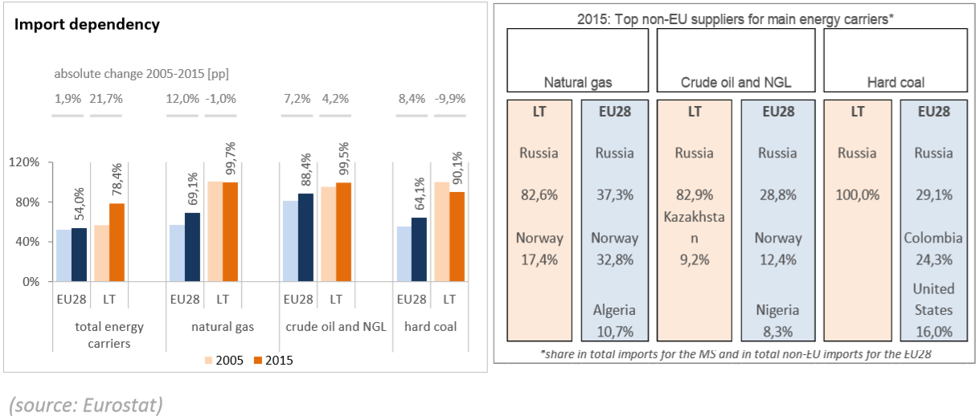Figure 1.1.3. Energy import dependency

Natural gas. Lithuania is highly dependent on energy imports, the vast majority of which are coming from Russia. In 2015, 78% of Lithuania's energy consumption came from imports, of which about 83% came from Russia. However, for natural gas, the Liquefied Natural Gas (LNG) terminal in Klaipėda that started operating in December 2014 is already helping greatly to diversify gas imports.
On the upstream gas market, the Klaipėda LNG terminal is sufficient to cover around 90% of all current demand of the three Baltic States.The gas pipeline Klaipėda-Kuršėnai is also fully functional, but the work on the gas interconnector pipeline with Poland (known as GIPL) is behind schedule. This pipeline will connect the Baltic countries with the continental European gas network for the first time and is essential for the development of the regional market for natural gas. Analysis indicates that one regional LNG terminal, together with the pipeline projects that are being built in the region (with substantial EU financial support), including the GIPL (Poland-Lithuania) and the Baltic connector (Estonia-Finland), are sufficient to cover future supply needs of the region.
Electricity. Lithuania is part of the Nordic and Baltic wholesale electricity market. The interconnection capacity for electricity in the Baltic States increased to 23.7% in 2017, exceeding the 10% target. This was possible thanks to the commissioning of electricity interconnections with Finland via the Estlink2, with Poland via LitPol Link and with Sweden via NordBalt.
Electricity interconnections and gas imports diversification had a positive impact on energy prices, despite the very high concentration on the wholesale gas market. Better interconnections and the diversification of gas imports via the LNG terminal have increased competition and benefitted Lithuanian electricity and gas consumers (as well as Latvian and Estonian consumers). In 2016, households' electricity and gas prices in Lithuania were already below the EU average.
The next main objective for Lithuania is to synchronise its electricity systems with the European network. For historical reasons, the Baltic States are today operated in a synchronous mode forming the so-called BRELL ring (Belarus-Russia-Estonia-Latvia-Lithuania). The three Baltic States aim to synchronise their grids with the European network by 2025. The core of the work is being carried out within the Baltic Energy Market Interconnection Plan (BEMIP). A dedicated BEMIP working Group was set up supported by the Commission to work on the identification of the most cost-efficient synchronisation scenario that ensures system stability. The infrastructure element of the synchronisation of the Baltic States' electricity system with the European network has beenincluded in the third list of projects of common interest.

      - Projections of development with existing policies and measures at least until 2040 (including for the year 2030)
This part to be defined in the final version of the Plan.

Dimension internal energy market

Electricity interconnectivity
      - Current interconnection level and main interconnectors

Currently, electric power system of Lithuania is directly connected with five neighbouring countries:
- Sweden – electric system connected with “NordBalt” high voltage direct current interconnection with capacity of 700 MW;
- Poland - electric system connected with 400 kV double-circle line “LitPol Link”, which operates through direct current converter. Capacity of converter – 500 MW, thus total interconnection capacity – 500 MW.
- Latvia – electric system connected by four 330 kV and three 110 kV transmission lines. Section capacity is 1500 MW (Latvia – Lithuania) and 1200 MW (Lithuania – Latvia).
- Belarus – electric system is connected with five 330 kV and seven 110 kV transmission lines. Capacity of this section is 1300 MW (Belarus – Lithuania) and 1350 MW (Lithuania – Belarus)
- Russia (Kaliningrad region) – transmission electric system is connected with three 330 kV and three 110 kV lines. Capacity of this section is 600 MW (Russia – Lithuania) and 680 MW (Lithuania – Russia).

      - Projections of interconnector expansion requirements (including for the year 2030)
After accomplishment of two strategic projects (“LitPol Link and “NordBalt”), Lithuanian transmission system operator “Litgrid” during upcoming years plans to concentrate all efforts for synchonization with European electricity network realization and internal transmission network strenghthening. Till 2025 plans regarding electricity transmission network development for synchonization:
- Accurate number of lines with Poland and connection schemes needed for synronous work with continental Europe would be revealed after study led by ENTSO-E for technical connection conditions.
- Direct current converter in Alytus transformer substation usage and need of new converters will depend on negotiations results with Russia and Belarus according to reorientation of Baltic state’s system for synchronous work with continantal Europe network.

Energy transmission infrastructure
      - Key characteristics of the existing transmission infrastructure for electricity and gas
Lithuanian electricity transmission network – it's 400, 330 and 110 kV transformer substation, connected to the high voltage power transmission lines. Electricity produced in Lithuanian power plants or imported from other power systems through such lines is reaching distribution network, and then electricity consumers. Total air and cable lines length of about 7 000 kilometers.
Lithuania’s natural gas transmission system is connected with the transmission systems of the Russian Federation (Kaliningrad Region), Belarus, Latvia and the LNG terminal in Klaipėda.
The total length of pipelines of the transmission system in the territory of Lithuania is more than 2 100 km. In order to secure a smooth operation of the transmission system and to facilitate the supply of natural gas to distribution systems, 65 M&R Stations and 1 GMS were built. Two GMS owned by the Company were installed in the territory of Lithuania for interconnections with gas transmission systems of other countries. Panevėžys and Jauniūnai gas compressor stations, together with agreements concluded with operators of neighboring systems wherefrom gas is received ensure the required gas pressure parameters throughout the transmission system.
Technical capacities of gas pipeline interconnections with gas transmission systems of other countries and the LNG terminal:
- at the entry point via Kotlovka GMS – 325.4 GWh per day;
- at the entry point via Klaipėda GMS (at the interconnection point of the transmission system and the LNG terminal) – 122.4 GWh per day;
- at the entry point Kiemėnai GMS to Lithuania – 65.1 GWh per day;
- at the exit point Kiemėnai GMS from Lithuania – 67.6 GWh per day;
- at the exit point Šakiai GMS – 114.2 GWh per day.
The existing transmission system capacities at points of interconnection with Lithuania’s distribution systems and the directly-connected system users are sufficient to secure the needs of Lithuanian consumers.

      - Projections of network expansion requirements at least until 2040 (including for the year 2030)
Electricity. Until 2025 planned development of the electricity transmission network for the Baltic power systems in sync with the continental European networks:
  - construction of 330 kV double-circuit overhead transmission line Kruonis PSPP-Alytus;
  - the updated power management and monitoring systems;
  - construction of 330 kV distribution – Musa and Vilnios 330/110/10 kV transformer substation;
  - construction and reconstruction of 330 kV lines: Panevezys-Musa, Vilnius-Vilnia-Neris, Vilnius-Lithuania Power Plant;
  - construction of the additional transformer substations users reserving Belarus border 110 kV overhead line.

It is planned to implement reforms and other internal electricity transmission network development projects designed for reliable operation and improved network management system and to ensure network restore (mainly substations and lines of reconstruction projects) and the indicative telecommunication technologies and systems to upgrade and install.
Natural gas. Amber Grid AB (hereinafter - the Company) is the Lithuania's natural gas transmission system operator responsible for safe operation and development of the system. In order to ensure the reliability of natural gas supply (uninterrupted supply and sufficient capacity of the system) to Lithuania’s consumers, efficient development of the gas transmission system aiming at its smooth integration into the Pan-European Natural Gas Transmission System and enabling the diversification of gas supply sources is important.
The gas transmission system consists of gas transmission pipelines, gas compressor stations, gas metering and regulation stations (hereinafter - M&R Stations), gas metering stations (hereinafter - GMS), gas pipeline anti-corrosion protection equipment, data transmission and communication systems and other facilities attributed to the transmission system. The Lithuania’s gas transmission system is connected to infrastructure of the Klaipėda liquefied natural gas terminal (LNGT) and gas transmission systems of the Russian Federation (the Kaliningrad Region), Belarus and Latvia. Gas is supplied to the Lithuania’s gas transmission system from Russia (via the gas pipeline from Belarus via the Kotlovka GMS) and through the Klaipėda LNGT; gas can also be transported by gas transmission pipeline coming from Latvia. In 2018–2027, the plan is to continue diversification of sources of gas supply, to increase the reliability of gas supply, to continue developing the cooperation between the Baltic Region states in the creation of a common market and to continue the integration of the Baltic Region transmission systems into the single gas system of the EU. Implementation of the following investment projects is planned in pursuit of successful achievement of these goals:
- constructing interconnection between the Lithuanian and Polish gas transmission systems;
- carrying out a joint project of Lithuania's and Latvia's natural gas transmission system operators aimed at increasing the capacity of the gas transmission system interconnection between the two countries.
These projects will be relevant for processes of the formation of the regional gas market in the East Baltic Region and will enable transmitting gas to participants of gas markets of other countries of the region.
The implementation of several large transmission system rehabilitation and modernization projects co-financed from the EU Structural Funds planned in 2018–2027:
- installation of pig launching and receiving stations and implementation of prompt technological control of the gas transmission system (stage 1) in 2017–2018;
- installation of pig launching and receiving stations and implementation of prompt technological control of the gas transmission system in 2018-2021 (stage 2);
- implementation of the system of remote control of technological processes of the gas transmission system and collection of gas meter data in 2017-2019;
- replacement of valve units and their connection to SCADA remote control system in 2018–2022;
- reconstruction of individual sections of the gas transmission pipeline Vilnius– Panevėžys–Riga in 2017–2019;
- modernization of Panevėžys gas compressor station in 2016–2018;
- modernization of Jonava M&R Station in 2016–2018;
- modernization of Alytus M&R Station in 2016–2018; - reconstruction of individual sections of the second part of the gas transmission pipeline Vilnius–Kaunas planned in 2019–2021.

Electricity and gas markets, energy prices
      - Current situation of electricity and gas markets, including energy prices
In 2016, the total installed electricity-generating capacity in Lithuania was 3591 MW, 2222 MW out of it – reliable power for peak consumer demand. In 2016, the peak demand was 1979 MW. The projected peak demand will be 1980 MW in 2020, 2450 MW in 2030, and 3150 MW in 2050. At the same time, however, the reliable power is expected to decrease down to 2261 MW in 2020, and 1599 MW in 2030 and 2050. Therefore, one of the challenges to be solved in the near future will be the management of the imbalance between the increasing peak demand and the decreasing reliable power after 2020.

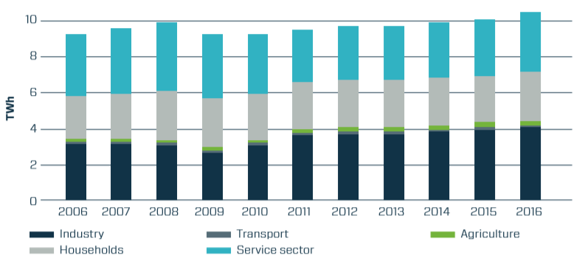
Figure 4.5.3.1. Electricity consumption in 2006–2016 according to consumer groups

In 2016, Lithuania produced a total of 3.97 TWh of electricity. Half of all electricity produced in the country was generated by power plants using renewable energy sources. About 0.45 TWh of electricity was generated by hydropower plants (excluding Kruonis PSPP), 1.13 TWh – by wind turbines and about 0.44 TWh was produced by solar, biomass and biogas fired power plants. The remaining electricity was produced by conventional fuel-fired power plants. The largest share of electricity consumed in the country (about 72% of total electricity consumption or 68% of total electricity demand) was imported in Lithuania during 2016. Most of it (37%) was imported from Latvia and Estonia, (27%) – via NordBalt interconnection with Sweden, (5%) – via LitPol Link interconnection with Poland, and the rest (31%) – from third countries.

Price structure (2016):
3.678 ct/kWh – purchase price
1.986 ct/kWh – distribution through low voltage grids max price cap
1.386 ct/kWh – public interest services
0.830 ct/kWh – distribution through medium voltage network max price cap
0.672 ct/kWh – transmission services max price cap
0.393 ct/kWh – price of system services
0.143 ct/kWh – public supply service price cap

Figure 4.5.3.2. Electricity prices for for medium size households, 2008–2017, EUR/MWh (Eurostat)

Figure 4.5.3.3. Electricity prices for for medium size industries, 2008–2017, EUR/MWh (Eurostat)

The share of natural gas in the country’s overall consumption of fuel and energy remains significant (25.1% in 2016), yet as of 2012, there has been a downward trend (35.9% in 2012). From 2006 to 2012, the country’s natural gas needs ranged around 33.5 TWh, while in 2013–2016, due to the increasing use of renewable resources, the overall consumption of natural gas decreased to 23.38 TWh. In 2016, 65% of natural gas imported in Lithuania was consumed in industry (the majority in the production of fertilisers), 21% in the energy sector, and 14% in households and the small commercial sector.

Figure 4.5.3.4. Natural gas prices for for medium size households, EUR/GJ, 2008–2017 (Eurostat)

Figure 4.5.3.5. Natural gas prices for medium size industries, EUR/GJ, 2008–2017 (Eurostat)

Following the completion of the liquefied natural gas terminal in Klaipėda and the EU Third Energy Package in late 2014, and the second gas pipeline Klaipėda-Kuršėnai in 2015, the situation in the natural gas market has been substantially improved by enabling acquisition of natural gas in international markets, eliminating decades-old monopoly in the natural gas sector and creating competition. Lithuania has become able to independently supply itself with natural gas (and to supply significant quantities to the Baltic region) through the LNG terminal in the event of a disruption of supply from Russia or a lack of competitiveness. In 2016, 60% of the natural gas consumed in Lithuania was imported through the Klaipėda LNG terminal. These significant changes in the natural gas sector as well as favorable trends in international markets have led to a 50% decrease in the price of imported natural gas in Lithuania from 2012 to 2016, transforming Lithuania from one of the highest prices for natural gas paying EU members to one of the lowest price natural gas paying EU members. Considering the results achieved, the global dynamics of the LNG market and the potential of the regional natural gas market, it is strategically important for Lithuania to secure long-term LNG supply in order to ensure a competitive and reliable supply of natural gas.

Figure 4.2.5.4. Average import price of natural gas in 2007–2016, EUR/MWh

      - Projections of development with existing policies and measures at least until 2040 (including for the year 2030)
The aim is to switch from regulated electricity prices to electricity in the market-based model, based on the laws of supply and demand. The European Union will promote consumer empowerment (decentralized system development, distributed generation, greatly increasing installed renewable resources of the system, particularly in the household sector), the future will be aimed at the domestic consumers to fully participate in the electricity market together with other market participants. Renewable integration will be widely used in user load response (load management) and energy storage systems and aimed to improve efficiency as possible, decarbonization process to achieve at the lowest cost. The average market price for electricity in the last few years has been quite dynamic.
It is anticipated that in Lithuania natural gas will remain an important energy resource for the transition to a low-carbon economy in 2050. In 2020–2030, the demand for natural gas in the country will reach 20.4–20.9 TWh, of which about 51% will be comprised of the demand for gas as a raw material in the fertilizer industry. The demand for natural gas is expected to increase to 24.5 TWh by 2040 and consumption of natural gas as a raw material for fertilizer production (non-energy use) is expected to amount to 44%. The increase of natural gas consumption as a primary energy resource in the country is associated with an increase in the RES balancing needs in the production of electricity and heat. In 2050, the total consumption of natural gas in the country will be 20 TWh, of which 55% will be consumed for non-energy purposes (fertilizer production).

Figure 4.5.3.5. Forecast of average natural gas prices to end consumers' in Lithuania, EUR/MWh

Dimension research, innovation and competitiveness

      - Current situation of the low-carbon-technologies sector and, to the extent possible, its position on the global market (that analysis is to be carried out at Union or global level)
The Eco-Innovation Scoreboard 2017, published by the European Commission in 2017, ranks Lithuania in 17nd place among the 28 EU Member States. The performance of Lithuania in every component is below the EU average.
Lithuania’s leading eco-innovation areas are assessment and management of contaminants in soil, cleaner production, resource and energy efficiency, promotion of renewable energy, water protection and research and development (R&D) in the biotechnologies sector.
An analysis of the barriers and drivers reveals that the key barriers are still a lack of common understanding of the eco-innovation definition and an even greater lack of understanding of circular economy. Cooperation between business and academia has improved due to the introduction of integrated science, studies and business centers (valleys). The main drivers are favorable financial support, especially from EU structural funds, a positive relationship in the form of collaborative grants for eco-innovation with Norway, and sufficient and well-qualified human resources and infrastructure, which remains a stable part of the Eco-IS rating.
During the period of 2014-2016 Lithuania has continued its eco-innovation development, building on the effective waste management, renewable energy resources, and electric vehicles. The process of ‘clusterisation’ also continues, with more than redoubled the number of new clusters working with eco-innovation comparing with 2013.
The trend of utilization of renewable energy resources and the process of establishing clusters is still ongoing. In addition to VESK cluster (promoting use of wind energy), BJVK (developing modern, innovative biofuel equipment and technologies, in order to effectively use biomass), several new clusters have emerged. Among these are the Smart & Green City cluster (promoting the use of new technologies to achieve environmentally friendly solutions), the Photovoltaic Technology cluster (the development of environmental energy technologies).
The growing number of clusters demonstrates that Lithuanian businesses are becoming more environmentally responsible and understand the benefits of eco-innovation. These clusters are also a fertile ground for the future of Lithuanian circular economy as they already base their operations on energy efficiency and effective use of their resources.
It is very important for Lithuania to encourage cross-sector cooperation for the development of Eco-innovation.
At the moment around 3 000 domestic consumers have smart meters installed in their households (out of 1 700 000). Almost half of all business consumers (32 000) have such meters installed.
Regarding electric vehicles, in 2017 there are 2 public high-power charging points installed on 38.08 km and 45.86 km of national importance road A1 Vilnius-Kaunas-Klaipeda. By the end of 2017 it was planned to develop the charging infrastructure with another 10 stations on the all main trans-European road network (on the international highways E85 and E67), and by the end of 2018 to install 14 units more. This infrastructure is being created and developed in accordance with the European Union standards and provides the possibility of recharging for all types of electric vehicles (AC, DC (Combo2) and others). The information system www.eismoinfo.lt will provide electronic services on information about the type, status and occupy of these charging points in real time.
Lithuanian municipalities are planning to develop charging infrastructure installing about 100 public charging points by 2020, financed by the EU Structural Funds allocated by the Ministry of Transport, and about 300 public charging points more, after 2020.

Figure 4.6.1. Number of registered electric vehicles in Lithuania (Regitra, 2018)

The Lithuanian electric vehicle charging infrastructure map can be viewed at the Lithuanian Motor Vehicle Association page (today there are marked more than 70 charging points).
      - Current level of public and, where available, private research and innovation spending on low-carbon-technologies, current number of patents, and current number of researchers
In 2012–2014 environmental innovation was introduced by 50.9% of innovative enterprises. 47.6% of innovation introduced by enterprises was directly beneficial to the environment within the enterprise, 31.6% – through the use of goods or services. Environmental innovation was mainly introduced by water supply, sewerage, waste management and remediation (81.4% of innovative enterprises) and electricity, gas, steam and air conditioning supply (81.1%) enterprises, while those ranking last in terms of this indicator were financial and insurance (17.2%), information and communication (23.4%), and professional, scientific and technical activities (29.4%) enterprises.
The main purposes of environmental innovation, indicated by the largest number of enterprises, were as follows: to reduce energy use or CO2 footprint (27.7%), soil, noise, water or air pollution (27.7%), and material or water use per unit of output (14.8%).
The main factors affecting enterprises’ decision to take up environmental innovation were as follows: improving enterprise’s reputation (64.5%), high cost of energy, water or materials (62%), and voluntary actions or initiatives for environmental good practice within the sector (55%). The said factors were insignificant only to a small number of innovative enterprises (5.1, 7.3, and 7.7% respectively).
In 2012–2014, 19.7% of enterprises had control procedures to regularly identify and reduce enterprise’s environmental impacts in place. Such procedures were introduced by 11.6% of innovative and 8.1% of non-innovative enterprises. Among innovative enterprises, such control procedures were in place in 33.5% of manufacturing and 25.6% of service enterprises, among non-innovative enterprises – in 13.6% of manufacturing and 13.7% of service enterprises.
In 2015, R&D expenditure amounted to EUR 387 million. Compared to 2014, it increased by EUR 10.2 million, or 2.7%. The total R&D expenditure in Lithuania accounted for 1.04% of GDP (in 2014, 1.03%). R&D expenditure as a percentage of GDP in the higher education and government sectors made up 0.76% (in 2014, 0.71%), in the business sector – 0.28% (in 2014, 0.32%).
In 2015, high-tech manufacturing enterprises created 0.7% of value added, medium-high-tech – 2%, knowledge-intensive service enterprises – 7.7% of the gross value added in the whole economy.
      - Breakdown of current price elements that make up the main three price components (energy, network, taxes/levies)
ACER analysed the breakdown of the standard incumbent electricity and gas offers available to household consumers in EU capital cities for five consecutive year. Similarly to the MMR covering 2016, the analysis for 2017 is based on an annual consumption of 3,500 kWh for electricity and 11,000 kWh for gas.
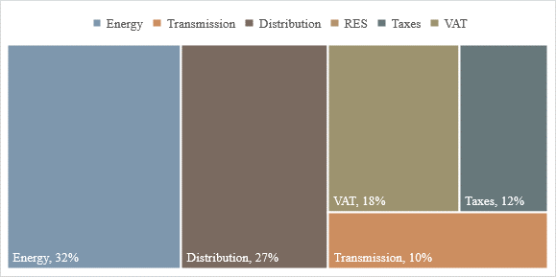
Figure 4.6.2. POTP electricity breakdown of incumbents’ standard offers for households in Lithuania - 384 EUR (November–December 2017)

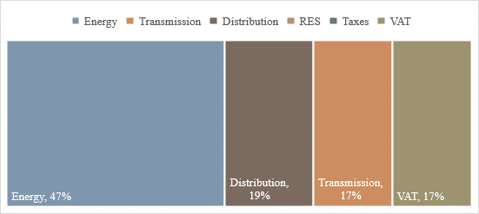
Figure 4.6.2. POTP gas breakdown of incumbents’ standard offers for households in Lithuania – 457EUR (November–December 2017)

The Eurostat figures reveal the prices of electricity, water, gas and science in Lithuania show the biggest difference from the EU average, making just 40 % of the EU average.
During the second half of 2017 electricity price in Lithuania was the second lowest in EU.
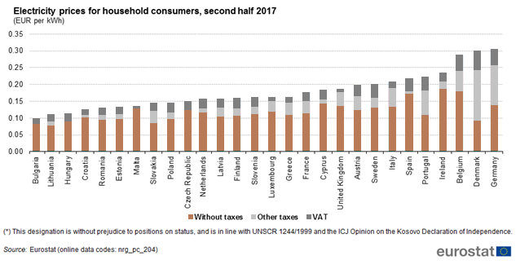

For non-household consumers (defined as medium-size consumers with an annual consumption within the range of 500 MWh < consumption < 2 000 MWh), electricity price in Lithuania during the second half of 2017 was among the lowest ones.
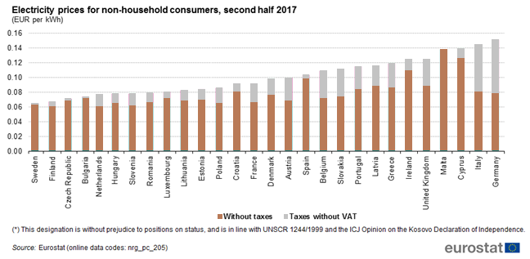

Table 4.6.1. Power transmission and distribution service price caps for 2012–2017 (ct/kWh)
Name of the regulated service | Supplier of the regulated service | Regulated service price cap (ct/kWh)
Name of the regulated service | Supplier of the regulated service | 2012 | 2013 | 2014 | 2015 | 2016 | 2017
Power transmission | TSO Litgrid | 0.672 | 0.699 | 0.639 | 0.538 | 0.691 | 0.672
Power distribution for medium voltage network | DSO ESO | 1.413 | 1.375 | 1.297 | 1.178 | 1.000 | 0.830
Power distribution for low voltage networks | DSO ESO | 1.856 | 1.801 | 1.785 | 1.550 | 1.766 | 1.655

      - Description of energy subsidies, including for fossil fuels
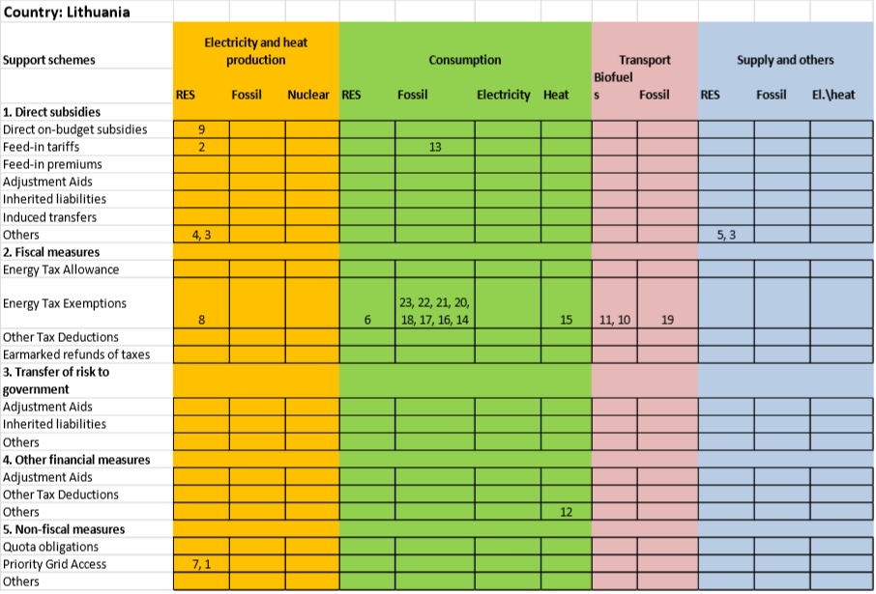
Figure 4.6.2. Energy support in Lithuania 2005-2012

1. The operators of renewable energy plants are entitled to priority connection to the grid. The grid operator shall ensure priority transmission of electricity from renewable energy sources. The grid operators are obliged to optimise, boost or expand their grids if this is required for RES plant connection.
2. Feed-in tariff (Law on Energy from Renewable Sources) - In Lithuania, renewable electricity generation is promoted through a feed-in tariff. According to the National Control Commission for Prices and Energy (NCC), the operators of renewable electricity generation plants are entitled against the grid operator to payment for electricity exported to the grid. All electricity produced by RES plants whose total installed capacity does not exceed 10 kW shall be purchased at the feed-in tariff set by the NCC. Feed-in tariff contracts for the operators of RES plants with a total installed capacity exceeding 10 kW are awarded through tenders. Tariff rates for RES plants with a generating capacity of up to 10 kW and maximum tariff rates for RES plants exceeding 10 kW on a quarterly basis shall be set by the NCC. The feed-in tariffs are guaranteed for 12 years.
3. Loan (The Fund of the Programme for Climate Change Mitigation) - The Fund for the Programme for Climate Change Mitigation supports projects aiming to reduce GHG emissions. The funds for this programme are intended to be used to encourage renewable energy use and the introduction of environmentally friendly technologies. This fund provides support in the form of loans and subsidies according to the Guidelines for the Use of the Fund for the Special Programme for Climate Change Mitigation, approved by Order No. D1-275/2010.
4. Subsidy (LEIF) - The Lithuanian Environmental Investment Fund (LEIF) supports projects aiming to reduce environmental damage in the long term. This definition includes RES-E projects with the exception of geothermal energy. Projects are supported in the form of interest subsidies and soft loans. There are two calls a year that are published in the media or on the website of the LEIF. For general information in English on the funding of projects by the Lithuanian Environmental Fund please see www.laaif.lt/index.php.
5. Tax regulation mechanisms (Law on Excise Taxes) - In Lithuania, the obligation to pay excise tax on electricity arises where: it is sold or otherwise transmitted to a person who has no business licence; it is received by an unlicensed person from another EU member state; it is imported by an unlicensed person or it is consumed by the holder of a licence or an electricity producer for own use. Electricity consumption for own use is defined as the consumption of electricity for purposes other than electricity production processes and production process maintenance (Chapter IV Art. 45 Law on Excise Taxes).
6. Price-based mechanisms (Purchase of heat produced from RES) - The production of heat and the purchase of heat produced from renewable sources are public service obligations. The state promotes the purchase of heat produced from all renewable energy sources. Utilities have a priority purchase obligation for renewable heat generated by independent producers. Heat suppliers are obliged to purchase all RES heat generated by independent heat producers which satisfy quality, supply security and environmental requirements. This obligation does not apply where the supply of renewable heat generated by independent heat producers exceeds network capacity (Chapter IV Art. 25 Law on Energy from Renewable Sources; Chapter II Art. 4, Chapter IV Art. 10 Law on Heat). The procedure and the conditions for the purchase of heat from independent heat producers are defined by the National Control Commission for Prices and Energy (Chapter II Art. 4 Item 2, Chapter IV Art. 10 Item 1 Law on Heat).
7. Tax regulation mechanism (Law on Environmental Pollution Taxes) - Environmental pollution tax for stationary sources of pollution shall be paid by all operators of fuel-burning installations whose nominal thermal capacity exceeds 50 MW. This tax must also be paid by operators using at least one solid fuel boiler whose thermal capacity amounts to or exceeds 0.5 MW and operators using incinerators whose thermal capacity amounts to or exceeds 1 MW (Appendix 1 Item 1.1; Appendix 2 Items 5, 6 Order No. 80/2002 as amended on 29.06.2005). Operators using liquid biomass shall be exempt from environmental pollution tax for all stationary source emissions resulting from the use of liquid biomass (Art. 5 Par. 4 Law on Environmental Pollution Taxes).
8. Subsidy (National Paying Agency under the Ministry of Agriculture) - Part of the price of rape oil used for the production of rapeseed methyl (ethyl) ester (RME) and part of the price of rape seed and cereal grain purchased for the production of dehydrated ethanol will be reimbursed under this support scheme (Chapter I Item 3 Order No. 3D-417). The maximum reimbursement for rapeseed and cereal grains is set by the Minister of Agriculture each year (Chapter V Item 11 Order No. 3D-417). This measure is implemented by the National Paying Agency on behalf of the Ministry of Agriculture (Chapter IX Item 18 Order No. 3D-417).
9. Tax regulation mechanism (Law on Environmental Pollution Taxes) - Natural and legal persons using biofuels, including biohydrogen, in vehicles are exempt from environmental pollution tax on their mobile source emissions. The decision to grant exemption from environmental pollution tax is based on documentary evidence. Moreover, in order to be eligible for environmental pollution tax relief, biofuels must meet certain statutory standards. The amount of subsidy is equal to the amount of tax a natural or legal person is exempt from (Art. 5 Par. 3 Item 4 Law on Environmental Pollution Taxes).
10. Tax regulation mechanism (Law on Excise Taxes) - Excise tax relief applies to transport biofuels produced from biomass. The excise tax rate is reduced in proportion to the percentage of biomass per tonne of biofuel. The relief applies to bioethanol, biodiesel, bio-ETBE and vegetable oil. To be eligible under this support scheme, biofuels must comply with the mandatory statutory quality requirements and other requirements, standards and European norms (Chapter III Art. 40 Law on Excise Taxes).
11. Fixed prices for CHP-generated electricity. CHP electricity is supported by setting regulated fixed prices for determined production quota.
12. Feed-in tariff for electricity produced from biofuels.
13. Reduced rate of excise tax for heating.
14. Reduced VAT for Heat Energy in the Residential Sector.
15. Exemption of excise tax for agriculture and fisheries. No estimates available.
16. Excise-tax Reduction on Fuel Oil for Licenced Purchasers. Fuel oil that corresponds to certain criteria set by the Government or its authorized institution is taxed by the excise tax at a rate of 52 LTL / 1000 litres. However, if fuel oil does not satisfy these criteria, it is taxed at a rate of 1043 LTL / 1000 litres. No estimates available.
17. Excise-tax Reduction on Coal for Licenced Purchasers. For coal a reduced excise tax of 13 LTL/ t (standard excise tax rate is 26 LTL / t) is applied if the fuel is used for business needs. For business use of coke and lignite a reduced excise tax rate of 16 LTL / t (standard excise tax rate is 31 LTL / t) is applied. The mentioned excise tax rates are practiced if fuels are sold to a subject, who has a license issued by the Central Tax Administrator. No estimates available.
18. Excise-tax Exemption on Natural Gas Used for Public Transport. A standard excise tax rate of 758 LTL / 1000 m is applied to natural gas that is applied as motor fuel. However, if natural gas is used as motor fueal for local (city and suburb) buses, then the excise tax is not applicable. No estimates available.
19. Excise-tax Exemption for Natural Gas Used in Electricity and Heat Production.
20. Excise-tax Exemption for Coal Used in Electricity and Heat Production. No estimates available.
21. Excise-tax Exemption for Oil Used in Electricity and Heat Production. No estimates available.
22. Excise-tax exemption for home use. A standard excise tax rate of 1050 LTL / t is applied to (liquid) petroleum gas. However, petroleum gas is exempt from excise tax if it is poured into home gas cylinders. No estimates available.

- IMPACT ASSESSMENT OF PLANNED POLICIES AND MEASURES

Impacts of planned policies and measures described in section 3 on energy system and GHG emissions and removals including comparison to projections with existing policies and measures (as described in section 4).
      - Projections of the development of the energy system and GHG emissions and removals as well as, where relevant of emissions of air pollutants in accordance with Directive (EU) 2016/2284 under the planned policies and measures at least until ten years after the period covered by the plan (including for the last year of the period covered by the plan), including relevant Union policies and measures.
In addition to impacts of implementation existing policies and measures in all economy sectors, which the most will be continued beyound 2020, on energy system and GHG emission reduction and generation of removals described in Section 4.2.1, the planned policies and measures were identified. The evaluation of policies and measures is still under development.
Ministry of Energy and Environment initiated dialogues with Minsitry of Agriculture, Transport and communication and with the departments at the Ministry of Environment. The ministries and departments were informed on the proceeding preparation procedure of the NECP and were asked to indicate the planned policies and measures related with GHG mitigation and adaptation for the period 2021–2030. The negotiation process has been prolonged due to issues related with unclear financing and implementation mechanism.
In this stage we present the plannned measures which were identified in preparation of GHG projections in 2016.
      - Assessment of policy interactions (between existing policies and measures and planned policies and measures within a policy dimension and between existing policies and measures and planned policies and measures of different dimensions) at least until the last year of the period covered by the plan, in particular to establish a robust understanding of the impact of energy efficiency / energy savings policies on the sizing of the energy system and to reduce the risk of stranded investment in energy supply
This part to be defined in the final version of the Plan.
      - Assessment of interactions between existing policies and measures and planned policies and measures, and between those policies and measures and Union climate and energy policy measures
This part to be defined in the final version of the Plan.

Macroeconomic and, to the extent feasible, the health, environmental, employment and education, skills and social impacts including just transition aspects (in terms of costs and benefits as well as cost-effectiveness) of the planned policies and measures described in section 3 at least until the last year of the period covered by the plan, including comparison to projections with existing policies and measures
Based on data, provided in the Commission impact assessment accompanying A policy framework for climate and energy in the period from 2020 up to 2030, implementation of Lithuania’ s GHG emissions reduction target will cost annually from 0.39% to 0.91% of GDP depending on the range of percentage of RES in final energy demand and EE improvement, at the same time it will allow to save from 2.9 till 4.7 billion EUR for the purchasing fossil fuels, in comparison with oil prices in 2014, in the period 2021–2030.

Overview of investment needs
      - existing investment flows and forward investment assumptions with regards to the planned policies and measures
This part to be defined in the final version of the Plan.

      - sector or market risk factors or barriers in the national or regional context
This part to be defined in the final version of the Plan.
      - analysis of additional public finance support or resources to fill identified gaps identified under point ii
This part to be defined in the final version of the Plan.

Impacts of planned policies and measures described in section 3 on other Member States and regional cooperation at least until the last year of the period covered by the plan, including comparison to projections with existing policies and measures
      - Impacts on the energy system in neighbouring and other Member States in the region to the extent possible
This part to be defined in the final version of the Plan.
      - Impacts on energy prices, utilities and energy market integration
This part to be defined in the final version of the Plan.
      - Where relevant, impacts on regional cooperation
This part to be defined in the final version of the Plan.

Available online: http://www.am.lt/VI/en/VI/index.php#a/717
Doha Amendment to the UNFCCC Kyoto protocol in the period 2013-2020
established by the Order No 1-71/D1-249 of the Minister of Energy and Minister of Environment (2017)
https://epilietis.lrv.lt/lt/dalyvauk-1/dalyvauk-viesosiose-konsultacijose/dalyvauk-viesosiose-konsultacijose-1?page=1
Consistency to be ensured with long-term low emission strategies pursuant to Article 14.
available online: http://www.am.lt/VI/en/VI/index.php#a/717
Lithuanian biomass energy association (Litbioma): http://www.biokuras.lt/en
Tebėra, A., 2014 m. „Medienos kuro pasiūlos ir paklausos įvertinimas“
STR 2.01.02:2016 „Design and Certification of Energy Performance of buildings “, adopted on 11 November 2016 by the Order No D1-754 of the Minister of Environment
http://publications.jrc.ec.europa.eu/repository/bitstream/JRC101191/ldna27998enn.pdf
In accordance with Regulation (EU) No 347/2013 of the European Parliament and of the Council of 17 April 2013 on guidelines for trans-European energy infrastructure and repealing Decision No 1364/2006/EC and amending Regulations (EC) No 713/2009, (EC) No 714/2009 and (EC) No 715/2009 (OJ L 115, 25.4.2013, p. 39).
https://www.kn.lt/en/our-activities/lng-terminals/klaipeda-small-scale-lng-terminal/560
https://ec.europa.eu/eurostat/web/microdata/european-union-statistics-on-income-and-living-conditions
Source: www.energypoverty.eu
By the request of the Ministry of Economy, the Ministry of Energy and the Ministry of Transport Communications a comprehensive feasibility study on the development of electric vehicles was carried out in 2012. The aim of the study was to investigate the need and possibilities of developing electric vehicles and related transport infrastructure in Lithuania, to evaluate its potential economic and environmental benefits, identify problems and obstacles, and, taking into account foreign experience, to provide recommendations for the development of electric vehicle transport and related transport infrastructure in Lithuania
https://sumin.lrv.lt/lt/administracine-informacija/nacionaline-susisiekimo-pletros-2014-2022-metu-programa
Source: http://www.am.lt/VI/files/File/Klimato%20kaita/studija%202030.pdf
When planning those measures, Member States shall take into account the end of life of the existing installations and the potential for repowering.
http://www.krea.lt/images/angle180/klimato-kaita-gaires-savivaldybems.pdf
http://www.am.lt/VI/files/0.801697001448351965.pdf
In accordance with Article 2a of Directive 2010/31/EU.
In accordance with Article 18 of Directive 2012/27/EU.
In accordance with Article 8 of Directive 2012/27/EU.
In accordance with Articles 12 and 17 of Directive 2012/27/EU
In accordance with Article 19 of Directive 2012/27/EU.
In accordance with Article 15(2) of Directive 2012/27/EU.
Policies and measures shall reflect the energy efficiency first principle.
Consistency shall be ensured with the preventive action and emergency plans under Regulation (EU) 2017/1938 of the European Parliament and of the Council of 25 October 2017 concerning measures to safeguard the security of gas supply and repealing Regulation (EU) No 994/2010 (OJ L 280, 28.10.2017, p. 1) as well as the risk preparedness plans under Regulation (EU) 2018/... [as proposed by COM(2016) 862 on risk-preparedness in the electricity sector and repealing Directive 2005/89/EC].
Policies and measures shall reflect the energy efficiency first principle.
Other than the PCI Regional Groups established under Regulation (EU) No 347/2013.
Other than the PCI Regional Groups established under Regulation (EU) No 347/2013.
http://www.vkekk.lt/en/Pages/national-decisions.aspx
In accordance with Article 15(8) of Directive 2012/27/EU.
Current situation shall reflect the date of submission of the national plan (or latest available date). Existing policies and measures encompass implemented and adopted policies and measures. Adopted policies and measures are those for which an official government decision has been made by the date of submission of the national plan and there is a clear commitment to proceed with implementation. Implemented policies and measures are those for which one or more of the following applies at the date of submission of the national plan or progress report: directly applicable European legislation or national legislation is in force, one or more voluntary agreements have been established, financial resources have been allocated, human resources have been mobilised.
The selection of exogenous factors may be based on the assumptions made in the EU Reference Scenario 2016 or other subsequent policy scenarios for the same variables. Besides, Member States specific results of the EU Reference Scenario 2016 as well as results of subsequent policy scenarios may also be a useful source of information when developing national projections with existing policies and measures and impact assessments.
Source: http://ec.europa.eu/transport/sites/transport/files/media/publications/doc/trends-to-2050-update-2013.pdf
Source: http://ec.europa.eu/transport/sites/transport/files/media/publications/doc/trends-to-2050-update-2013.pdf
Source: http://www.am.lt/VI/files/File/Klimato%20kaita/Prognoziu%20ataskaitos/PaMs%20report%202017.pdf
https://ec.europa.eu/energy/en/topics/renewable-energy/national-action-plans
https://ec.europa.eu/energy/en/topics/renewable-energy/national-action-plans
https://ec.europa.eu/energy/en/topics/renewable-energy/national-action-plans
Tebėra, A., 2014 m. „Medienos kuro pasiūlos ir paklausos įvertinimas“
In accordance with Article 14(1) of Directive 2012/27/EU.
This reference business as usual projection shall be the basis for the 2030 final and primary energy consumption target which is described in 2.3 and conversion factors.
With reference to overviews of existing transmission infrastructure by Transmission System Operators (TSOs).
With reference to national network development plans and regional investment plans of TSOs.
With reference to overviews of existing transmission infrastructure by TSOs.
With reference to national network development plans and regional investment plans of TSOs.
https://enmin.lrv.lt/uploads/enmin/documents/files/National_energy_independence_strategy_2018.pdf [retrieved on 31.07.2018]
VESK - http://maps.klaster.lt/klasterioaprasymas/vejo-energetikos-skatinimo-klasteris-vesk-paslaugos-keiciancios-kliento-materialiniu-gerybiu-savybes/ [retrieved on 31.10.2018]
BJVK - http://maps.klaster.lt/klasterioaprasymas/bio-jegainiu-vystymo-klasteris-paslaugos-keiciancios-kliento-materialiniu-gerybiu-savybe/ [retrieved on 31.10.2018]
Smart & Green City Cluster - http://maps.klaster.lt/klasterioaprasymas/ismaniojo-zalio-miesto-klasteris-informacines-paslaugos/ [retrieved on 31.10.2018]
Photovoltaic Technology cluster - http://maps.klaster.lt/klasterioaprasymas/fotoelektros-technologiju-klasteris-elektronikos-pramone/ [retrieved on 31.10.2018]
Decision-Aiding Evaluation of Public Infrastructure for Electric Vehicles in Cities and Resorts of Lithuania https://www.mdpi.com/2071-1050/10/4/904 [retrieved on 31.10.2018]
Regitra data online - https://regitra.lt/lt/paslaugos-ir-veikla/duomenu-teikimas/statistika/transporto-priemones-2?filesyear=2018&filesquery= [retrieved on 31.10.2018]
EV charging stations map - http://www.elektromobilis.org/dokumentai/krovimo-stoteli-em-lapis/ [retrieved on 31.10.2017]
Research and Development Activities in Lithuania 2015 - https://osp.stat.gov.lt/en/informaciniai-pranesimai?articleId=4740809 [retrieved on 31.10.2017]
https://acer.europa.eu/Official_documents/Acts_of_the_Agency/Publication/MMR%202017%20-%20RETAIL.pdf
Electricity price statistics - https://ec.europa.eu/eurostat/statistics-explained/index.php/Electricity_price_statistics [retrieved on 31.10.2018]
National Commission for Energy Control and Prices - http://www.regula.lt/SiteAssets/naujienu-medziaga/2017/2017-rugpjutis/Annual%20Report%20for%20EC%20on%20Lithuanian%20gas%20and%20electricity%20markets_NCC_2017.pdf [retrieved on 26.10.2018]
Country profile - European Environment Agency - https://www.eea.europa.eu/publications/energy-support/lithuania-country-profile [retrieved on 31.10.2017]
RES legal: Lithuania - http://www.res-legal.eu/search-by-country/lithuania/single/s/res-e/t/promotion/aid/subsidy-leif/lastp/159/ [retrieved on 29.10.2018]
Planned policies and measures are options under discussion and having a realistic chance of being adopted and implemented after the date of submission of the national plan. The resulting projections under section 5.1.i shall therefore include not only implemented and adopted policies and measures (projections with existing policies and measures), but also planned policies and measures.
http://am.lrv.lt/uploads/am/documents/files/%C5%A0ESD%20apskaitos%20ir%20kt%20ataskaitos/7th%20National%20Communication.pdf

